SPEAK OUT (Whistleblowing) policy
- INTRODUCTION
  - Sheffield Hallam University (“the University”, “we”, “our” and “us”) values openness and accountability and is committed to conducting its business with fairness, integrity and respect for the law. In line with this commitment, we encourage employees, members of the Board of Governors and those contracted to provide services to the University, who have serious concerns about any aspect of our work, to come forward and voice those concerns with the knowledge that, if made in the public interest, action will be taken to address these.
  - This Policy is available to:
    - someone who works or worked for us;
    - a current or former member of the Board of Governors or its committees;
    - any party with whom we have, or have had, some type of business relationship;

and who wishes to raise a concern about possible misconduct or wrongdoing within the University.
  - This Policy is not intended for students. If you are a student, then please use the student complaint route signposted in Section 1.5 B.
  - The purpose of this Policy is:
    - to encourage you to speak out to report suspected wrongdoing as soon as possible, in the knowledge that your concerns will be taken seriously and investigated as appropriate, and that your confidentiality will be respected;
    - to provide you with guidance as to how to raise those concerns;
    - to reassure you that you should be able to raise genuine concerns without fear of reprisals even if you turn out to be mistaken.
  - This Policy should not be used for complaints relating to your own personal circumstances, such as the way you have been treated (A) at work or (B) as a student. In those cases, you should consider using our existing procedures on:
- Treatment at work
        - grievance (the Problem Resolution Framework – individual and collective grievance procedures);
        - discrimination, bullying, harassment, and victimisation (Prevention of Bullying, Discrimination, Harassment and Victimisation Policy); and
        - misconduct in research (The Principles of integrity in research and procedure for dealing with allegations of research misconduct).

Details of these procedures can be found on our relevant intranet pages.
- Student complaints
            - Terms and Conditions and Student Regulations: https://students.shu.ac.uk/regulations/index.html
            - If you are a student and have a general concern, in the first instance please seek support and advice from your academic advisor, student support advisor, the International Experience Team and Disabled Student Support teams, Student Wellbeing Services and the Student Union Advice Centre as appropriate.
            - If you are a student who is concerned about the behaviour of another student which may be in breach of the Student Anti-Harassment Policy or the University Code of Conduct within our Disciplinary Regulations, then you can either seek support in the first instance through your student support advisor or report the issue through “Report and Support” or directly to the team responsible for student conduct casework by emailing studentconduct@shu.ac.uk.
            - If you are a student on placement who wishes to raise a concern about the external placement organisation with which you are placed, you are advised to follow the public interest disclosure or complaints procedures of that external organisation.
  - This Policy does not form part of any contract of employment or other contract to provide services, and we may amend it at any time.
- who is responsible for this policy?
  - The University’s Board of Governors through its Audit and Risk Committee has overall responsibility for overseeing the effectiveness of this Policy.
  - The University Executive Board is responsible for the effective operation of this Policy and for reviewing the application of actions taken in response to concerns raised under this Policy.
  - The University Secretary (or their designated nominee) is the designated officer with day-to-day operational responsibility for this Policy. You should refer any questions about this Policy to the University Secretary in the first instance. The University Secretary must ensure that regular and appropriate training is provided to all managers who may deal with concerns or investigations under this Policy.
  - The University Secretary shall keep a register of disclosures made under this Policy and shall submit to the Audit and Risk Committee as part of the yearly reporting cycle an anonymised report of all disclosures and any actions taken.
  - This Policy is reviewed at least once every three years by the Audit and Risk Committee.
  - We rely on you for the success of this Policy and invite you to make use of it to disclose any suspected danger or wrongdoing. You are welcome to comment on this Policy at any time and suggest ways in which it might be improved. Comments, suggestions and queries should be addressed to the University Secretary.
- what concerns CAN you raise under this policy?
  - This Policy concerns the disclosure of information which relates to suspected wrongdoing or dangers at the University. This may include any of the following list of categories of situations, which the law identifies as protected disclosures:
    - criminal activity;
    - failure to comply with any legal or professional obligation or regulatory requirements (including any breach of the regulatory framework of the Office for Students);
    - miscarriages of justice;
    - danger to health and safety;
    - damage to the environment;
    - from 6 April 2026 sexual harassment that has occurred, is occurring, or is likely to occur; and
    - the deliberate concealment of any of the above matters.
  - You can speak out under this Policy to raise a genuine concern, also commonly referred to as a whistleblowing concern, relating to any of the above, which you perceive as a serious wrongdoing within the workplace. You have our assurance that you will not suffer any negative treatment for having done so.
  - We also have in place other policies and procedures to address issues which may arise at the University, including those relating to concerns about bribery, fraud and corruption and to sexual harassment and misconduct. In many instances where there is a suspicion of improper behaviour, it will be more appropriate to follow these specific policies and procedures. Details are set out in the Anti-Bribery Policy, the Anti-Corruption Policy, the Fraud and Corruption Response Plan, and the Prevention of Sexual Harassment and Sexual Misconduct Policy. The University has a Money Laundering Officer (MLRO) whose responsibilities are set out in the Financial Regulations. The MLRO's responsibilities include receiving reports from staff of their suspicions and deciding whether these should be reported as criminal activity.
  - If a complaint relates to your own personal circumstances but you also have wider concerns regarding one of the areas set out in this section, you may get in touch with the University Secretary to seek advice about which route is the most appropriate.
  - This Policy is not designed to permit or encourage the questioning of legitimate financial or business decisions taken by the University.
  - For the avoidance of doubt, this Policy cannot be used to re-open or review a matter that is currently, or has already been decided, under one of the University’s other procedures, unless you believe that the findings or the process fall within the remit of Section 3.1 of this Policy.
  - If you are uncertain whether something is within the scope of this Policy, you should seek advice from the University Secretary.
- SPEAKING OUT to raise a WHISTLEBLOWING concern
  - We hope that in many cases you will be able to raise any concerns with your line manager. You may tell them in person or put the matter in writing if you prefer. Your line manager may suggest a way of resolving your concern quickly and effectively. In some cases, your line manager may refer the matter to the Executive Dean of College or the University Executive Board (UEB) lead with responsibility for the professional services area to which the matter relates, as appropriate, who in turn may refer it to the University Secretary.
  - However, where the matter is more serious, or you feel that your line manager has not addressed your concern, or you prefer not to raise it with them for any reason, you may consider contacting in writing first the Executive Dean of College or the UEB lead (for professional services), as appropriate, or you may choose to contact directly the University Secretary or a designated officer in the circumstances of Section 4.3 of this Policy.
  - If your allegation relates to the University Secretary, then the designated officer to whom you can address the allegation is the Vice Chancellor. If your allegation relates to the Vice Chancellor, or the Vice Chancellor and the University Secretary together, then the designated officer is the Chair of the Audit and Risk Committee. The contact details of the designated officers are set out in Section 10.
- confidentiality
  - We hope that you will feel able to voice your concerns openly under this Policy. However, if you want to raise your concern confidentially, we will make every effort to keep your identity secret. Access to information that could identify you will be strictly limited to those who need it in order to investigate the concern, and we will take care to protect your identity. In some situations, it may be necessary to share your identity with others involved in the process or with external bodies, for example where there is a legal obligation. Where possible and appropriate, we will let you know if this is required.
  - We do not encourage you to make disclosures anonymously. We will aim to consider anonymous concerns; however, you should be aware that proper investigation may be more difficult or impossible if we cannot obtain further information from you. It is also more difficult to establish whether any allegations are credible.
  - If you are concerned about possible reprisals if your identity is revealed, please come forward informally to the University Secretary or another individual listed in Section 10 and we will endeavour to preserve your confidentiality.

If you are in any doubt and would benefit from guidance, you can seek advice from the independent whistleblowing charity Protect, which offers a confidential helpline. If you feel affected by the issues of concern, you may choose to seek support from our Employee Assistance Programme (EAP). The contact details are listed in Section 10.

- INVESTIGATION AND OUTCOME
  - Once you have raised a concern, we will carry out an initial assessment to determine whether the raised concern falls within the remit of this Policy and, if so, the scope of any investigation.
  - As part of this assessment, we may arrange a meeting with you to discuss your concern. You can bring someone with you to support you in the meeting. This may be a friend, a family member, a work colleague or a member of a trade union. There is no need to have formal legal representation. You must give us the name and position of your proposed companion in advance of the meeting. We reserve the right to refuse to permit attendance of the person you choose if there is good reason. Your companion will not normally speak on your behalf. Your companion must respect the confidentiality of your disclosure and any subsequent investigation.
  - We will take down a written summary of your concern and provide you with a copy after the meeting. We will also aim to give you an indication of how we propose to deal with the matter. You may be required to attend additional meetings in order to provide further information.
  - We may determine it is appropriate to appoint an investigator or team of investigators to lead the investigation. The investigator (or investigators) may make recommendations for change to enable us to minimise the risk of future wrongdoing.
  - We will aim to keep you informed of the progress of the investigation and its likely timescale. However, sometimes the need for confidentiality may prevent us from giving you specific details of the investigation, an outcome or any disciplinary action taken as a result. You should treat any information about the investigation as confidential.
  - If we conclude that a staff member has made false allegations maliciously, they may be subject to disciplinary action.
- IF YOU ARE NOT SATISFIED
  - While we cannot always guarantee the outcome you are seeking, we will try to deal with your concern fairly and in an appropriate way. By using this Policy, you can help us to achieve this.
  - If you are not happy with the way in which your concern has been handled, you can escalate it to the Chair of the Audit and Risk Committee. Contact details are set out in Section 10 at the end of this Policy.
- EXTERNAL DISCLOSURES
  - The aim of this Policy is to provide an internal mechanism for reporting, investigating and remedying any wrongdoing at the University. In most cases you should not find it necessary to alert anyone externally.
  - The law recognises that in some circumstances it may be appropriate for you to report your concerns to an external body such as a regulator. It will very rarely, if ever, be appropriate to alert the media. We strongly encourage you to seek advice before reporting your concern to anyone external, in particular, in relation to your duty of confidentiality and to data protection law. The independent whistleblowing charity Protect operates a confidential helpline. They also have a list of prescribed regulators for reporting certain types of concern. Their contact details are in Section 10 of this Policy.
  - Where the University itself is required to report information to an external organisation, for example, to a regulator, law enforcement or a safeguarding authority, we will ensure that any disclosure is lawful, necessary and limited to the minimum information required. Decisions to share information will be considered and documented on a case‑by‑case basis. In such instances, we will aim to preserve your anonymity and will inform you of our reporting action.
  - Concerns raised under this Policy usually relate to the conduct of our staff, but they may sometimes relate to the actions of a student, supplier or service provider. In some circumstances the law will protect you if you raise the matter with the third party directly. However, we encourage you to report such concerns internally first, in line with this Policy. You should contact for guidance your line manager, the Executive Dean of College or the relevant UEB member, as appropriate, or an individual from the list in Section 10.
- PROTECTION AND SUPPORT FOR those who speak out
  - It is understandable that if you want to speak out, you may be worried about possible repercussions. We aim to encourage openness and will support those who raise genuine concerns under this Policy even if they turn out to be mistaken.
  - People who speak out must not suffer any detrimental treatment as a result of raising a concern. Detrimental treatment includes dismissal, disciplinary action, threats or other unfavourable treatment connected with raising a concern. If you believe that you have suffered any such treatment, you should immediately inform your line manager or the University Secretary. If the matter is not remedied, you should raise it formally using our grievance procedure or the Dignity at Work policy, as appropriate.
  - Our employees and students must not threaten a person who chooses to speak out and must not retaliate against them in any way. If an employee or a student is involved in such conduct, this may be investigated and could result in disciplinary action under the Problem Resolution Framework or the Disciplinary Regulations for Students. In some cases, the person who has spoken out and has been mistreated for that could have a right to sue personally for compensation.
  - A confidential support and counselling service from the Employee Assistance Programme (EAP) and support from the Staff Wellbeing intranet site are available to all staff. Further useful information for those who raise concerns under this Policy can be obtained from Citizen’s Advice and ACAS. The contact details for those are set out at in Section 10 of this Policy.

- contacts
University Secretary | Clair Marlow  Telephone: 0114 225 3625; 07775 013 430  Email: c.marlow@shu.ac.uk
University Vice-Chancellor | Professor Liz Mossop  The Vice Chancellor’s Office  Email: Liz.Mossop@shu.ac.uk
Chair of the Audit and Risk Committee | Jo Allen  Email: governance@shu.ac.uk (marked ‘confidential – for the attention of the Chair of ARC’)
Employee Assistance Programme (EAP)  Service is provided 365 days a year, 24/7 online, telephone and face to face.  EAP aims to help you deal with personal and professional problems that could be affecting your home life or work life, health or general wellbeing. | Telephone: If you are seeking help right now, contact 0800 028 0199  Mobile App: you can access support (including chat) on the Health Assured Wisdom Online Portal or Wisdom App  To register an account, visit either platform, enter the organisation code MHA096585 and follow the instructions - once registered, the same username and password can then be used to access both at any time.
Staff Wellbeing intranet site | Resources to support you as an individual at: Staff Wellbeing - Talk to someone (sharepoint.com) https://sheffieldhallam.sharepoint.com/sites/3005/polproc/staffwellbeing/SitePages/Staff-Wellness---I-need-support-now.aspx
Protect  (Independent whistleblowing charity) | Helpline: 0203 117 2520  Email: info@protect-advice.org.uk  Website: https://protect-advice.org.uk/contact-protect-advice-line/
Citizens Advice | Website: https://www.citizensadvice.org.uk/
Advisory, Conciliation and Arbitration Service (ACAS) | Helpline: 0300 123 1100  Website: https://www.acas.org.uk/advice
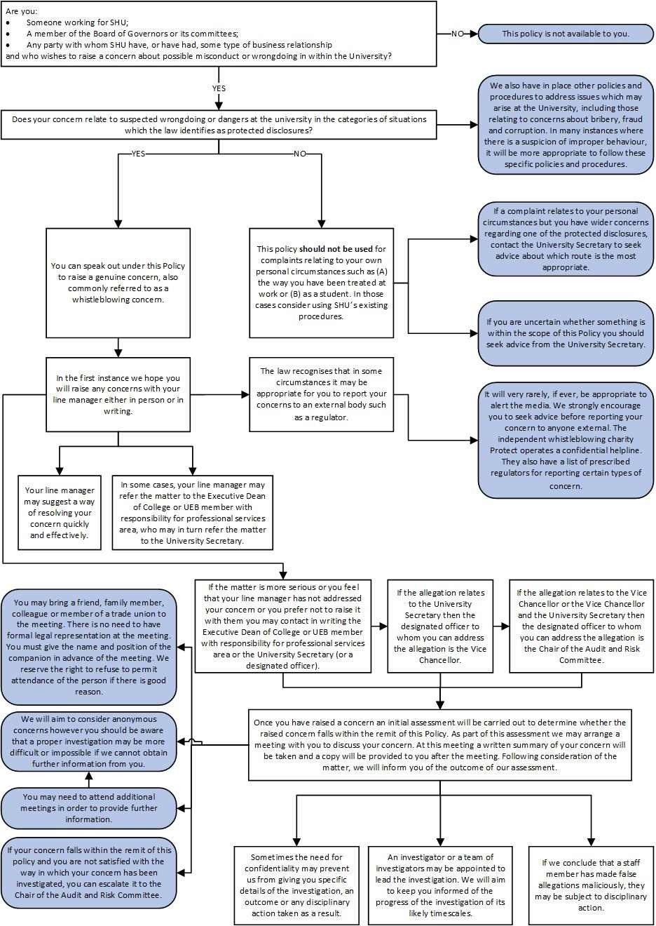
Policy TITLE: | SPEAK OUT (Whistleblowing) policy
Policy Owner: | University Secretary
Approved by: | University Executive Board  4 November 2025
Directorate/Team: | Governance, Legal and Compliance
Version | 1.5
Amendments since approval: | Details of revision: | Date of revision: | Revision approved by:
Amendments since approval: | Update to University Secretary details - as policy owner (v1.1) | 29/5/2019 | Clair Marlow, Interim University Secretary
Amendments since approval: | Updates to the language and the presentation style; revised pathway for addressing disclosures; incorporated guidance into one single document (v1.2) | 18/07/2023 | University Executive Group
Amendments since approval: | Updates to University Secretary and Vice-Chancellor details  Updates to information about Employee Assistance Programme (v1.3) | 4/09/2024 | Clair Marlow, University Secretary
 | Update to job titles  Process amended to make a meeting as part of the initial assessment of a compliant optional rather than compulsory  (v1.4) | 4/11/2025 | University Executive Group
 | Updates to (i) scope of the Policy (amendments to 1.2.1 and 1.2.2) (ii) addition of a new protected disclosure (3.1.6), (iii) confidentiality provision and (iv) external disclosures.  (v1.5) | 12/3/2026 | Clair Marlow, University Secretary

