

**Sheffield Hallam University Response to the Initial Teacher Training Review**

22.08.2021

1. **Background and overview**

*In the 2019*[*teacher recruitment and retention strategy*](https://www.gov.uk/government/publications/teacher-recruitment-and-retention-strategy)*, the government committed to reviewing the ITT market to support it to work more efficiently and effectively. This builds on the existing reforms to teacher training detailed in our June 2021 publication*[*delivering world-class teacher development*](https://assets.publishing.service.gov.uk/government/uploads/system/uploads/attachment_data/file/991390/Delivering_World-Class_Teacher_Development.pdf)*.*

*These include the*[*ITT core content framework (CCF)*](https://www.gov.uk/government/publications/initial-teacher-training-itt-core-content-framework)*and the*[*early career framework (ECF)*](https://www.gov.uk/government/collections/early-career-framework-reforms)*, both published in 2019, and the 2020*[*national professional qualification (NPQ) frameworks*](https://www.gov.uk/government/publications/national-professional-qualifications-frameworks-from-september-2021)*.*

*The review has now concluded and its report has been published alongside this consultation. The report contains 14 recommendations for improvements to the ITT systems, based on the latest pertinent research and national and international practice.*

*Given the importance of ITT, and with each ITT recruitment round resulting in around 30,000 qualified teachers, we would like to implement any recommendations that are agreed following consideration of the consultation responses as quickly as possible. We think that implementation may be possible for the 2022/23 postgraduate recruitment round, with DfE running an accreditation process early in 2022 and successful providers being announced before the end of the 2021/22 academic year. Providers would then have a further year to recruit trainees and prepare for first teaching of the new ITT courses*

1. **The case for change**

***The government is committed to ensuring that England is the best place in the world to become a teacher. We wish to build on the good practice that already exists in teacher training and the opportunities afforded by the teacher development reforms that we have already announced.***

***In paragraph 18 of its report, the review has identified some of the challenges that exist in the current ITT system. Which of the themes set out in the report do you particularly recognise as key area(s) where there is an opportunity to further increase the quality of ITT?***

With over 100 years of experience, we are one of the largest providers of teacher professional development, we work with over 600 partners, and we are home to many of the leading academic thinkers and influential school leaders in this space. As educators and trainers of over 2,200 trainees and student teachers (ITT and SCITT total, July 2021) we pride ourselves on our innovative and comprehensive approach to teacher development and as a partnership, our mission to transform lives shapes everything that we do.

We value and promote school-led teacher development and support both School Direct and SCITT partnerships. We were involved from inception in the development of Teaching School Alliances then Teaching School Hubs in the region, and are a partner in delivery of the ECF and NPQs. We therefore recognise many of the themes in the report as priorities across our partnerships. Our partnerships have considerable strengths in these areas, so we are not working from a deficit model.

Our work on ITT curriculum ([Perry et al, 2019](http://shura.shu.ac.uk/24770/)) stressed the importance of an evidence based curriculum and our school partners report they seek opportunities to develop further alignment between the taught curriculum and training environments in schools.

Our [Sheffield Institute of Education Research and Knowledge Exchange Centre](https://www.shu.ac.uk/sheffield-institute-education-research) has led innovations in teacher professional development, and evaluated national programmes including those focusing on evidenced-based teaching, maths mastery and literacy. Sam Twiselton’ s [three stage model of curriculum sequencing](https://impact.chartered.college/article/twiselton-developing-effective-teachers-perspectives-approaches/) has strongly influenced our partnerships’ developments in terms of curriculum sequencing and trainee support, and this work has been operationalised through our School Direct and SCITT community networks, and our revision of school based training expectations, intervention, and assessment. Sam’s leadership across our partnerships and the ITT sector (Carter Review, Bennett Behaviour in ITT, Recruitment and Retention Strategy, Core Content Framework, member of Expert Panel on this review) has ensured good practice in coherent curriculum design has been shared to benefit all providers and partners in our region.

We recognise the crucial importance of mentor preparation and training and have worked as both ITT and SCITT partnerships in developing successful mentor training programmes. We have supported considerable development work in mentoring through our research (e.g. [Hobson & Maxwell, 2017](http://doi.org/10.1002/berj.3261)) and as a partnership continue to improve our support for mentors in the delivery of our ITT curriculum and the joint assessment of trainees.

We have always recognised the importance of clarity in the ITT market. Our Partnerships for Attainment and [South Yorkshire Futures](https://southyorkshirefutures.co.uk/syf/) work with regional providers and bodies such as the Doncaster Opportunity Area has improved the clarity from a trainee’s perspective, and we would wish to continue this activity across our partnerships.

Our investment in a sector leading education placements team has ensured that we have had appropriate high quality placements for our provision. We recognise that further improvements can be made here, building on our partnership success of sourcing appropriate UG and PGCE placements, and the high levels of trainee satisfaction expressed in NSS, and PGCE satisfaction survey scores evidences the strength we build on as a partnership.

* 1. ***Do you think that there are any other key areas for improvement in the ITT system?***

Civic engagement and locality-based education developments. We are home to the Civic University Network, initially funded by the DfE, the UPP Foundation and the Arts Council, which aims to help better connect universities’ civic ambitions and obligations to the localities in which they are based. Sheffield Hallam’s own [Civic University Agreement](https://www.shu.ac.uk/about-us/our-role-in-the-region/civic-university-agreement/our-education-and-skills), launched in July 2021, also features prominently commitments to education, skills and specifically teacher preparation, highlighting the importance of this offer to our local community and partners. It follows that having recently hosted a conference focusing on the civic contribution of MATs, universities, and other public sector bodies to education, we would argue that this civic role of education should be included in reforms.

Wellbeing and mental health support. Whilst we support the focus on curriculum development and support for cognitive development in both school students and trainee teachers, we believe this cognitive development occurs in a social, psychological, and economic context. It therefore follows that, especially given the timing of this consultation in relation to Covid-19, ITT training recognises the context in which learning takes place. We have ensured all our trainees and student teachers have received introductory training in supporting the mental health of children and young people, and evaluation data to date suggest this is a key area for all engaged in education and schooling.

We would also argue that our experience of the pandemic leads to the inclusion of several other key areas:

* Equality, Diversity, and Inclusion (EDI): MATs, individual schools, the university, and other private and public sector bodies have all been doubling down on their actions to become more diverse, inclusive, and equal organisations over the last two years. We believe EDI should be more of a focus in the ITT training system given the ambition to provide a world class service.
* Blended Learning, remote learning, and simulation: many of the changes implemented in ITT in the last two years are proving important to sustain and a future facing curriculum should reflect recent changes in teaching and learning and professional development.
* Interprofessional working: teachers have had to engage with (for example) social workers, speech and language therapists, and health professionals in more depth, and our MAT partners have taken many of these services in-house. The pandemic, and a series of public enquiries, has emphasised the importance of inter-professional collaboration and communication. This is reflected in our healthcare and police training provision, and we see this as another area for improvement, in training teachers to play their part in collaboration between children’s and young people’s services
* Progression from Early Years education to primary schooling: given the undisputed evidence of the importance of 0-5 education we are surprised that this is not highlighted in the consultation.
* Progression from Secondary education to Post 16 and FE: given the current policy developments in post 16 and FE we feel transition to FE could be given more consideration in any future ITT ‘system’.

**2.3** ***Taken together, the review’s proposals set out an overall approach to addressing the challenges identified in paragraph 18 of its report. If you think that there are alternative approaches to addressing these challenges, please specify what these are.***

We think a review of international approaches to teacher development highlight the importance of a broader range of research than is referenced in the consultation document. Models of clinical practice, internship and social pedagogy are all evidence-based and well evaluated approaches and we would expect to see this recognised in a world class ITT proposal.

We see a risk to provision in ‘cold spots’ met by smaller SCITT provision in the proposals so we would support location/context specific solutions rather than a single English solution.

**3.** **Quality Requirements for ITT providers: Curriculum**

***The review concludes that all ITT courses should centre on an evidence-based training curriculum which allows trainees to understand and apply the principles of the CCF in a controlled, cumulative and logical manner. To achieve this, the review recommends the adoption of the requirements set out in section 1 of ‘Initial teacher training (ITT) review – draft Quality Requirements for ITT providers’ (pages 39-43 in the review’s report). Accredited providers would still have freedom to design their curriculum and programme as long as these requirements are met.***

***Intensive practice placements. Under section 1 of the Quality Requirements, providers will be required to incorporate intensive practice placements, which are designed to provide opportunities for groups of trainees to practise selected, sequenced components of their training curriculum, and receive highly targeted feedback.***

***3.1 Minimum time allocations***

*ITT providers would also be required to design a curriculum that reflects the minimum time allocations for pivotal aspects of ITT programmes set out in the table below and on page 43 of the review’s report.*

**Proposed ITT minimum time allocations**

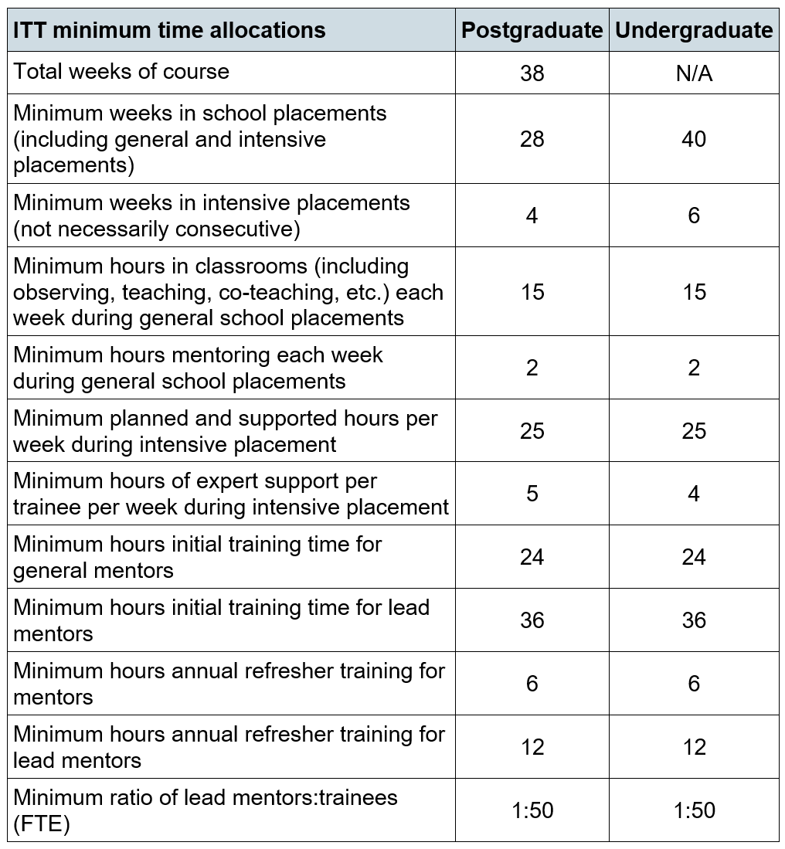

***3.2 Please provide any comments you have on a) the proposed approach to intensive practice placements, b) any barriers to implementation, and c) any support you would need to overcome these barriers. Please provide comments on the proposed approach to intensive practice placements***

We have operated intensive placements focusing on behaviour management, Early Reading, Early Maths and EAL across our wider partnerships with both primary and secondary trainees and student teachers. We have also focused on SEND as a specialism and delivered such intensive placements in our partnership with Teach First during the Summer Institute (SI).

We welcome the approach as one tool to ensure progression for trainees at the early stages of their education and training. However, we think it may be counterproductive to define the timing and sequence in advance. The approach needs to be adapted to school and course/trainee needs in order to gain support from schools and settings. We have the expertise within our partnerships to design and deliver such placements and a track record of delivering similar placements focusing on pivotal elements of content in the ECF such as secondary school behaviour management, primary core curriculum content, and EAL in both phases.

Key points from our partnership consultation are below. Our partners are keen to consult further on the practicalities of the intensive placement proposals:

* The proposals provide a real challenge without further clarification (how many trainees to be hosted at one time; separate subject or cross subject groups; need flexibility for scheduling in rotation but how will the affect sequencing; how and where would they be housed given the shortage of space in many schools).
* The implementation of intensive placements appears to be more challenging for primary settings, and more information, clarity and additional funding would be needed.
* Concern about length of trainee time in school on the workload of school staff. Concern about impact of trainees on student progress if trainees with classes for longer.
* Some feedback that 28 weeks could be accommodated, though extra funding needed to match the increase in time in school.
* It is not clear there would be a suitable geographic spread of placements and remote intensive placements were requested.

**3.3 *Please provide comments on barriers to implementation.***

Our partnership feedback is that the barrier to implementation is the provision of necessary financial resource to plan and deliver the placements by lead mentors, and also the difficulty in making actual time and space available for intensive placements in small secondary schools and primary schools.

***3.4 Please provide comments on any support you would need to overcome the barriers identified above.***

These barriers could be mitigated by ensuring appropriate resource and the support of Teaching School Hubs and MATs. Alternatives such as simulated intensive placements, and online support would need to be developed for smaller schools, and those who were not able to release staff.

Appropriate support for employment-based routes would also be needed, such as agreed time away from employment commitments and liaison with other employment based settings to ‘exchange’ groups of trainees for placement learning.

***3.5 Please provide any comments that you have on the minimum timings set out in the table above.***

Feedback from partners suggest that extending the period in school would be difficult for some schools but not all, and that this is likely to reduce overall placement capacity. The minimum hours tariff for mentoring was seen as a problem by many of our partners given their prime focus on the education of school students. Our experience of the time commitment for mentor training is this is also an area of concern. Our partners fed back that recruitment of ECF mentors had reduced the remaining capacity for ITT mentoring in some schools.

The level of specification for lead mentors is unnecessarily bureaucratic and devalues the contribution that existing lead practice educators already make to current programmes. All our partnership programmes have been co-created with partners and quantifying the input of expert school colleagues may be counter-productive given their level of experience. The significant increase in the undergraduate placement time (200 days + 30 days intensive placement) may also lead to difficulties in recruiting undergraduate placements

**3.6** ***Please provide any comments you have on any of the other curriculum requirements (excluding those requirements relating to intensive practice placements and minimum time allocations covered above), referencing by number any of the specific requirements included in the Quality Requirements that you wish to comment on.***

We welcome requirement 1.1, specifically the opportunity to further develop an ambitious curriculum which includes further content to be taught (over and above maintaining existing requirements and principles of the Core Content Framework). This supports our work on reflecting the local context and needs in curriculum design and course delivery. Partnership feedback is that school based colleagues recognise the importance of preparation for the Early Career Framework in the ITT phase. Those colleagues who are currently delivering the ECF are personalising delivery to their schools’ needs, and therefore a continuation of this approach in initial teacher preparation should be continued.

**4.** **Quality Requirements for ITT providers: Mentoring**

***The review identifies effective mentoring as a critical component of high-quality ITT and recommends the adoption of the requirements on mentoring set out in section 2 of ‘Initial teacher training (ITT) review – draft Quality Requirements for ITT providers’ (pages 44-46 in the review’s report). This would include a requirement for providers to develop a detailed training curriculum for mentors at all levels, including elements to subject or phase. It also suggests that lead mentors should take either the NPQ in leading teacher development, one of the other 2 specialist NPQs or training with the equivalent content and quality, and that each school that hosts a trainee should have at least one member of staff who is undertaking or has completed one of these courses.***

***Please provide any comments you have on a) the proposed approach, b) any barriers to implementation, and c) any support you would need to overcome these barriers.***

***Please provide comments on the proposed approach.***

Feedback from our partners raised issues of capacity, training space, and availability of time and financial resource. Most respondents to our partnership consultation were mentors or responsible for mentoring in their school, MAT or Teaching School Hub so we have summarised their responses below:

* It may be possible to work across Trusts to follow the NPQs but single schools do not have the capacity.
* Mentors need support with supply cover to allow this training to take place.
* Support for smaller schools is a problem; larger school direct partners are more able to support the mentoring requirements; 2 hours per week in a small school was seen as very difficult.
* It was suggested having a central team of NPQLTD trained lead mentors in place to visit smaller/remote schools.
* It was suggested existing senior mentor co-ordinators (SMCs) could be trained using the NPQ LTD and that a pilot should be run to evaluate credibility of this approach; this could also be extended to university tutors.
* School leaders were supportive of using existing ECT mentoring roles to support trainees but were concerned about overall capacity.
* Partnership colleagues were supportive of developing a detailed curriculum for mentors (recommendation 5) but raised concerns about time expectations and funding of this development.
* As a partnership we have combined research in mentoring with innovation in online mentoring curriculum development via an open online course and developed age phase specific mentoring programmes for early years, primary, secondary and post 16 trainees. We have also support subject specific mentoring in areas such as computing, physics, mathematics, and foreign languages. We run successful subject specific communities of practice in secondary sciences, primary core subjects, and currently introduce trainees to subject associations, MAT subject support, and regional teacher preparation networks via the teaching school hubs and bodies such as Learn Sheffield. We are aware of the time and resource needed to develop and delivery these programmes and would therefore stress that extra resource is allocated to these.

***4.1 Please provide comments on barriers to implementation:***

The barriers can be summarised as the competition between the ECF and ITT demands in schools for mentors, the time pressure of complete the NPQ, the risk to mentoring in small schools and primaries, and the cost of providing extra resource for mentoring, lead mentor deployment, and enhanced training.

***4.2 Please provide comments on any support you would need to overcome the barriers identified above:***

Support needed includes the provision of extra DfE funding for mentor training and development, and the provision of support for schools not in a MAT or federation from which they may be able to draw support. We currently fund all mentor training, development, and support, and also share fees with School Direct partners to enable this in SD provision. We would need to jointly access extra resource to implement the proposed requirements.

**5.** **Quality Requirements for ITT providers: Assessment**

***The review recommends adoption of the requirements set out in section 3 of ‘Initial teacher training (ITT) review – draft Quality Requirements for ITT providers’ (pages 47-48 in the review’s report), which would require providers to develop an assessment and progression framework which is aligned to the planned and sequenced curriculum and assesses trainees with appropriate frequency both on knowledge of the content of the curriculum and ability to apply it in classroom practice. Please provide any comments you have on this proposed approach to assessment of trainees undertaking ITT, referencing by number any of the specific requirements included in the Quality***

We welcome the specific references to improvement through evidence-based approaches and research evidence (requirements 3.3 and 3.7). Our partner responses to the assessment proposals valued the adoption of a common assessment language and framework for teacher development. Our current cross partnership work reflects the requirements detailed in 3.1 to 3.9. As a partnership we are updating our common assessment framework, applicable to both undergraduate and postgraduate provision, and this framework has been evaluated as straightforward to use, and is based on agreed evidenced-based principles.

We know that across the country other partnerships have done, and are doing, similar work. Local contextual co-construction is crucial for implementation of any assessment framework.

**5.1** **Quality Requirements for ITT providers: Quality assurance**

***The review recommends adoption of the requirements set out in section 4 of ‘Initial teacher training (ITT) review – draft Quality Requirements for ITT providers’ (pages 49-50 in the review’s report), which would require providers to design and implement rigorous quality assurance arrangements.***

***Please provide any comments you have on this proposed approach, referencing by number any of the specific requirements included in the Quality Requirements that you wish to comment on.***

Feedback from our partners suggests that our jointly developed existing quality assurance systems are effective. We are concerned that an imposition of additional bureaucracy (for example ‘fidelity checks’ on the quality of curriculum delivery), may deflect resource which could otherwise be focused on supporting the progress of trainees. We have reviewed the specific requirements (4.1 – 4.8) and do not find them greatly different to the existing expectations in the ITT Criteria. Our current partnership agreement, School Direct and SCITT contracts already cover this form of assurance.

* 1. **Quality Requirements for ITT providers: Structures and partnerships**

***The review recommends adoption of the requirements set out in section 5 of ‘Initial teacher training (ITT) review – draft Quality Requirements for ITT providers’ (pages 51-52 in the review’s report), which would require providers to set out the essential features of their structures and partnerships that enable them to deliver teacher training in the way described in sections 1 to 4 of the same document. Please provide any comments you have on this proposed approach, referencing by number any of the specific requirements included in the Quality Requirements that you wish to comment on.***

We currently have very successful structures in place for SCITT, School Direct and provider led partnerships. We welcome the opportunity to develop our co-constructed curriculum, and work on mentor training and curriculum development.

We currently collaborate on shared responsibilities (requirement 5.1) and would not merely ‘delegate responsibility to lead partners’ but rather continue to jointly plan successful ITT and ECF teacher development as a successful school led, research informed, comprehensive set of partnerships. Our trainees currently work in a wide range of contexts in our broad geographic area. Our mission is to transform lives and we would argue that requirement 5.8 is strengthened to reflect the mission of schools, trusts and higher education institutions in eradicating educational inequality.

Qualified Teacher Status and the PGCE

**6.** **Accredited Providers**

***The review concludes that all accredited providers should be able to offer teacher training leading to QTS within a recognised postgraduate academic course at a regulated and manageable cost and with any additional training content aligned with and complementary to the content required for a curriculum which meets the requirements for the award of QTS. It therefore proposes that DfE should facilitate any accredited providers which wish to do so to partner with an institution, such as the Institute of Teaching when it is ready, to offer a postgraduate award. Further detail can be found at paragraphs 64-67 of the review’s report. Please provide any comments you have on this proposal.***

We provide a recognised postgraduate course (PGCE and PGDE) with our current partners, and have very positive feedback that this is appropriate, adds much value to the training experience, and is an integral part of the overall trainee development. We would welcome any conversations with any future accredited providers to partner with them in PGCE or PGDE delivery. This is ready now and does not depend on any future development of the Institute of Teaching.

**7. Routes into teaching:**

***The recommendations apply to all 3 core routes into teaching: undergraduate ITT, postgraduate ITT fee-funded (both PGCE and QTS only) and postgraduate employment-based ITT. They do not, however, apply to early years ITT or further education ITE. Further detail can be found at paragraphs 68-72 of the review’s report.***

***Do you think that there are any specific considerations that a) providers of undergraduate ITT and b) providers of employment-based ITT would need to account for when implementing the Quality Requirements? In your answer, please include the approaches providers might take to address these.Please describe any specific considerations that providers of undergraduate ITT would need to account for.***

There are specific curriculum design opportunities for longer undergraduate routes. We welcome the opportunity to develop our primary (3-11) and secondary undergraduate courses but would need to ensure that we continued to work on consistency of assessment across one year and three year ITT routes, and also ensured that the undergraduate route featured in the mentor training curriculum, especially for the large numbers of primary trainees on this route. Currently we have a successful placement calendar, agreed across our partnerships, which does not overburden schools and supports the training of both undergraduate and postgraduate trainees. We would wish to continue to be led by our partners on both placement capacity and accommodating the specific training patterns of undergraduate ITT.

***7.1 Please describe any specific considerations that providers of employment-based ITT would need to account for. (Required)***

Our experience as both a provider of employment-based ITT, and a partner in SCITT provision indicates that the contents of Paragraph 71 (salaried intensive placements) have quality implications for delivery. Alternative or second placements have at times been difficult to organise and quality assure as the trainee is also an employee, and the demands of being a primary class teacher, or holding a role in a secondary subject department has meant release from that role can be difficult. Access to mentoring and concerns about overall workload have also been issues we have had to resolve.

***7.2******Please provide any comments on any indirect impacts on provision of a) early years ITT and b) further education ITE if these recommendations were to be implemented. Please describe any indirect impacts on provision of early years ITT.***

As an outstanding provider of early years ITT, we see the following indirect impacts:

* Management of any competition for 0-5 and 3-7 placements with schools and early years settings.
* Ensuring transition in the training of professionals working with the 0-3 age group and the 3-7 primary phase.
* Taking account, the difference in pay, conditions and resourcing between the early years and teaching workforce in any employment-based training routes.
* Respecting the research evidence on early years teaching, learning and development in the transition from the Early Years Foundation Stage and EYITT, to training in which the ITT Core Content is embedded.

**7.3 *Please describe any indirect impacts on provision of further education ITE.***

As a long-standing provider of excellent further education ITE, and an ETF partner on further education ITE mentor development, we see the following indirect impacts:

* Management of any competition for placements in 14-19 settings, for example UTCs to ensure continued high-quality setting based training.
* Congruence of mentor training arrangements, given the recommendation for a specific ITT mentor training curriculum in the consultation document
* The accreditation process and monitoring

**8.** **Accreditation**

***The review recommends that all accredited providers of ITT should be required to undergo accreditation or reaccreditation against the Quality Requirements. It acknowledges that, as a result of the raised standards, some providers will need to form different partnerships in order to have the capacity to meet the requirements for accreditation.***

***The review identifies some key roles and responsibilities that will need to exist within each ITT partnership: accredited provider, lead partner, and placement school. This is not envisioned as a one-size-fits-all model – for example, in some cases, a single organisation may wish to take both the accredited provider and lead partner role. Further detail can be found at paragraphs 77-81 and 86-89 of the review’s report. The review also recommends that DfE formally notifies accredited providers that have failed to continue to meet all aspects of the Quality Requirements, as set out in the ITT criteria.***

***Where providers receive a negative Ofsted judgment, it is also recommended that DfE should mandate support, or in some cases, broker mergers, between providers to ensure improvement. Further detail can be found at paragraphs 90-91 of the review’s report. Please provide any comments you have on the proposed approach to accreditation and re-accreditation.***

We do not support this approach to accreditation and re-accreditation. Our mission is to transform lives and raise educational opportunities in our region. A new accreditation process is a distraction from achieving that mission, and the accreditation and re-accreditation process does not value existing successful partnerships. Our partners were not convinced that re-accreditation of existing provision was necessary and were concerned about the impact of potentially losing providers during the process, and the knock-on impact on teacher recruitment. The accreditation process has particular risks for ‘cold spots’ and smaller providers including outstanding SCITTs, and also risks re-igniting damaging competition between providers, instead of encouraging collaboration.

***8.1 Please provide any comments you have on the proposed approach to monitoring set out above. Please provide any comments.***

The risks of a re-accreditation process/brokering of support after a negative inspection judgement is highly destabilising to placement supply, trainee recruitment, and stability of partnerships. This is only likely to reduce the size of the market and limit the gains made through the establishment of location specific SCITT provision and employment-based training. Partnership feedback included concerns about how schools would manage systems/paperwork if providers were to change, and the issue of providing an appropriate time lag if support was brokered or provision moved to a new provider.

**9.Timelines**

***DfE’s view is that, if they were to be implemented, the earliest that first delivery of the Quality Requirements in a reformed ITT market could take place is the autumn of 2023. This would involve the department launching the accreditation process in autumn 2021 and potential providers establishing partnerships, gathering evidence against the Quality Requirements and applying for accreditation or re-accreditation by spring 2022. The department would then assess and recommend accreditation in summer 2022, before the end of the 2021/22 academic year. Providers would then have a further year to recruit trainees and prepare for first teaching of the new ITT courses by September 2023. An indicative timeline is set out below.***

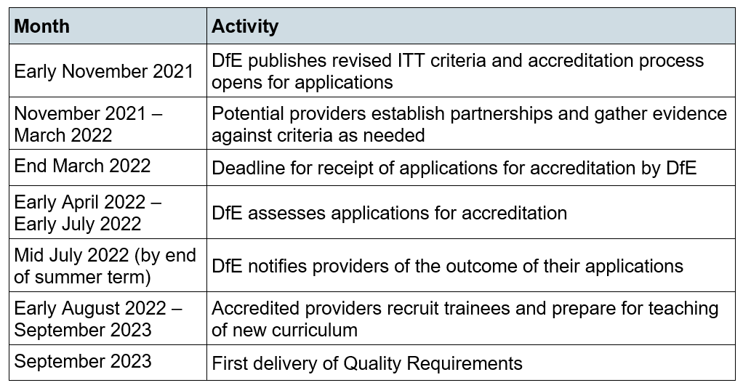

***Please provide any comments you have on a) the proposed target of September 2023 for first delivery of the Quality Requirements and b) DfE’s proposed timeline as set out above. Please provide comments on the proposed target of September 2023.***

This target is very risky. It damages existing successful ITT delivery in the region through forcing providers to conform to a yet unknown plan, instead of innovating based on current success. It would be important to test the deliverability of these reforms, so we would support piloting rather than wholescale change. We have no evidence from any of our partners that they view the September 2023 start date as a positive step.

**9.1** ***Please provide comments on the proposed timeline set out above.***

It is our view that this timeline is not deliverable. Our experience of implementing the Early Career Framework, our School Direct partnership and our SCITT provider network would guide us to report that the November- March window for partnership formation is too short. We are surprised that the DfE is committing to turn round the accreditation applications in under three months given the demands of a smaller accreditation resulting in four ECF providers. This timeline does not consider the priorities of schools, colleges, and universities in terms of Covid -19 recovery and the removal of regional inequalities in educational opportunity. We do not think this is deliverable given the legal and contractual changes that will need to be made to form new, different, or enlarged partnerships, given the need for all parties to ensure financial sustainability and protect the quality of educational delivery.

**9.2 *Having read ‘Initial teacher training (ITT) review – draft Quality Requirements for ITT providers’ and the anticipated timeline, if you think that your organisation would wish to deliver ITT in the future, would your organisation be likely to apply to become an accredited provider, seek to become or remain as a lead partner, or seek to become or remain as a placement school? As stated by the review, organisations may in some cases wish to take more than one role – as such, please select as many options as apply. Please specify the conditions under which you would apply for the role selected above.***

We would need to work through the cost and quality implications of accreditation with our partners before applying to be an accredited provider. This would involve ensuring our bid was sustainable, in the best interests of future trainees and educational institutions in the region, and ensuring any accreditation supported the mission of our partners, the Transforming Lives strategy in the university, and our joint civic aspirations including post-Covid educational recovery. The professional development of teachers, health professionals, and other vocations is a central part of the work of the university, so we would wish to ensure that any accreditation framework supported our work and did not risk quality or sustainability.

**9.3** ***If adopting a future model such as the one set out by the review, would you be looking to add more organisations to your current partnership?***

*If you are responding to this consultation as an individual or on behalf of an organisation that is not a current or potential provider of ITT (not including a School Direct lead school), please enter N/A.*

(Required) Yes No N/A

**9.4 *If you answered yes to the previous question, would your organisation require support to identify potential partners? Please also explain what support would be needed and what barriers this would overcome.***

If you are responding to this consultation as an individual or on behalf of an organisation that is not a current or potential provider of ITT (not including a School Direct lead school), please enter N/A.

(Required) Yes No N/A

***9.5 Please explain what support would be needed and what barriers this support would overcome.***

Support from the DfE would be welcome in brokering any new partnerships. We do have considerable experience developing SCITT, School Direct and Teach First partnerships, but we would also be happy to work with other schools and organisations who share our mission and values.

**10. Teaching school hubs**

***As they are particularly well-placed to act as a lead partner, the review recommends that teaching school hubs should be required to partner with an accredited provider to deliver ITT (unless they are operating at accredited provider level). In addition to working with accredited ITT providers, teaching school hubs will need to support local ITT delivery as an advocate for high-quality ITT in their respective areas, undertaking specified strategic roles as required. This could include building school capacity for ITT by building an active mentor network in the local area, providing specific support for schools serving disadvantaged communities to enable them to engage with ITT, or modelling high quality intensive practice placements for other schools undertaking this aspect of ITT for the first time. Further details can be found at paragraphs 82-85 of the review’s report.***

***Please provide any comments you have on the proposed role of teaching school hubs in the future ITT market.***

We have strong relationships with Teaching School Hubs in our wider region. We would be working with the hubs even if this review was not taking place. We see opportunities for hubs to contribute to ITT, but are concerned that any future transition from being a successful School Direct partner, or SCITT provider needs to be managed carefully. There is a danger of DfE ‘initiative overload’ for hubs as they seek to develop their ECF, NPQ and Appropriate Body roles alongside additional involvement in ITT. Feedback from our partners acknowledged that some partners are not involved with hubs yet, and other feedback was not supportive of hub involvement in ITT. However, the feedback from hub representatives suggests that that TSH can support the wider system to increase capacity, for example in mentor training. ITT as a system-wide responsibility

**11.** **ITT and mentor Training**

***The review argues that schools and trusts should see participating in ITT and mentor training as one of their core responsibilities and that it can bring many benefits to participating schools. To increase participation of trusts in ITT, the review proposes that regional schools commissioners should consider involvement in ITT as a condition of growth of trusts and that DfE should also make ITT involvement part of the eligibility for academy funding streams, such as the Trust Capacity Fund or sponsor grants. Further details can be found at paragraphs 99-104 of the review’s report.***

***Please provide any comments you have on the proposed approach to increasing involvement of trusts in ITT.***

Feedback from our partnership was varied: some feedback stated it that increasing the focus on ITT in the school inspection framework was sufficient. Other suggestions for increased involvement included good and outstanding trust schools playing a wider regional role in recruitment and teacher development. It was also suggested that small schools may need more financial support to contribute further. Responses from trusts included the need to meet their own MAT needs first, then offer out training and expertise. This could be done via hosting trainees, providing venues for training, and planning capacity for intensive placements. As a university provider we have strong relationships with trusts at a regional and national scale, and these relationships have supported successful provider led, School Direct and SCITT teacher development. We would wish to continue this success as it benefits the wider region in which we serve.

**12. Incentives**

***Please provide any comments you have on other incentives that could encourage schools and***

***trusts to participate in ITT.***

ITT needs to be seen by schools and trusts as a net benefit to their activity. Our partners value and participate in ITT with great commitment and the current success of existing partnerships should be shared and further publicised. Current some provision is highlighted by the DfE in social media campaigns for example, but a systematic approach to publicising the benefits of ITT involvement could draw greater success. We are wary of compulsory involvement: partners need to recognise the benefits in terms of recruitment, development of staff expertise, and retention of staff. Schools are also an important employers in localities where employment is scarce, so this broader economic impact should be recognised.

**13. Recruitment and selection**

***The review suggests that the proposed reforms should create an ITT landscape that is more easily navigable for potential trainees, building on the work already done to streamline the application journey. DfE’s view is that a future model that includes the key roles and responsibilities identified by the review as needing to exist within each ITT partnership (accredited provider, lead partner, and placement school) could help to simplify the landscape for applicants and provide opportunities to disseminate good recruitment practices. Please provide any comments you have on a) the impact of the proposed reforms on the recruitment and selection process, including potential for streamlining of the recruitment process and sharing of recruitment practices, b) any barriers to implementing the proposed reforms at the recruitment stage, and c) support that would be needed to overcome these barriers.***

***Please provide comments on the impact of the proposed reforms on the recruitment and selection process.***

The reforms risk undoing the work we have done in streamlining recruitment processes with partners and providers in the region. Recruitment to ITT is now strong and providers and partners work together on entry to the teaching profession, rather than competing for entrants. Market reform, with the threat of providers leaving the market, is only likely to reduce recruitment to the profession.

**13.1** ***Please provide comments on barriers to implementation.***

Barriers to implementation include confusion over the status of undergraduate ITT provision administered by UCAS, and the potential churn in providers using DfE Find and Apply.

**13.2 *Please provide comments on any support you would need to overcome the barriers identified above.***

Support needed to overcome these barriers include a DfE commitment to publicise all forms of ITT in the future, as opposed to leading on school led provision. Our experience is that the focus needs to be on the attractiveness of the teaching profession, rather than the ideology behind the training provision or the site/location of the training.

**14. Impact assessments**

***In order to inform its decisions on the proposals made by the review, DfE will undertake both an Equalities Impact Assessment and a Rural Impact Assessment on the proposals.***

***Please use this space to raise any a) equality impacts and b) any impacts specific to schools in rural areas that would result from the implementation of the proposed Quality Requirements.***

The review does not sufficiently stress the role of ITT in supporting local and regional development, nor the statutory duties of reducing inequality. As such there is a risk that trainees, schools, and providers may be excluded through proposed market reforms. Trainees with disabilities, trainees from minoritized groups, and trainees who cannot select from a range of providers may also be at risk.

***15.* Rural Areas**

***Please describe any impacts specific to schools in rural areas.***

Any reduction in the number and reach of providers could well result in rural schools, especially primary schools, not having access to ITT. As previously stated, the mentoring, mentor training and intensive placement requirements may be more difficult to meet. Our broad partnership supports many such schools in the Yorkshire and Humber region, either through location specific SCITTs or larger scale ITT partnerships. Many schools support employment based training and this proposal potentially puts existing successful employment routes at risk.

**16. International Qualified Teacher Status**

***To note, DfE has recently concluded a public consultation on International Qualified Teacher Status (iQTS), a new UK government-backed international teaching qualification. iQTS will be closely aligned to English methods and standards of initial teacher training. DfE therefore reserves the right to amend certain parts of the iQTS framework in line with any future changes in domestic requirements, where appropriate.***

***Please use this space to give any comments you have on any aspect of the report of the review or the ‘Initial teacher training (ITT) review – draft Quality Requirements for ITT providers’ document that you have not had the opportunity to provide in response to any of the other questions.***

***Please provide comments below.***

Our current shared priority is to provide support in terms of research, CPD, training and education in the post Covid-19 recovery. This consultation runs the risk of detracting from that priority, both in terms of its timing, and the lack of recognition of the current success of existing schools, SCITTs and HEIs in providing an excellent training and educational experience for prospective teachers.

The costs inherent in these proposed reforms are a concern. Feedback from senior professional service leaders in the institution suggests much more detailed costing is necessary to ensure we sustain and enhance the quality of partnership teacher preparation at scale.

**Professor David Owen**

Head of Sheffield Institute of Education

22.08.2021