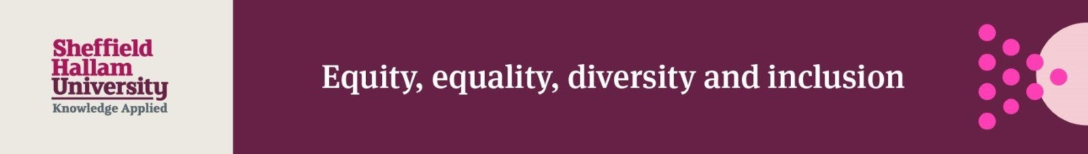

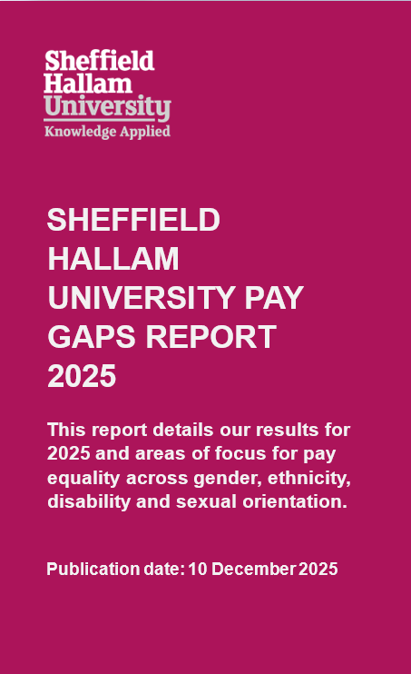

CONTENTS
SECTION 1. FOREWORD…………………………………………………………. Page 3.
SECTION 2. EXECUTIVE SUMMARY……………………………………………. Page 4.
SECTION 3. INTRODUCTION…………………………………………………….. Page 4.
OUR WORKFORCE……………………………………………………………… Page 5.
SECTION 4. GENDER PAY GAP………………………………………………….. Page 5.
PAY QUARTILES…………………………………………………………………. Page 7.
SECTION 5. ETHNICITY PAY GAP……………………………………………….. Page 8.
PAY QUARTILES…………………………………………………………………. Page 9.
SECTION 6. INTERSECTIONALITY PAY GAP………………………………… Page 11.
SECTION 7. DISABILITY PAY GAP……………………………………………… Page 11.
PAY QUARTILES………………………………………………………………... Page 12.
SECTION 8. SEXUAL ORIENTATION PAY GAP………………………………. Page 14.
PAY QUARTILES………………………………………………………………... Page 14.
SECTION 9. BONUS GAPS……………………………………………………… Page 15.
GENDER BONUS GAPS………………………………………………………. Page 15.
OTHER BONUS GAPS………………………………………………………… Page 16.
SECTION 10. CLOSING THE GAP……………………………………………… Page 16.
SECTION 11. ACCESSIBILITY STATEMENT………………………………….. Page 17.
SECTION 12. GLOSSARY……………………………………………………….. Page 18.
Pay……………………………………………………………………………….. Page 18.
Pay gap…………………………………………………………………………... Page 18.
Equal pay………………………………………………………………………… Page 18.
Mean pay………………………………………………………………………… Page 18.
Median pay………………………………………………………………………. Page 18.
Quartiles………………………………………………………………………….. Page 19.
.

SECTION 1. FOREWORD
As Vice-Chancellor and lead for equity, equality, diversity and inclusion (EEDI), I’m pleased to introduce our ninth annual pay gaps report.
Our vision - “Sheffield Hallam: A Culture of Inclusion” - reflects our belief that no one should face disadvantage due to their background, identity, or personal characteristics. We are pleased to see reductions this year in nearly all gaps and are continuing to take action to reduce these further. While some pay gaps arise from role differences, experience, or length of service, we remain committed to the principle of equal pay for work of equal value.
A fair and transparent pay system is key to building an inclusive, representative workforce. That’s why, beyond the legal requirement to report gender pay gaps, we also voluntarily publish data on ethnicity, disability, and sexual orientation to help us monitor and address disparities. We remain steadfast in our commitment to addressing pay gaps over the coming years.

Professor Liz Mossop
Vice-Chancellor

SECTION 2. EXECUTIVE SUMMARY
Since first reporting in 2018, we have steadily reduced our gender pay gap. This year marks our lowest figures yet, highlighting continued progress.
Since last year, we have achieved reductions in the mean ethnicity pay gap, the mean and median disability pay gaps, and the mean sexual orientation pay gap. When comparing 2025 data with the previous year:
- The mean gender pay gap has decreased to 8.6% from 9.3%
- The median gender pay gap has decreased to 11.5% from 12.2%
- The mean ethnicity pay gap has decreased to 7.9% from 8.6%
- The median ethnicity pay gap has increased to 5.6% from 2.9%
- The mean disability pay gap has decreased to 5.2% from 7.1%
- The median disability pay gap has decreased to 8.2% from 10.8%
- The mean sexual orientation pay gap has decreased to 8.9% from 12.8%
- The median sexual orientation pay gap has stayed relatively stable at 17.3%, compared with 17.8% in 2024

SECTION 3. INTRODUCTION
Sheffield Hallam University is driven by our purpose to transform lives and our ambition to be a world-leading applied university, built on a culture of collaboration, inclusion and sustainability.
Legislation, introduced in April 2017, requires all employers with 250 or more employees to publish the gender pay gap of those in scope annually. The legislation requires employers to carry out seven calculations that show the difference between the average earnings of men and women.
The gender pay gap is different from equal pay. Equal pay only deals with the pay differences between people with different protected characteristics (e.g. men and women) who carry out the same jobs, similar jobs or work of equal value. The gender pay gap shows the overall difference in average pay between all men and women within an organisation.
The median pay gap compares the middle value of women and men's pay (in a population of five people this would be the third value when sorted from lowest to highest). The median pay gap is useful as extreme outliers do not affect it. With smaller populations the median pay gap can change dramatically year-on-year, as the departure of a few members of staff can shift the middle point considerably.
In this case the mean pay gap (the gap between the average pay of women and men) may deliver a more useful perspective. However, the mean pay gap is more likely to be affected by large outliers, and so any smaller population with a large outlier will be skewed in that direction.

OUR WORKFORCE
Every job at the University is evaluated and placed within a grade. Grades vary by levels of responsibility, and each grade has a specific pay range. Employees progress through the grades and pay range as they develop their careers. A proportion of employees are appointed on a fixed rate salary within casual or training roles. While the proportion of female and male employees has remained relatively consistent over the last three years, the workforce decreased last year, from 4,687 employees in 2024 to 3,990 in 2025. On 31 March 2025, 57.8% of our employees were female (2,307 female employees), and 42.2% were male (1,683 male employees).

SECTION 4. GENDER PAY GAP
The gender pay gap calculation includes all employees who received their usual rate of pay in March 2025. This means that employees on reduced pay or unpaid leave in that month are excluded. The percentage figure shows the difference between the average hourly rates of pay that males and females received.
This year we can report progress in reducing the overall gender pay gap. The mean pay gap decreased from 9.3% in 2024 to 8.6% in favour of males in 2025 and the median pay gap decreased from 12.2% to 11.5%. The graphs below illustrate the mean and median gender pay gaps and rates of pay in 2024 and 2025:

Graph 1: Mean gender pay gaps

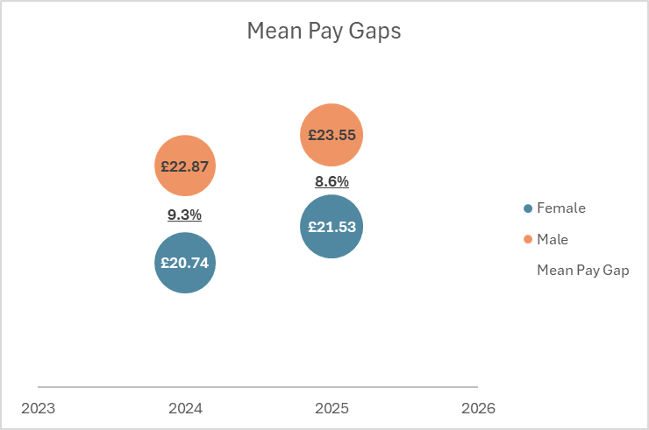

Graph 2: Median gender pay gaps:
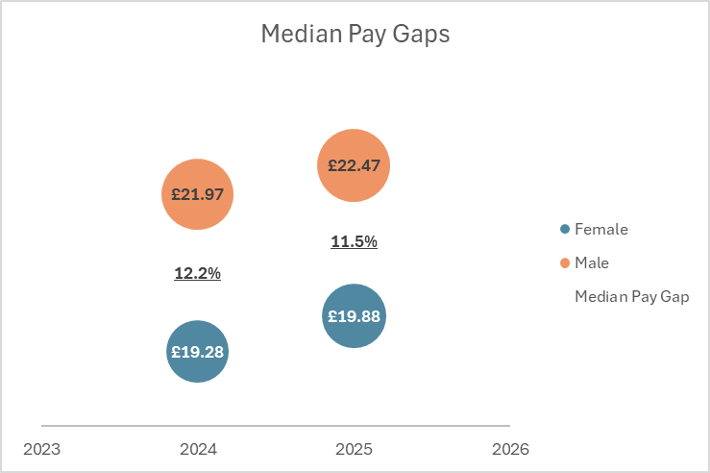

The report includes casual workers who were paid in March, and this has the potential to affect the data. Casual workers are engaged on an irregular or flexible basis, often to meet a fluctuating demand for work. There is no agreement as to whether any work will be offered, and the worker is not obliged to accept it. Roles typically undertaken by casual workers include Student Ambassadors and Exam Invigilators.

If this group of casual workers are removed, the mean improves from 8.6% to 7.3% and the median from 11.5% to 8.2%. This follows the same trend in terms of the University’s overall gender pay gap, with both the mean and the median decreasing.
As the number of casual workers who are paid each March will vary, we will continue to monitor the gap excluding casual workers too.

PAY QUARTILES
The graph below illustrates the proportion of male and female employees on 31 March 2025 in four quartile pay bands: lower, lower middle, upper middle and upper.

Graph 3: 2025 gender pay quartiles
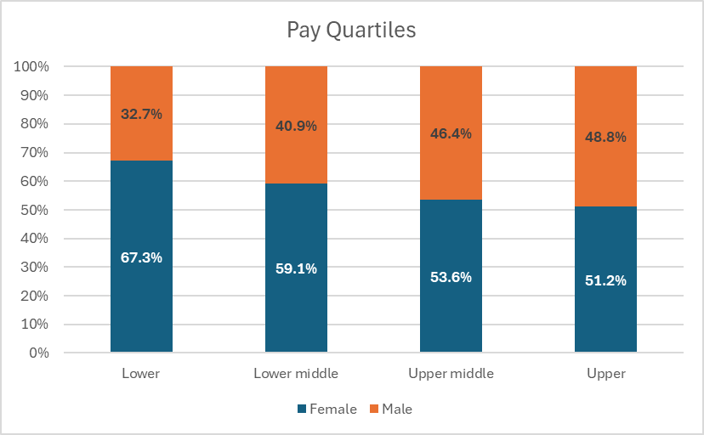
In order to complete the calculations, the University is required to list all employees, along with their gender, in order of lowest hourly rate to highest hourly rate of pay. The list is then split into four equal sections, known as quartiles, with an equal number of employees in each section.
The pay quartiles are shown for 31 March 2024 in the graph below to provide a comparison.
Graph 4: 2024 gender pay quartiles
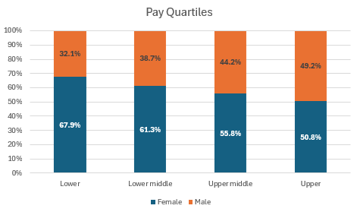

As with many organisations and the economy as a whole, a key factor behind Sheffield Hallam’s gender pay gap is the imbalance of men and women across job levels. The lower and lower middle quartiles are made up by 63.2% (1,262) females compared with 36.8% (734) males. However, there continues to be a slightly higher proportion of females than males in the upper quartile. This shows a continued representation of women in senior positions, promoting gender diversity in leadership roles.

SECTION 5. ETHNICITY PAY GAP
These figures are based on the pay gap between white and ethnic minority employees which we recognise has limitations in identifying the differences between different ethnic groups.
Out of a total workforce of 3,990 employees, on 31 March 2025 we had 697 (17.5%) ethnic minority employees and 3,043 (76.3%) white employees. There were 250 (6.3%) employees whose ethnicity was unknown.
In 2025, the mean ethnicity pay gap was 7.9% in favour of white employees and the median gap was 5.6% in favour of white employees. Excluding casuals, the mean ethnicity pay gap was 1.7% in favour of white employees and the median gap was
-0.5%.
The improvement in the pay gap once casual workers are removed occurs because ethnic minority employees are more likely to be academics who have a higher average salary than Professional Services employees.
The mean pay gap has improved since 2024 when the gap was 8.6% in favour of white employees however the median pay gap has increased from March 2024 when it was 2.9% in favour of white employees.
The median pay gap has increased because the median spinal point for white employees has increased by one spinal point whereas the median spinal point for ethnic minority employees did not change. This is due to differences in the proportion of white and minoritised ethnic employees who left the University as a result of University change processes, which affected the white median hourly rate.
The proportion of ethnic minority employees has increased from 16.4% (767) in 2024 to 17.5% (697). The proportion of ethnic minority employees has increased even though the numbers of ethnic minority employees have decreased due to the reduction in the overall workforce population. All quartiles have seen proportional increases except the upper middle quartile. The biggest proportional increases are seen in the lower middle quartile followed by the upper quartile.

PAY QUARTILES
The graphs below show the proportions of white and ethnic minority employees in each quartile and only include staff who had declared their ethnicity.
As previously noted, proportions of ethnic minority employees have increased in all quartiles except for the upper middle quartile.
Graph 5: 2025 ethnicity pay quartiles
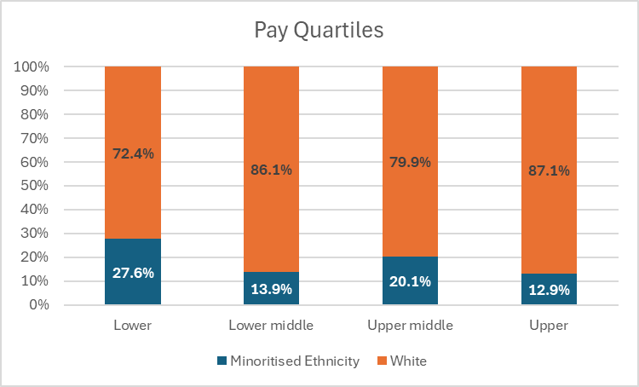

Graph 6: 2024 ethnicity pay quartiles
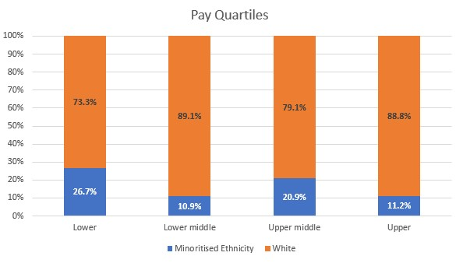

SECTION 6. INTERSECTIONALITY PAY GAP
Intersectionality recognises that employees belong to several different groupings and aims to identify how these different groupings interrelate. These figures indicate that the greatest pay gap was between ethnic minority females and white male employees. The figures including casual workers can fluctuate due to the nature of the workforce.
The table below shows the difference in mean and median hourly rates of pay.

Table 1: 2025 intersectionality pay gaps
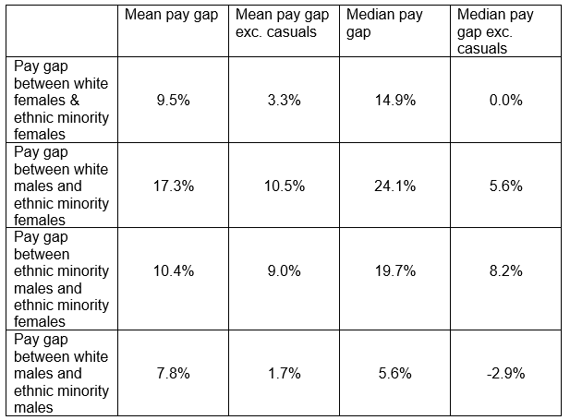

SECTION 7. DISABILITY PAY GAP
Out of a total workforce of 3,990 employees, on 31 March 2025 we had 360 (9.0%) employees who had declared a disability, 3,307 (82.9%) who had not declared a disability and 323 (8.1%) whose disability status was unknown.
The University’s mean disability pay gap was 5.2% and the median disability pay gap was 8.2%.
Excluding casuals, the University’s mean disability pay gap was 5.6% and the median disability pay gap was 8.2%.
The mean and median disability pay gaps have decreased from March 2024 when the mean was 7.1% and the median was 10.8%. We are pleased to report that the 2025 mean disability pay gap stands at its lowest figure since we began reporting in 2017.
The proportion of staff who have declared a disability has increased slightly since March 2024 and the proportion of staff whose disability status is unknown has stayed relatively stable. We are committed to promoting a culture of inclusion and equal opportunities to all, and this highlights our dedication to fostering a workplace that values and supports individuals of all abilities.

PAY QUARTILES
The proportion of disabled staff has decreased in the lower quartile but increased in the other quartiles compared with 2024. There are ongoing activities to increase disclosure rates at the University, and we are dedicated to fair and inclusive recruitment practices and providing equal opportunities for all, regardless of disability status.
The graphs below show the proportions of disabled and not disabled staff in each quartile and only include staff who have declared their disability status.
Graph 7: 2025 disability pay quartiles
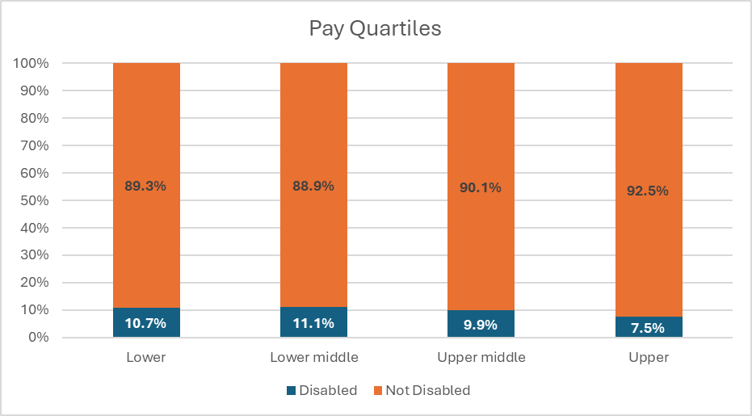

Graph 8: 2024 disability pay quartiles
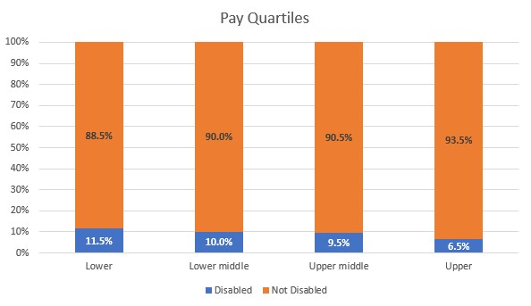

SECTION 8. SEXUAL ORIENTATION PAY GAP
Out of a total workforce of 3,990 employees, on 31 March 2025 we had 285 (7.1%) LGBTQ+ employees, 2,663 (66.7%) heterosexual employees and 1,042 (26.1%) whose sexual orientation was unknown. Whilst the proportion of employees whose sexual orientation was unknown reduced from 1,305 (27.8%) in 2024, this is still a large number which we will continue to address over the next 12 months.
The University’s overall mean sexual orientation pay gap was 8.9% and the median sexual orientation pay gap was 17.3%. These gaps have reduced since 2024 where the mean gap was 12.8% and the median gap was 17.8%.
Excluding casuals, the mean sexual orientation pay gap was 7.3% and the median sexual orientation pay gap was 8.2%.
Due to the significant minority of staff who had not declared their sexual orientation, it is unclear whether the decreases in the mean and median gaps are reliable. Our continued focus will therefore be on reducing that number.

PAY QUARTILES
The graphs below show the proportions of heterosexual and LGBTQ+ employees in each quartile and only include staff who have declared their sexual orientation.
Graph 9: 2025 sexual orientation pay quartiles
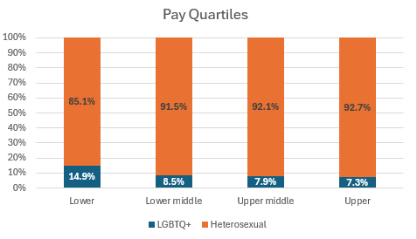

Graph 10: 2024 sexual orientation pay quartiles
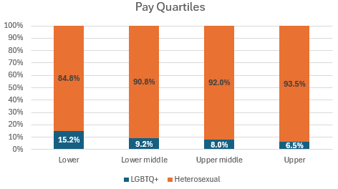

SECTION 9. BONUS GAPS
Bonuses at Hallam include royalty payments and honoraria. As one-off payments for performance were not made in 2024-25, this year the figures only include ad-hoc one-off payments such as honoraria and royalty payments.

GENDER BONUS GAPS
The figures below show the difference between the bonus payments that relevant male and female employees received within the last 12 months.
The mean bonus gap was 93.9% in favour of males and the median bonus gap was 96.3%. 0.2% of females were paid a bonus, representing 9 females in total and 0.4% of males were paid a bonus, representing 9 males in total. Excluding royalty payments, the mean gender bonus gap was -10.9% and the median gender bonus gap was 14.3%.
The bonus gaps have increased from March 2024 when the mean bonus gap was 64.6% in favour of males and the median bonus gap was 24.9%.
This increase is because the number of bonus payments paid dropped significantly in 2025, meaning the mean and median pay gaps were affected by outliers.
A small number of large one-off payments which are classed as bonuses - including royalty payments which are outside of the University's control - can significantly distort the bonus gaps and lead to them fluctuating from year to year.

OTHER BONUS GAPS
Bonus gaps exist for other protected characteristics however these are largely related to royalty payments and honoraria payments. The numbers of bonus payments this year are so small that the gaps do not tell us anything meaningful. We would not normally report figures where numbers involved are less than five therefore these bonus gaps are not included in this report. We will continue to monitor bonus gaps each year and report where the numbers allow.

SECTION 10. CLOSING THE GAP
Equity, equality, diversity and inclusion are a priority for the University, and we will continue to work towards closing the pay gaps along with other initiatives to improve equality for students and staff. We will continue to prioritise activity that helps attract, retain and develop ethnic minority, female, disabled and LGBTQ+ employees, particularly in those areas where there is the greatest need.
We are committed to closing the pay gap for all groups. To achieve this, we have outlined specific, meaningful actions for the next year, as well as reporting on progress made in the previous twelve months.
Actions for the next year:
- Implement recommendations related to a recent review of the starting salaries process and guidance, including provision of more timely guidance on setting starting salaries from Senior Resourcing Advisors.
- Continue to encourage employees to complete their diversity information to reduce the number of employees whose status under each protected characteristic is unknown.
- The completion of an end-to-end review of the recruitment process with a focus on inclusive recruitment processes and practices.

In the last twelve months, we have:
- Undertaken a review of the starting salaries process and guidance and made recommendations to improve the support provided to hiring managers related to making equitable starting salary decisions.
- Embedded equality impact assessments in our decision making and processes, ensuring they are completed for decisions that affect pay.

SECTION 11. ACCESSIBILITY STATEMENT
We are committed to ensuring our materials are accessible to all. If you encounter any accessibility barriers or have suggestions for improvement please contact us using our web accessibility report form. Your feedback helps us enhance our accessibility efforts and improve our service.

SECTION 12. GLOSSARY

Pay
Pay includes basic pay, allowances, paid leave and shift premium pay. It does not include overtime, redundancy payments or expenses. Bonus pay includes cash, vouchers and any remuneration which relates to productivity, performance, incentive or commission.

Pay gap
The pay gap is the difference in hourly pay between two groups of employees in an organisation. It is expressed as a percentage of the group who are usually paid more
e.g., the gender pay gap is a percentage of the hourly pay of male employees. A positive number means male employees earn more than female employees and a negative number means the reverse.

Equal pay
As set out in the Equality Act 2010, male and female employees in the same employment performing equal work must receive equal pay. This is different from the pay gap which looks at all employees, not just those performing equal work.

Mean pay
The mean is the sum of all the hourly pay rates for a group of employees added together and then divided by the number of employees in that group. Due to the way in which it is calculated, the mean is affected by hourly pay rates that are very low or very high in comparison to other pay rates.

Median pay
The median is the hourly pay rate that falls in the middle of a group of pay rates when they are ordered from smallest to largest. Due to the way in which it is calculated, the median is not affected by hourly pay rates that are very low or very high in comparison to other pay rates.

Quartiles
Quartiles divide employees into four groups, depending on their pay rate, when these are ordered from smallest to largest. Each quartile is then analysed to establish the percentage of employees in each quartile who are from each group.

