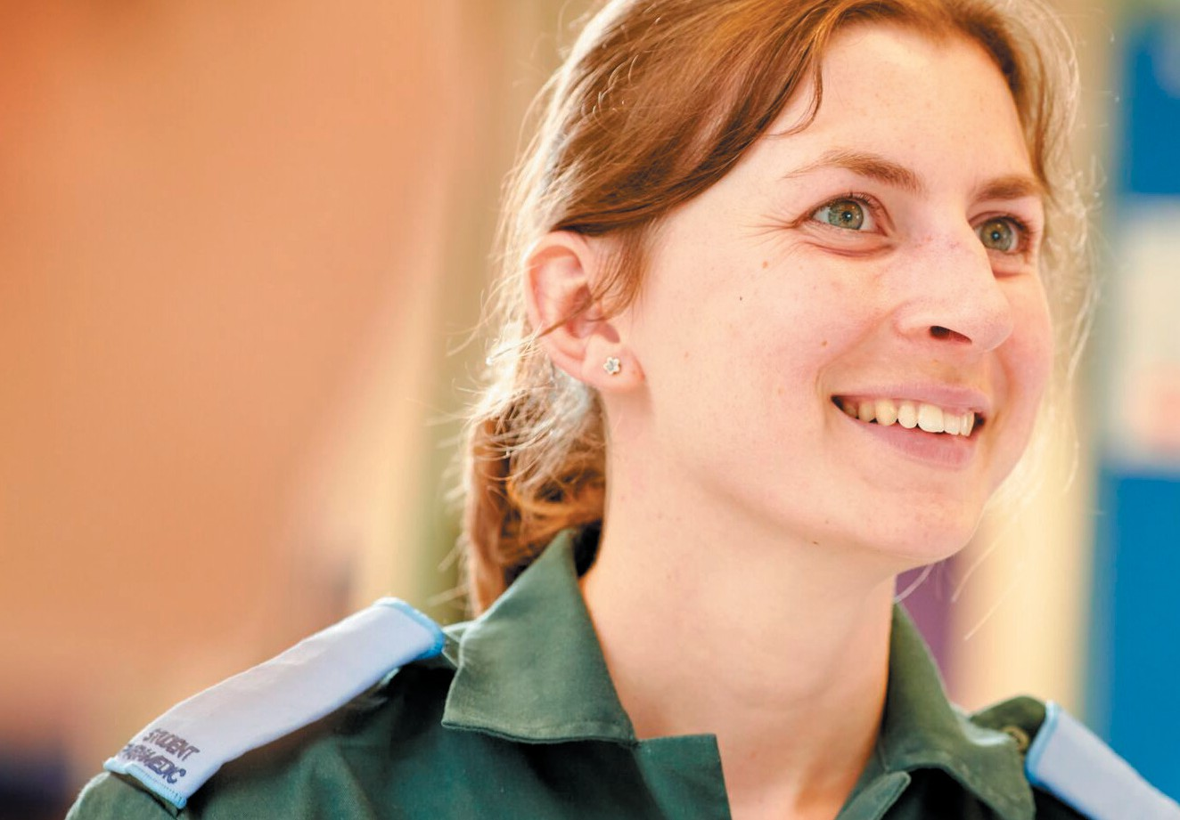




EQUITY, EQUALITY, DIVERSITY
& INCLUSION (EEDI)

ANNUAL REPORT 2023-2024

CONTENTS

Foreword 3
Equality Objectives 2021-24 4
CASE STUDIES
Accomplished Study Programme in Research Excellence (ASPIRE) 5
Talk Club 6
Hallam Students’ Union Accessible Events Policy 7
Equity Accomplice Professional Services Pilot 8
Sanctuary Scholarships 9
Data Capture & Name Change Policy 10
Civic Fellowship Programme 11
Doncaster Muslim Wellness Conference 12
Reflections 13
Staff Diversity Data 14
Student Diversity Data 16

FOREWORD
As Vice-Chancellor and Institutional Lead for equity, equality, diversity and inclusion (EEDI), I’m delighted to introduce our Annual EEDI Report 2023/24. This report constitutes a collection of EEDI case studies from across the University demonstrating the significant impact we are making to address inequality and improve the lives of all our staff, our students and the communities we work with. This is our third and final year reporting against the Equality Objectives outlined in this report. In September 2024 we published our EEDI Framework 2024-27, which articulates our vision for “Sheffield Hallam – A Culture of Inclusion”, including new Equality Objectives which will underpin our future reporting. The
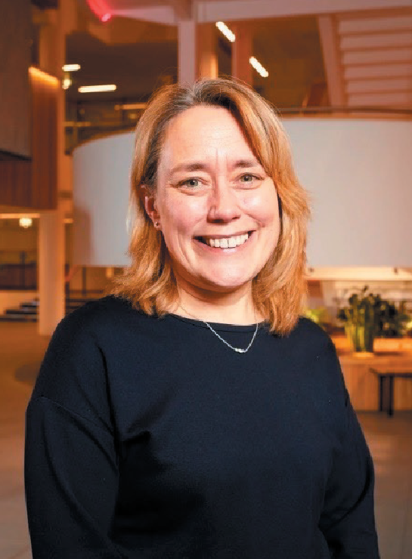

report is a snapshot of the work we are doing in pursuit of fairness and social justice. In a
challenging global context, where these principles are increasingly under threat, I am proud that our commitment to our EEDI agenda remains central to Hallam’s vision and mission.

Prof. Liz Mossop
Vice-Chancellor

EQUALITY OBJECTIVES
OUR 2021-24 OBJECTIVES:

CULTURAL COMPETENCE
Empower students and staff with the skills to respect different cultures and to study, work and lead inclusively.

EQUALITY OF ACCESS, OUTCOME AND EXPERIENCE
Improve these for students and staff so that all can succeed and thrive.

INCLUSION
Support all students and staff to bring their whole selves to study or work in order that everyone knows that they belong.

PLACE
Be a leader in inclusive practice, collaborating with individuals, stakeholders and society.

SAFETY
Safety: Provide an environment where all students and staff feel confident in raising concerns and receiving a response.
These objectives are underpinned by a fundamental position that all students and staff know that they belong at Hallam and can succeed and thrive. They apply to all protected characteristics and recognise the intersectional nature of people’s identity and experience.
The above objectives apply to the period 2023-24 covered by this report.
A refreshed set of Equality Objectives has been approved for 2024-27

CASE STUDY

ACCOMPLISHED STUDY PROGRAMME IN RESEARCH EXCELLENCE
(ASPIRE)

BACKGROUND
ASPIRE is an innovative programme designed by Black academics to meet the unique and racialised needs of Black students. Funded by the Office for Students and Research England, Hallam leads
the programme in collaboration with Manchester Metropolitan University and Advance HE. ASPIRE is dedicated to empowering the next generation of Black scholars and transforming the academic landscape.

APPROACH
ASPIRE is grounded in Compassionate Pedagogy, Ubuntu, and Omoluabi philosophy. It fosters a personalised mentorship framework that is culturally sensitive and responsive to the racialised experiences of Black students navigating UK higher education.
Each Black scholar receives dedicated support from a Black academic mentor over six months, ensuring
tailored guidance and encouragement throughout their journey.
The programme is structured around five core pillars: personal and professional development, employability, academic writing, qualitative and quantitative research, and project management.
Further enriching the programme, each scholar is supported by a White/Asian academic who has
completed anti-racist training specific to the ASPIRE programme. This academic supervises the scholar’s six-week project, providing additional guidance
and fostering meaningful cross-cultural academic engagement.

IMPACT
Across three cohorts, the programme has mentored 59 students, with 14 successfully commencing
fully funded PhDs at universities across the UK. Additionally, 15 scholars graduated with first-class degrees or distinctions, and another 16 secured graduate employment. ASPIRE has also contributed to narrowing the ethnicity degree awarding gap.

AT A GLANCE
How the ASPIRE programme is empowering the next generation of Black scholars.
Challenges
- Maintaining resources and funding for the programme in an environment of financial challenge and structural change
Benefits of chosen approach
- Post-programme survey results revealed that all scholars reported significant improvement in their skills compared to when they began the programme
- ASPIRE scholars were better prepared for doctoral studies, professional life, and employment than their peers

Through ASPIRE, I learned that I do belong in research and improved my confidence. I now understand the freedom and opportunities a PhD offers and the power it holds. I recognise that I represent not only myself but every student who looks like me and aspires to achieve. Ultimately, ASPIRE has set me on this path and provided opportunities I would have missed.
Jerome Smith
Research Student

CASE STUDY

TALK CLUB

BACKGROUND
AT A GLANCE
How the Student Wellbeing team supported male students to hold space for conversations with other male students to improve mental health.
Challenges
- Business case for funding Talk Club ‘Captains’ in the first stage of the project
- The scalability of projects
Benefits of chosen approach
- As this was a peer-led programme, it was clinically managed but not resource intensive
- Participants can become Captains, taking on a leadership role
- Improved employability outcomes for Captains
The Talk Club @ SHU project serves two main purposes. Firstly, to provide male students with a space for supportive conversations and activities, promoting improved mental and physical health, wellbeing, social connections, and engagement in valued activities. And secondly, the sessions also offer skills and training opportunities for male students to become ‘Captains’ - facilitating, organising, and contributing to the evaluation of Talk Club sessions.

APPROACH
Talk Club sessions prompt men to assess their emotional state and allow them to reflect on and share their feelings and experiences. Evidence, both nationally and within Hallam, has shown that a structured approach helps to build participants’ resilience.
Each Talk Club session follows a structured format:
Assessment of emotional state, gratitude and positivity, plans for mental fitness and a closing assessment where participants re-evaluate their emotional state, providing closure to the session.

IMPACT
Since the launch of the first Talk Club group in February 2024, there has been enthusiastic engagement from both Captains and participants.
There have been 22 sessions to date, with groups as large as 12 participants per session.
An exciting, and unexpected impact has been on Captain employability. Two previous Captains are now working in paid employment within the mental health sector.
I love the phrase mentally fit or mental strength…it could be for anyone who isn't even struggling with mental health issues, because they might in the future, like it can prove preventative as well as like
prescriptive… it's a check in, it's management, it's building more strength to talk about things.
Talk Club Captain

CASE STUDY

HALLAM STUDENTS’ UNION ACCESSIBLE EVENTS POLICY

BACKGROUND
AT A GLANCE
How Students’ Union (SU) staff collaborated to review and implement policy that makes events more accessible to disabled students.
Challenges
- SU colleagues initially lacked confidence due to lack of formal knowledge about events access
- Completing this work before students arrived in September for Welcome Week, ensuring partners were aware of the policy and access adaptations
Benefits of chosen approach
- Once they were trained, having a small group of experts in their areas helped to evaluate the needs and changes to be made really quickly
- Having a student with lived experience involved throughout helped to sense-check decisions
The SU’s 2023-24 Disabled Students’ Representative passed a policy at their student-led council for accessible events. It highlighted that the SU could
be more transparent about access for events, provide more guidance for student-led events, and add information to their web pages to allow disabled students to make more informed decisions about attending events.

APPROACH
The SU formed a working group with staff from its events, & societies, campaigns and marketing teams who regularly organised events. Each team carried out an accessibility audit of their areas.
A business case was put together to commission training from a disabled person led organisation that provides accessible events training. Using their
guidance the teams then each took on different areas of provision based on expertise and implemented actions.

IMPACT
Improvements have been made to both the SU staff and student-led events processes and guidance, as well as the society event guidance.
The SU is now collaborating with their partners to create an accessibility checklist for partner venues, The SU events web pages now gather reasonable adjustments at point of ticket purchase.
The SU’s AccessAble venue access page has been updated and an accessibility web page is being built. Accessibility will also be integrated into website training for admins.
Training on how to run accessible events is now delivered to student societies.

Thank you so much for all the hard work you’ve put into making the policy a reality, it means so much to me and I really appreciate you all.
Cai Ware
Disabled Students’ Representative

CASE STUDY

EQUITY ACCOMPLICE PROFESSIONAL SERVICES PILOT

AT A GLANCE
How Hallam’s Academic Development and Inclusion (AD&I) team developed
anti-racist training for Professional Services staff.
Challenges
- Condensing existing content from a more in- depth course into a smaller number of sessions
- Ensuring that participants have space to reflect on their learning and how this might influence their practice
Benefits of chosen approach
- The ability to deliver anti-racist training to more people with reduced resource
- Opportunities to understand the experiences of a broader range of colleagues

BACKGROUND
The Equity Accomplice programme is an anti-racism programme, originally designed for academics. The original programme was six sessions. In 2023-24 colleagues from the AD&I team wanted to rollout the EA programme for Professional Services in order to address the need for anti-racism training for frontline staff. The length of the programme made it problematic to deliver to teams within Professional Services.

APPROACH
The AD&I team ran a number of in-person, shortened, and either two or three session versions of the
EA programme with Professional Services areas, including Student Support Advisers, Apprenticeship Coaches and Hallam Help student support staff.
Approximately 130 Professional Services staff completed the programme during this period.

IMPACT
Survey data shows that participants have a greater awareness of the issues which impact on race equity, with 66% of respondents indicating they were very
or extremely aware after the sessions compared with 20% before. 68% of respondents indicated that they were extremely or very aware of the impact of microaggressions on the lives of racially minoritised
people after the sessions compared with 20% before.
In terms of respondents’ awareness of their social, cultural and racial advantage before and after
the sessions, there was an increase in awareness from 56% to 72%.

I will try my best to address racism when it’s heard/seen, rather than being a bystander.
Professional Services Participant

CASE STUDY

SANCTUARY SCHOLARSHIPS

BACKGROUND
AT A GLANCE
How Hallam is offering scholarships to support people seeking asylum in the UK.
Challenges
- High demand for scholarships
- The differences between the quality of applications can be very fine, leading to difficult decisions
Benefits of chosen approach
- High level of support for candidates
- A transformational impact for scholarship recipients
Hallam is a proud University of Sanctuary and was first awarded Sanctuary status in 2021. Hallam works hard to create a community of support and welcome for people seeking asylum and refugee communities. and to celebrate and recognise their achievements and contributions. One of the important ways we do this is through Sanctuary Scholarships.

APPROACH
Hallam offers three Sanctuary Scholarships per year, currently two postgraduate and one undergraduate. Over the past five years we have awarded 15 Sanctuary Scholarships, each covering the cost of fees and a £4,000 per year study costs grant paid directly to the student.
SHU Progress, Hallam’s applicant and transition support scheme, works with refugees, asylum seekers and supporting charities to help students understand the UK Higher Education system and to apply.
Applicants are selected for interview where they can demonstrate that they are facing the most barriers.
Two candidates are interviewed per Scholarship and unsuccessful candidates are directed to other sources of support. Local applicants are prioritised.

IMPACT
Sanctuary Scholarships are transformational for recipients. They enable students to overcome financial barriers to access higher education and progress
their careers and aspirations. Scholarships have been awarded for a variety of degree courses for
example MA in Teaching English to Speakers of Other Languages (TESOL), MSc Computing, MSc Cancer Biology, BSc Mechanical Engineering and BSc Mental Health Nursing. Each student awarded a Sanctuary Scholarship has graduated and gone on to successful careers in their field.

The Sanctuary Scholarship has been truly life- changing for me. Although the hardships and challenges I faced were significant, receiving this scholarship felt like a dream come true, almost unreal. It filled me with immense pride, knowing that all my hard work had paid off. It has inspired me to push myself even further in my studies and personal growth while also encouraging me to raise awareness about such opportunities within my community.
Mahammad Almahdi Altejani Osman
MSc Computing Student

CASE STUDY

DATA CAPTURE & NAME CHANGE POLICY

BACKGROUND
AT A GLANCE
How Hallam’s Human Resources and Organisational Development (HROD) directorate used case work and staff networks to develop processes to change personal information and the Trans Staff policy.
Challenges
- Difficulty with navigating contradictions between legal requirements and the needs of the community
- Ensuring all the right people were consulted and engaged with
Benefits of chosen approach
- Collaborating with different expertise internally and externally for a well-informed outcome
HROD case work demonstrated the need to improve the experience of Hallam staff and job applicants - as far as possible within current legislation, resources and system capability - when recording gender identity and other personal details on the Core HR System to ensure that our processes uphold our value of inclusion.

APPROACH
The project team consulted with relevant staff networks, Hallam’s Equity, Equality, Diversity and Inclusion (EEDI), Recruitment and Reward, Business Systems and Service Development, and Payroll
and Pensions teams, as well as HM Revenues and Customs (HMRC), on good practice, restrictions and compliance.
Processes and policies were reviewed and a series of updates and amendments were recommended and approved.

IMPACT
The Staff Transgender Policy has been updated with enhancements to the name change process.
HROD’s document requirement checks for staff identifying as Transgender have been simplified and staff guidance has been updated.
The HROD Admin Team, who are responsible for these checks, have been trained on the new processes and on trans awareness.
Whilst system limitations meant not all desired changes could be implemented, an explanatory paragraph was added to Hallam’s e-recruitment system explaining why and outlining the University’s aspiration for improved gender expression as soon as possible.
The project has also informed further gender capture work into a new systems group.

This work is a crucial step that allows me to feel more comfortable not only with
expressing my own identity but also safer in the knowledge that others are given the option to do the same. I feel reassured knowing I'd
be starting work at a university that is actively working to be more understanding and accepting.
19-year-old non-binary job applicant

CASE STUDY

CIVIC FELLOWSHIP PROGRAMME

BACKGROUND
AT A GLANCE
How the Civic Fellowship programme is seeking to change outcomes for underserved communities in Sheffield.
Challenges
- Moving past deep-rooted mistrust of traditional power infrastructure organisations
- Shaking down traditional ways of working and adopting alternative positive
approaches with community organisations alongside the University
Benefits of chosen approach
- Empowering communities and encouraging sustainability while contributing to long term trusted relationships and collaboration
- Offers long-term youth engagement and supports positive health and employment outcomes
The programme has enabled research projects between the Advanced Wellbeing Research Centre (AWRC) and Darnall Well Being, a local community charity supporting the residents of Darnall and Tinsley, two of the city's most diverse and underserved areas.
Funded by Westfield Health and delivered in partnership with Darnall Well Being and the Darnall Educations and Skills Academy (DESA), the focus of the programme is on the role of sport and physical activity in raising aspirations, creating improved employability, and improving health outcomes for young residents of Darnall.

APPROACH
An Embedded Researcher and support team interviewed community leaders to gain insights into Darnall and explore how sport and physical activity could improve outcomes for young people in the area. They also worked with paid youth interns to understand how young Darnall residents were building resilience in the aftermath of the pandemic.
The AWRC recruited two cohorts of 12 interns aged between 16 and 23, investigating their physical activity, wellbeing, experiences living in the area, aspirations for the future and any barriers to employment opportunities.

IMPACT
Six of the participants secured placements with the AWRC and local organisations while others have gone on to University and full-time employment. Two participants have contributed to the Darnall and Tinsley Attercliffe partnership board, sharing their views and insights with business leaders, locally elected members and MPs.
The initial research project has been published in a peer reviewed journal and presented at international
conferences as an example of best practice for meaningful and principled University-community engagement. The programme has led to work on the development of an area youth plan for Darnall, shaped by over 100 responses to questions about local services. The plan aims to ensure that provision is coordinated, appropriate and attractive to children and families in the area.

Working with Sheffield Hallam University on this applied community project has helped young people explore their identify, understand sport, health and physical activity and consider their futures. The approach has complemented the work we do at DESA in the way we support the development of whole
young person and work with them to make a difference in their lives that matters.
Abdul Malik
DESA Founder & Director

CASE STUDY

DONCASTER MUSLIM WELLNESS CONFERENCE

BACKGROUND
AT A GLANCE
Challenges
- Building trust, understanding and empathy between the community, academic institutions and third sector - unlike previous extractive research approaches
- Progressing at the pace and direction of the community
Benefits of chosen approach
- Raising the voice of the community to a level where it drives real change and becomes the catalyst for other communities coming onboard, driving community cohesion, momentum and an appetite for effective engagement and change
Doncaster’s Muslim community numbers around 7,000 people (2.2 per cent of the town’s population) and is centred around two Mosques, each with a distinct congregation and lead Imam. The community has culturally distinct mental health needs and aspirations.
Through progressive and open-minded community leadership, with the support of an Embedded Researcher from Doncaster Health Determinants Research Collaboration (HDRC), this research project is seen as a potentially pioneering, lived-experience approach to community cohesion.

APPROACH
The Embedded Researcher worked with Imams at both Mosques and a very well respected Community Connector (who had lived-experience of trauma and suicide) to establish The Doncaster Muslim Wellness Conference – a forum for the community to discuss mental health, trauma and suicide in an open, non- judgemental environment.
By providing an opportunity to listen to respected community members, and others, talk about these issues from a human perspective, the conference aimed to be a catalyst for all Doncaster communities to be empowered and be heard through lived experience research collaboration.
The ambition to bring other communities onboard, when they are ready to engage, was paramount, along with enshrining this event as an annual part of the Doncaster calendar to provide an ongoing legacy for all communities via facilitation of community-led research.

IMPACT
The inaugural conference in November 2024 was an incredible success. The follow-up is scheduled for August 2025. The project has fostered considerable community cohesion and engagement, and an appetite for openness around mental health from the Muslim community - so much so that other faith
groups and locations are considering it as a template.

It was so important for me to share my personal experience of my husband, aged 48, taking his own life, and the pain of feeling like I had to keep it a secret out of fear of judgement. Talking about Muslim mental health, trauma and suicide is essential, and this conference was a ground-breaking step in creating safe spaces for these difficult,
but necessary, conversations. Hearing lived experiences and Imams addressing these taboo topics with compassion and understanding reminded us that healing begins with honesty, and true change happens when our communities come together to support one another.
Akeela Mohammed DL Founder of The HealthyHer Muslim Ladies Group

REFLECTIONS

Since the inception of the EEDI team in September 2023, progress has been made in a number of key areas. The Hallam EEDI Framework 2024-27 was
published in Spring 2024, followed by the EEDI Delivery Plan in January 2025. The University’s first EEDI staff survey took place in October and November 2024, with the results used to inform future activity.
The team uses a business partner model to engage with stakeholders across
the University, with an emphasis on collaboration and co-creation, driven by clear governance and strategic planning. The Senior Business Partners have been involved in key cross-university programmes and projects, ensuring
that EEDI is considered early and incorporated into planning.
The team has supported and encouraged grassroots activity, via groups and networks, and through a series of specific roundtables on anti-racism, disability and neurodiversity.
Frequent meetings are held between the EEDI team and Students’ Union,
allowing for greater synergy between the University and the HSU, and building a closer relationship between the two.
Looking to the future, progress will be driven by the university-wide EEDI Delivery Plan. The 2024-27 equality objectives sit alongside agreed KPIs which will be monitored and reported
on, and metrics will be included in future annual reports.
The refreshed governance model will ensure reporting of progress against the plan, providing scrutiny and oversight and ensuring that actions include appropriate levels of accountability and monitoring.
This report reflects a transition from the approach of previous years, in
cataloguing activities, to an emphasis on impact. The case studies demonstrate the real-world effect of our activities
and provide learnings that will be taken forward into future actions. The focus on impact echoes the University’s mission: we transform lives.

STUDENT DIVERSITY DATA

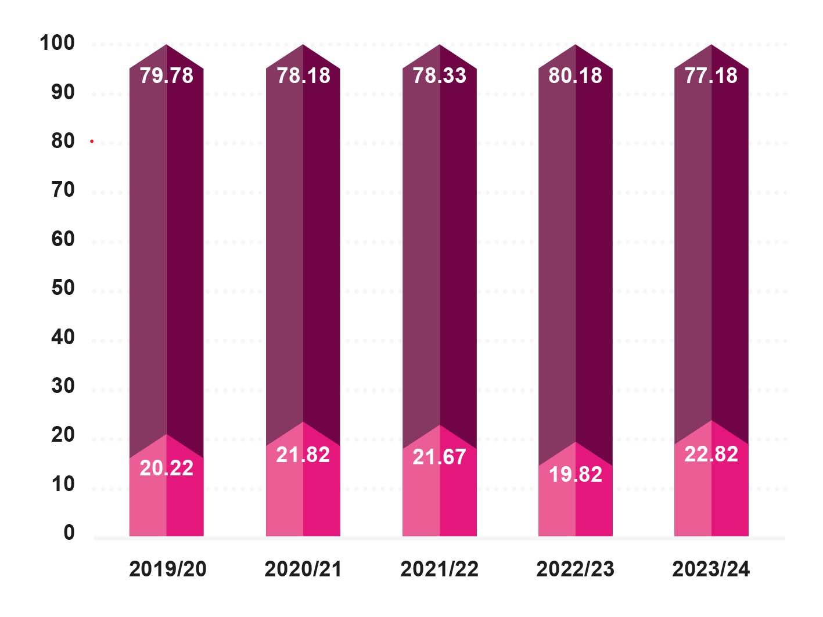
No Known Disability (%) Disability (%)

The proportion of students with a declared disability has been relatively stable.

80
70
60
50
40
30
20
10
0
2019/20 2020/21 2021/22 2022/23 2023/24

White (%) Asian (%) Black (%)
Mixed or multiple ethnic background (%) Any other ethnic background (%)
Not applicable / Not known (%)

The proportion of minority ethnic students shows a small but steady increase over the last five years.

STUDENT DIVERSITY DATA

50

40

30

20

10

0
2019/20 2020/21 2021/22 2022/23 2023/24

Buddhist (%) Christian (%) Hindu (%)
Jewish (%) Muslim (%) Sikh (%)
No religion (%)
Any other religion or belief (%) Not available (%)

Over the past five years we have seen an increase in the proportion of most religious identities and in students declaring no religion.

90
80
70
60
50
40
30
20
10
0
2019/20 2020/21 2021/22 2022/23 2023/24

Bisexual (%)
Gay or lesbian (%) Heterosexual or straight (%)
Not available (%)
Other sexual orientation (%)

The significant increase in the proportion of not available responses in 2023/24 is the result of a system error which has now been fixed, not a demographic change.

STAFF DIVERSITY DATA

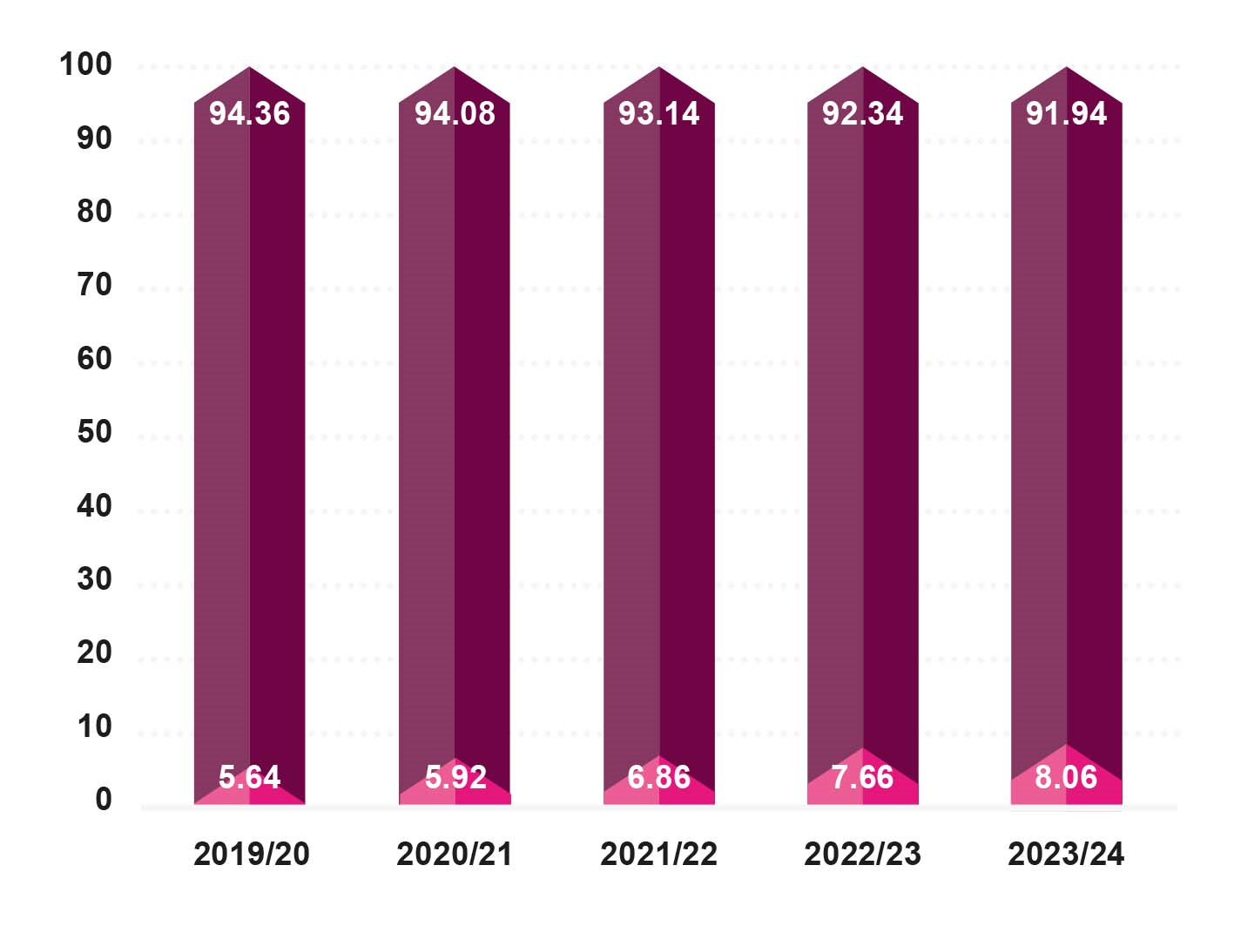
 No Known Disability (%)  Disability (%)

The proportion of staff with a disclosed disability has increased slightly over the past five years

90
80
70
60
50
40
30
20
10
0
2019/20 2020/21 2021/22 2022/23 2023/24

White (%) Asian (%) Black (%)
Mixed or multiple ethnic background (%) Any other ethnic background (%)
Not applicable / Not known (%)

There has been a gradual increase in the proportion of minority ethnic staff.

STAFF DIVERSITY DATA

50

40

30

20

10

0
2019/20 2020/21 2021/22 2022/23 2023/24

Buddhist (%) Christian (%) Hindu (%)
Jewish (%) Muslim (%) Sikh (%)
No religion (%)
Any other religion or belief (%) Not available (%)

Over the past five years we have seen an increase in the proportion of most religious identities and in staff declaring no religion.

70
60
50
40
30
20
10
0
2019/20 2020/21 2021/22 2022/23 2023/24

Bisexual (%)
Gay or lesbian (%) Heterosexual or straight (%)
Not available (%)
Other sexual orientation (%)

The proportion of staff declaring their sexual orientation has increased over the last five years.
