PAY GAP REPORT 2023
This report details our results for 2022 and areas of focus to ensure equality across gender, race, disability and sexual orientation

Publication Date: 12 December 2023

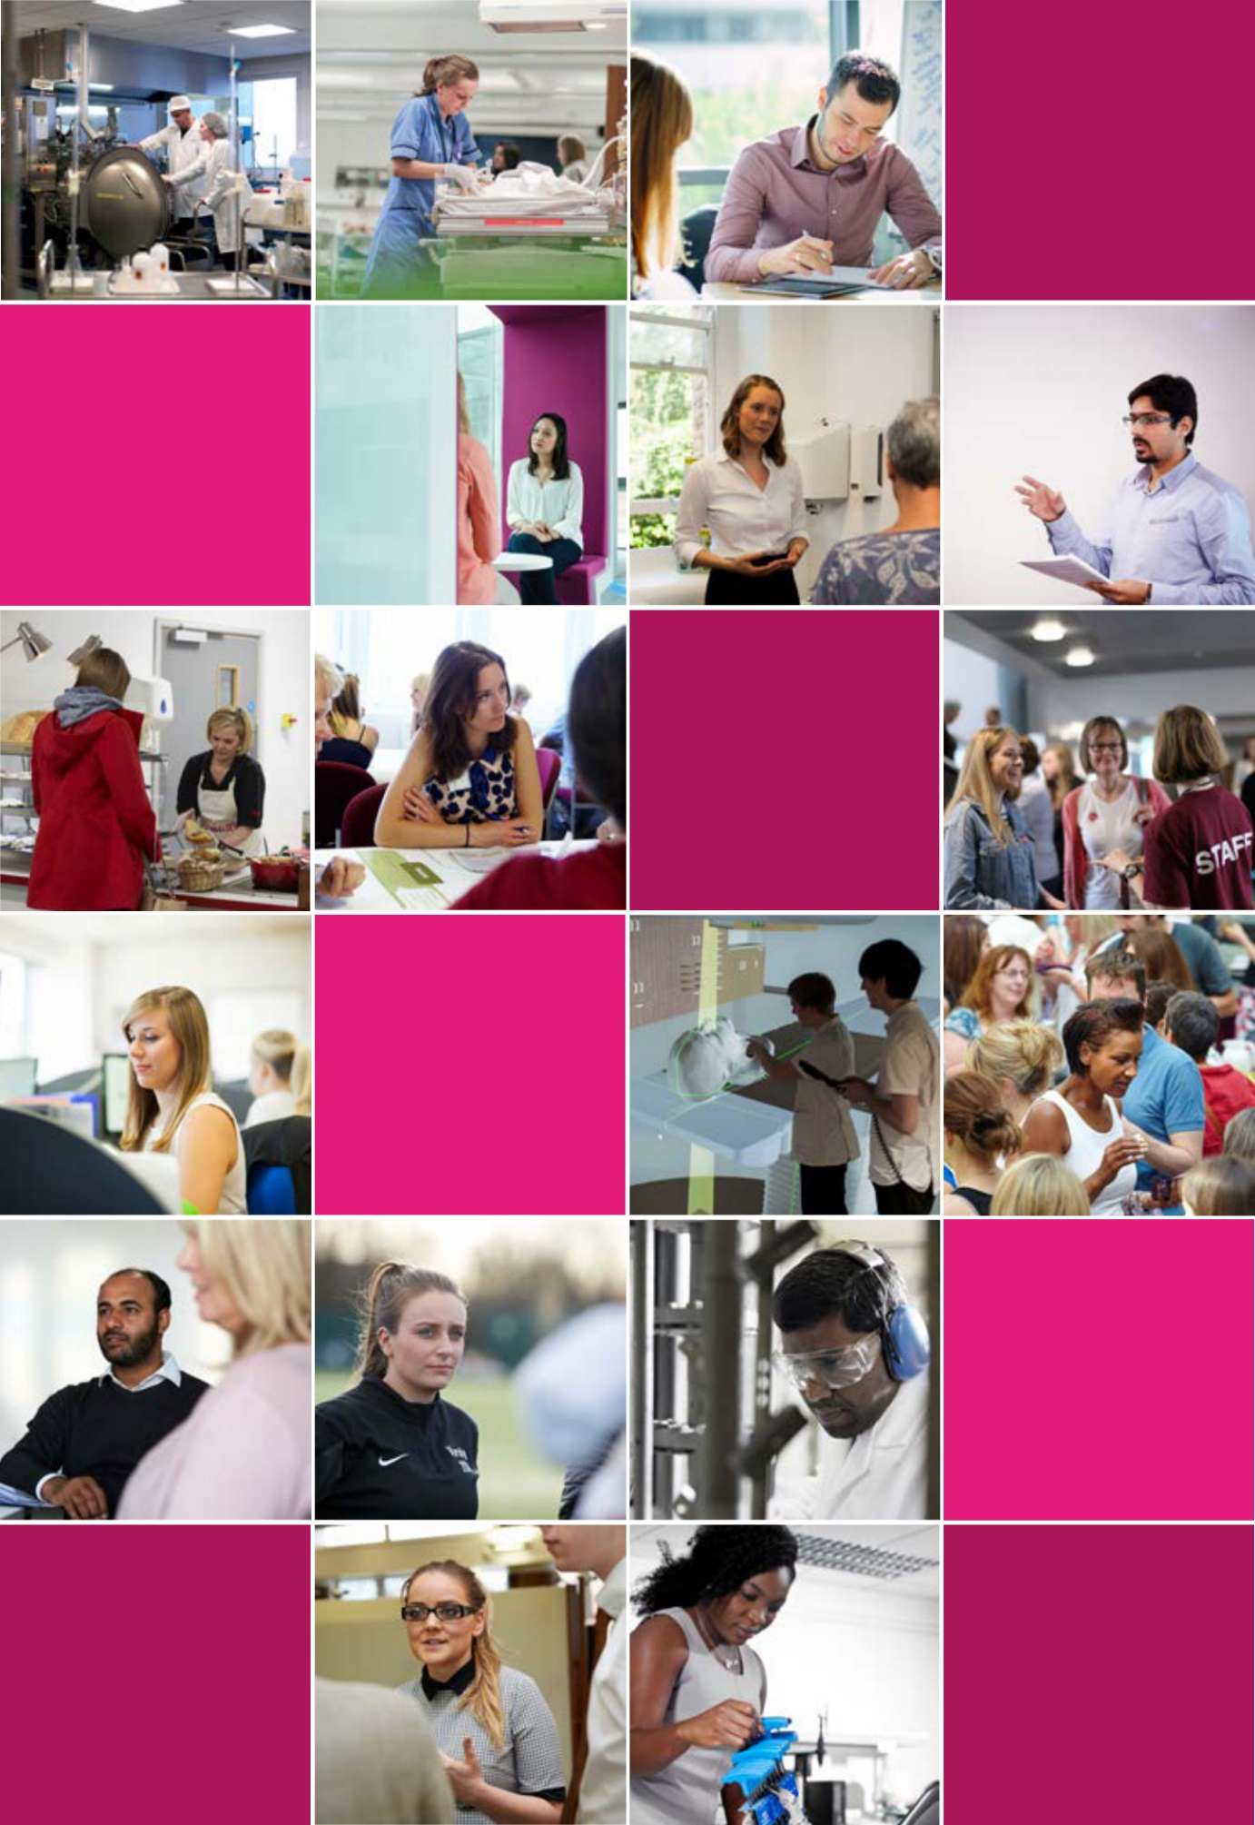

SHEFFIELD HALLAM UNIVERSITY PAY GAP REPORT 2023

This report details our results for 2023 and areas of focus to ensure equality across gender, race, disability and sexual orientation

Publication Date: 12 December 2023

CONTENTS
- Foreword
- Introduction
- Gender Pay Gap
- Ethnicity
- Intersectionality
- Disability
- Sexual Orientation
- Closing The Gap
- Glossary

FOREWORD
A message from Professor Sally Jackson Chief People Officer and Pro Vice-Chancellor (Diversity & Inclusion)
As the lead for Equity, Equality, Diversity and Inclusion in the University I am pleased to introduce our seventh pay gap report. In addition to reporting on gender in line with the mandatory requirements, the report continues to include additional data on ethnicity, disability and sexual orientation. I believe that this demonstrates our commitment to pay equity for all employees, regardless of any protected characteristic. In 2021, the University launched a new set of Equality Objectives. This includes an objective to improve equality of access, outcome and experience for students and staff so that all can succeed and thrive. Our work to reduce our pay gaps supports this objective and we remain committed to reducing them through delivering the actions identified.

INTRODUCTION
Sheffield Hallam University is committed to building a great university by providing an outstanding environment in which to study and work.
Gender Pay Gap legislation, introduced in April 2017, requires all employers with 250 or more employees to publish the gender pay gap of those in scope annually. The legislation requires employers to carry out seven calculations that show the difference between the average earnings of men and women in the University.
The gender pay gap is different from equal pay. Equal pay deals with the pay differences between men and women who carry out the same jobs, similar jobs or work of equal value.
The gender pay gap shows the difference in average pay between men and women.
Since reporting our initial pay gap in March 2018, we have been working across a number of fronts to reduce our gender pay gap. This year the University has achieved its lowest gender pay gap figures since the inception of reporting, reflecting the University’s progress in gender pay equality. We also report reductions in the median pay gap across ethnicity, disability and sexual orientation.
The University is committed to the principle of equal pay for work of equal value for all its employees. We believe that operating a fair, transparent and objective pay system is fundamental to sustaining wellbeing, success and organisational reputation.
Although it is not a legal requirement, we will continue to voluntarily publish our ethnicity, disability and sexual orientation pay gap data.
This is because we believe it’s an important step towards ensuring our workforce is diverse, inclusive and fair for everyone. We are committed to transparency and want to identify and address the challenges for colleagues from all minority backgrounds.

OUR WORKFORCE
Every job at the University is evaluated and placed within a grade. Grades vary by levels of responsibility and each grade has a specific pay range. Employees progress through the grades and pay range as they develop their careers. A proportion of employees are appointed on a fixed rate salary within casual or training roles. While the proportion of female and male employees has remained consistent over the last three years, the workforce has increased, from 4659 employees in 2022 to 4728 employees in 2023, resulting in higher overall employee numbers for both genders.
At 31 March 2023, the University has 4728 employees. 58.2% of our employees are female (2751 female employees), 41.8% are male (1977 male employees).
At 31 March 2023
4728 employees
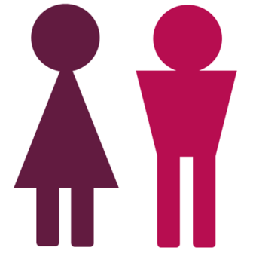

58.2% female (2751)
41.8% male (1977)

GENDER PAY GAP
The gender pay gap calculation includes all employees who received their usual rate of pay in March 2023. This means that employees on reduced pay or unpaid leave in that month are excluded. The percentage figure shows the difference between the average hourly rates of pay that males and females received.
Mean Pay gap |  | Median Pay gap
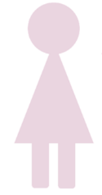 | 9.8%  (in favour of males) |  | 12.8%  (in favour of males)

At 12.8% our median gender pay gap is lower than the 13.7% provisional average pay gap across the Higher Education sector for academic year 2021/22.
 | 31 March 2023 | 31 March 2022 | 31 March 2021 | 31 March 2020
Mean pay gap | 9.8% | 11.0% | 10.8% | 9.8%
Median Pay Gap | 12.8% | 13.2% | 13.7% | 13.7%

This year we can report progress in reducing the overall gender pay gap. The mean pay gap decreased from 11.0% in 2022 to 9.8% in favour of males in 2023 and the median pay gap decreased from 13.2% to 12.8% in favour of males. A contributory factor is the increase in male representation, leading to a slightly more balanced distribution of genders across the pay levels.
The report includes casual workers who were paid in March, and this has the potential to affect the data. Casual workers are engaged on an irregular or flexible basis, often to meet a fluctuating demand for work. There is no agreement as to whether any work will be offered, and the worker is not obliged to accept it. Roles typically undertaken by casual workers include Student Ambassadors and Exam Invigilators.
If this group of casual workers are removed, the mean improves from 9.8% to 8.9% and the median decreases from 12.8% to 10.8%. This follows the same trend in terms of the University’s overall gender pay gap, with both the mean and the median decreasing.
As the number of casual workers who are paid each March will vary, we will continue to monitor the gap excluding casual workers too.
The report includes support staff from the Estates and Facilities Directorate in the pay gap calculation. If we were to exclude this category of staff, on the basis that approximately 50% of HE institutions outsource one or more of these services, this will have an impact on our gender pay gap figures in particular. If this group of manual and support workers are excluded from the pay gap calculation, the mean pay gap improves slightly from 9.8% to 9.7% and the median pay gap decreases from 12.8% to 10.8%
If we were to exclude both casuals and support staff, the mean pay gap decreases from 9.8% to 8.7% and the median pay gap reduces from 12.8% to 8.3%.
Category | Mean | Median
University all | 9.8% | 12.8%
Without manual & support (porters & security) | 9.7% (-) | 10.8% (-)
Without casuals/manual & support | 8.7% (-) | 8.3% (-)

BONUS GAP
The figures below show the difference between the bonus payments that relevant male and female employees received within the last 12 months. As one-off payments for performance were not made in 2022-23, this year the figures only include ad-hoc one-off payments such as honoraria and royalty payments and any all-staff one-off payments.
Mean Bonus Gap |  | Median Bonus gap
 | 4.6%  (in favour of males) |  | 0.0%

Proportion of employees who were paid a bonus
 | 62.7% of females received a bonus (2455 females in total) |  | 66.4% of males received a bonus (1726 males in total)

The mean bonus gap is 4.6% in favour of males
The median bonus gap is 0.0%
62.7% of females were paid a bonus, representing 2455 females in total
66.4% of males were paid a bonus, representing 1726 males in total
The bonus gap has decreased from March 2022 when the mean bonus gap was 7.8% in favour of males. The median bonus gap has remained the same as in March 2022 at 0.0%. The main reason for this decrease is that all eligible staff were awarded a one-off cost of living payment and fewer royalty and bonus payments were paid to staff this year.
The persistence of a 4.6% mean bonus pay gap can be attributed to the pro-rated nature of one-off payments for part-time staff and that a higher proportion of female staff are paid on a part time basis.
This gap could change again next year depending on whether employees receive bonus payments and if any further one-off payments are made to eligible employees. We are also conscious that some payments which are classed as bonuses, particularly royalty payments which the University does not have control over, can significantly skew the bonus pay gap figure. We will therefore continue to monitor bonus payments to ensure fairness and equity within the relevant processes.
PAY QUARTILES
The tables below show the proportion of male and female employees as at 31 March 2023 in four quartile pay bands; lower, lower middle, upper middle and upper.
In order to complete the calculations, the University is required to list all employees, along with their gender, in order of lowest hourly rate to highest hourly rate of pay. The list is then split into four equal sections, known as quartiles, with an equal number of employees in each section.
The pay quartiles are shown for 31 March 2023 and 31 March 2022 to provide a comparison. The lower pay quartile has seen an increase in male representation, contributing to a more balanced distribution of genders across the pay levels.

2023 results
 | Lower quartile | Lower middle quartile | Upper middle quartile | Upper quartile
Proportion of males | 34.3%  (406 males) | 38.2%  (451 males) | 45.6%  (539 males) | 49.2%  (581 males)
Proportion of females | 65.7%  (776 females) | 61.8%  (731 females) | 54.4%  (643 females) | 50.8%  (601 females)

2022 results
 | Lower quartile | Lower middle quartile | Upper middle quartile | Upper quartile
Proportion of males | 31.4%  (366 males) | 38.2%  (445 males) | 46.3%  (539 males) | 49.7%  (578 males)
Proportion of females | 68.6%  (799 females) | 61.8%  (720 females) | 53.7%  (626 females) | 50.3%  (586 females)

As with many organisations and the economy as a whole, a key factor behind Sheffield Hallam’s gender pay gap is the imbalance of men and women across job levels. Over the past year, there has been an increase in the proportion of males in the lower quartile (34.3%: 406 employees against 31.4%: 366 employees in 2022). This change indicates an improvement in the gender balance within the lower pay levels, contributing to a reduction in the overall pay gap.
The distribution of females across pay levels, excluding the lowest quartile, has remained relatively consistent. There are still a slightly higher proportion of females (50.8%: 601 employees) than males (49.2%: 581 employees) in the upper quartile, which indicates a continued representation of women in senior positions, promoting gender diversity in leadership roles.
However, it is noted that 54.8% (1507) of the University’s female employees are still within the lower and lower middle quartiles, as opposed to 43.3% (857) of male colleagues. Our longer-term actions as detailed under ‘Closing the Gap’ are intended to address this.

ETHNICITY
Due to our commitment in this area, although we are not required to report our ethnicity pay gap figures, we have again published these. The figures are based on the pay gap between white employees and employees from ethnic minority backgrounds which we recognise has limitations in identifying the differences between different ethnic groups. Now that the outcomes of the government consultation have been published, we will consider how we refine our approach for future years.

Pay gap data
Out of a total workforce of 4728 employees, we currently have 654 (13.8%) employees from ethnic minority backgrounds and 3780 (79.9%) white employees. There are 294 (6.2%) employees whose ethnicity is unknown.
Mean: 9.2% in favour of white employees
Median: 2.9% in favour of white employees

Excluding casual workers:
Mean: 2.8% in favour of white employees
Median: 0.0%
The improvement in the pay gap once casual workers are removed occurs because employees from ethnic minority backgrounds are more likely to be academic employees who have a higher average salary than Professional Services employees.
Although there has been a slight increase in the mean pay gap from March 2022 when this was 8.9% in favour of white employees, the median pay gap has decreased from March 2022 when it was 3.3% in favour of white employees.
These slight variations in the mean and median suggest that the ethnicity pay gap remains relatively constant. However, we can report that the proportion of employees from ethnic minority backgrounds has increased from 12.5% (582) in 2022 to 13.8% (654) in 2023. The biggest increases have been in the lower and upper middle quartiles.
Bonus Gap
Mean bonus gap: 3.1% in favour of employees from ethnic minority backgrounds
Median bonus gap: 0.0%

Proportion of staff paid a bonus:
% of employees from ethnic minority backgrounds receiving a bonus: 41.2%
% of white employees receiving a bonus: 71.0%
The difference in the proportion of employees who received a bonus is due to the inclusion of casual workers. Casual workers were not eligible for the one-off payment made to employees but still need to be included in the calculation. There were 547 casual workers from ethnic minority backgrounds (51.0%) and 1109 casual workers from white backgrounds (22.5%). It is the higher proportion of casual workers from ethnic minority backgrounds which has caused the difference in the overall proportion of employees paid a bonus.

Proportion of white and employees from ethnic minority backgrounds in pay quartiles
Over the last year, we have recruited more staff from ethnic minority backgrounds across the majority of the four quartiles. The most significant increases have been in the lower three quartiles, and this may be a factor in increasing the ethnicity pay gap. We recognised there was a risk that the pay gap would not decrease if we met our objective of increasing the number of staff from ethnic minority backgrounds. However, we felt that this was still the right action to take.

2023 results
 | Lower quartile | Lower middle quartile | Upper middle quartile | Upper quartile
Proportion of white employees | 77.7%  (862) | 91.1%  (1010) | 82.1%  (910) | 90.2%  (998)
Proportion of employees from ethnic minority backgrounds | 22.3%  (247) | 8.9%  (99) | 17.9%  (199) | 9.8%  (109)

2022 results
 | Lower quartile | Lower middle quartile | Upper middle quartile | Upper quartile
Proportion of white employees | 81.8%  (898) | 89.0%  (977) | 85.5%  (939) | 90.7%  (995)
Proportion of employees from ethnic minority backgrounds | 18.2%  (200) | 11.0%  (121) | 14.5%  (159) | 9.3%  (102)

INTERSECTIONALITY
Intersectionality recognises that employees belong to several different groupings and aims to identify how these different groupings interrelate. These figures indicate that the gaps for female employees from ethnic minority backgrounds are larger than for males from ethnic minority backgrounds and white females. This is a group we should consider specifically in terms of actions. The figures including casual workers can fluctuate due to nature of workforce.
Difference in mean and median hourly rates of pay:
 | Mean Pay gap | Mean Pay Gap exc. casuals | Median Pay gap | Median pay gap exc. casuals
Pay gap between females from ethnic minority backgrounds and white female employees | 11.2% (in favour of white females) | 3.2% (in favour of white females) | 20.2% (in favour of white females) | 0.0%
Pay gap between females from ethnic minority backgrounds and white male employees | 19.9% (in favour of white males) | 12.4% (in favour of white males) | 28.9% (in favour of white males) | 8.2% (in favour of white males)
Pay gap between female and male employees from ethnic minority backgrounds | 12.9% (in favour of male employees from ethnic minority backgrounds) | 8.7% (in favour of male employees from ethnic minority backgrounds) | 25.2% (in favour of male employees from ethnic minority backgrounds) | 10.8% (in favour of male employees from ethnic minority backgrounds)
Pay gap between males from ethnic minority backgrounds and white male employees | 8.0% (in favour of white males) | 4.0% (in favour of white males) | 4.9% (in favour of male employees from ethnic minority backgrounds) | 2.9% (in favour of male employees from ethnic minority backgrounds)

DISABILITY
Whilst we are not required to report pay gap data in relation to disability, we feel that it is important to report this to reflect our commitment to equality across all protected characteristics.
Out of a total workforce of 4728 employees, we currently have 407 (8.6%) employees who have declared a disability, 3938 (83.3%) who have not declared a disability and 383 (8.1%) whose disability status is unknown.

Pay gap data
The University’s overall mean disability pay gap is 8.7%
The University’s overall median disability pay gap is 5.6%

Excluding casuals:
The University’s overall mean disability pay gap is 8.3%
The University’s overall median disability pay gap is 12.1%
The mean and median pay gaps have both decreased from March 2022 when the mean was 10.1% and the median was 14.8%.
We are pleased to report a notable decrease in both the mean and median disability pay gaps, with the recorded figures standing at their lowest in the past five years. The proportion of staff who have declared a disability has also increased to 8.6% (407 employees) from 7.2% (334 employees) in 2022. This development reflects our ongoing commitment to promoting inclusivity and equal opportunities to all and highlights our dedication to fostering a workplace that values and support individuals of all abilities.

Bonus payments
Mean bonus gap: 1.6% in favour of non-disabled employees
Median bonus gap: 0.0%

Proportion of staff paid a bonus:
% of disabled employees receiving a bonus: 54.7%
% of non-disabled employees receiving a bonus: 66.1%
The difference in the proportion of employees who received a bonus is due to the inclusion of casual workers. Casual workers were not eligible for the one-off payment made to employees but still need to be included in the calculation. There were 233 disabled casual workers (39.1%) and 1472 non-disabled casual workers (27.4%). It is the higher proportion of disabled casual workers which has caused the difference in the overall proportion of employees paid a bonus.

Proportion of disabled and non-disabled employees in pay quartiles
The number of disabled staff has increased in all of the quartiles and reflects the ongoing activities to increase disclosure rates at the University. The rise in disabled employees across all pay levels reflects our dedication to fair and inclusive recruitment practices and providing equal opportunities for all, regardless of disability status. The upper middle quartile has seen the most significant increase in numbers which is the reason why the pay gap has decreased. This shows that a number of disabled staff have been recruited to or progressed into more senior roles.

2023 results
 | Lower quartile | Lower middle quartile | Upper middle quartile | Upper quartile
Proportion of employees not disabled | 88.0%  (956) | 90.2%  (980) | 90.7%  (986) | 93.7%  (1016)
Proportion of disabled employees | 12.1%  (131) | 9.8%  (107) | 9.3%  (101) | 6.3%  (68)

2022 results

 | Lower quartile | Lower middle quartile | Upper middle quartile | Upper quartile
Proportion of employees not disabled | 89.6%  (966) | 91.5%  (986) | 93.4%  (1007) | 94.5%  (1017)
Proportion of disabled employees | 10.4%  (112) | 8.5%  (92) | 6.6%  (71) | 5.5%  (59)

SEXUAL ORIENTATION
Whilst we are not required to report pay gap data in relation to sexual orientation, we feel that it is important to report this to reflect our commitment to equality across all protected characteristics.
Out of a total workforce of 4728 employees, we currently have 305 (6.5%) LGBTQ+ employees, 2970 (62.8%) heterosexual employees and 1453 (30.7%) whose sexual orientation is unknown. Whilst the proportion of employees whose sexual orientation is unknown has reduced from 1532 (32.9%) in 2022, this is still a large number which we will continue to address over the next 12 months.

Pay gap data
The University’s overall mean sexual orientation pay gap is 10.6%
The University’s overall median sexual orientation pay gap is 18.1%

Excluding casuals:
The University’s overall mean sexual orientation pay gap is 9.3%
The University’s overall median sexual orientation pay gap is 8.2%
Due to the significant minority of staff who have not declared their sexual orientation, it is unclear whether the increase in the mean pay gap is reliable. Our continued focus will therefore be on reducing that number.

Bonus Gap Data
Mean bonus gap: 1.0% in favour of LGBTQ+ employees
Median bonus gap: 0.0%

Proportion of staff paid a bonus:
% of LGBTQ+ employees receiving a bonus: 46.7%
% of heterosexual employees receiving a bonus: 59.8%
The difference in the proportion of employees who received a bonus is due to the inclusion of casual workers. Casual workers were not eligible for the one-off payment made to employees but still need to be included in the calculation. There were 213 LGBTQ+ casual workers (44.8%) and 1370 heterosexual casual workers (32.2%). It is the higher proportion of disabled casual workers which has caused the difference in the overall proportion of employees paid a bonus.

Proportion of LGBTQ+ and Heterosexual employees in pay quartiles

2023 results

 | Lower quartile | Lower middle quartile | Upper middle quartile | Upper quartile
Proportion of heterosexual employees | 86.3%  (707) | 91.3%  (748) | 90.5%  (741) | 94.6%  (774)
Proportion of LGBTQ+ employees | 13.7%  (112) | 8.7%  (71) | 9.5%  (78) | 5.4%  (44)

2022 results

 | Lower quartile | Lower middle quartile | Upper middle quartile | Upper quartile
Proportion of heterosexual employees | 88.4%  (691) | 92.1%  (720) | 92.7%  (725) | 94.4%  (737)
Proportion of LGBTQ+ employees | 11.6%  (91) | 7.9%  (62) | 7.3%  (57) | 5.6%  (44)

CLOSING THE GAP
Equity, equality, diversity and inclusion are a priority for the University and we will continue to work towards closing the pay gaps along with other initiatives to improve equality for students and staff. We will continue to prioritise activity that helps attract, retain and develop female, disabled and LGBTQ+ employees and employees from ethnic minority backgrounds, particularly in those areas where there is the greatest need.
As of September 2023, a new Equity, Equality, Diversity & Inclusion (EEDI) team has been formed, with responsibility for developing and delivering high-performing EEDI services, for both staff and students, to deliver the University’s operational priorities and strategic aims.
To support this work, the Executive Leadership Team has two or three champions for each of the protected characteristics who promote each group and lead activity to raise awareness and improve outcomes in their areas. The Champions are active in leading steering groups across the protected characteristics.
We are committed to closing the pay gap for all groups. To achieve this, most of the actions we outlined in our previous Pay Gap reports continue to be our key priorities. For clarity, we have divided these into principles which underpin our approach and are part of our ongoing work and areas where we are planning to take specific actions in the next year. These actions are focused around the themes identified below.

Principles
- Aim for a diverse workforce at every level of the University
- Publish regular Equal Pay Audits to provide analysis and insight into pay issues and track our progress
- Embed equality impact assessments in our decision making and processes, ensuring they are completed for all decisions that affect pay
- Develop our leadership and management development offer to ensure it fully supports all employees
- Continue to support employees from groups who are underrepresented at a senior level to progress in their careers by offering targeted development as well as ensuring their participation in other leadership development programmes.

Accountability
- Introduce a new Pay Gap Action Group to provide stronger accountability for monitoring and delivering our action plan
- Improve the EDI information, including pay gap data, which is available to leaders and managers to enable them to make informed decisions and drive local accountability
- Undertake further analysis on the effect of starting salary recommendations, revising the guidance to managers as appropriate
- Change the timings for our pay gap data communications to enable analysis and actions to be undertaken sooner
- Develop a communications plan to ensure staff are aware of pay gaps and activity to reduce them.

Inclusion
- Implement a development programme for professional services and support staff (Grades 2 to 5) in order to support them with their future personal and career development
- Improve our systems for monitoring the progression of employees with protected characteristics, who have been supported in their career development
- Investigate the barriers to part-time working at a senior level
- Review our approach to flexible working
- Review the impact of the introduction of mandatory unconscious bias training for all employees.

Representative Workforce
- Encourage employees to complete their diversity information to reduce the number of employees whose status under each protected characteristic is unknown
- Address the gender imbalances in the workforce, including areas where male employees are underrepresented
- Continue to support employees from groups who are underrepresented at a senior level to progress in their careers by offering targeted development as well as ensuring their participation in other leadership development programmes
- Support promotion and progression opportunities for academic employees from underrepresented groups
- Undertake more outreach activity to widen the pool of potential candidates for vacancies.

In terms of progress we have:
- Increased our pay rates to continue to match the recommended Living Wage Foundation hourly rate for all employees and casual workers
- Increased the proportion of female staff (from 55%:17 to 60%:9) and staff from ethnic minority groups (12%:3 to 27%:4) who were successful in applying for the Early Career Research and Innovation Fellowship scheme, despite fewer awards being made
- Run 9 sessions of the Collaborate network to support the further development of female staff who have attended Aurora and Leading Into the Future
- Continued to discuss the diversity profile of their area with each recruiting manager to identify areas of disparity and considered attraction strategies that will address them.
- Continued to use the equal merit principle in recruitment campaigns as a way of embedding positive action
- Undertaken outreach activity with schools including delivering talks and work experience sessions with a local Sheffield Academy to help raise the aspirations of students
- Continued to embed our Equality Impact Assessment process and guidance to ensure that all of our activities are inclusive and do not directly or indirectly discriminate against any protected characteristics
- Continued to embed the Hallam Values which include the value of inclusion.
- Progressed the EEDI Delivery plan to support the delivery of the Equality Objectives which include an objective to ‘improve equality of access, outcome and experience for students and staff so that all can succeed and thrive
- Continued the Inclusive Hallam events, with 8 all-staff events taking place through the year on broad range of EEDI themes, including racism in healthcare, neurodiversity, LGBTQ+ inclusion in football and imposterism
- Introduced a new Menopause Network, recognising the growing relevance of this issue for the University’s workforce
- Continued to deliver the Protect & Respect programme, a new approach to EEDI development focused on creating a safe and inclusive culture. Since the programme was launched in October 2021, 1284 staff (27.2%) have attended the Actively Building a Safe and Inclusive Culture workshop
- Delivered antisemitism training to the Senior Leadership Group
- Submitted for re-accreditation of our Institutional Athena Swan
- Successfully achieved a Silver Award in the annual Stonewall Workplace Equality index
- Continued our work towards submitting to Advance HE’s Race Equality Charter
- In collaboration with the University’s Parent and Carer’s network, we have introduced a set of employee guides around common parenting and caring challenges and have also set up two smaller groups for parental returners and parents of children with additional needs.

GLOSSARY

Pay
Pay includes basic pay, allowances, paid leave and shift premium pay. It does not included overtime, redundancy payments or expenses. Bonus pay includes cash, vouchers and any remuneration which relates to productivity, performance, incentive or commission.

Pay gap
The pay gap is the difference in hourly pay between two groups of employees in an organisation. It is expressed as a percentage of the group who are usually paid more e.g., the gender pay gap is a percentage of the hourly pay of male employees. A positive number means male employees earn more than female employees and a negative number means the reverse.

Equal pay
As set out in the Equality Act 2010, male and female employees in the same employment performing equal work must receive equal pay. This is different from the pay gap which looks at all employees, not just those performing equal work.

Mean pay
The mean is the sum of all the hourly pay rates for a group of employees added together and then divided by the number of employees in that group. Due to the way in which it is calculated, the mean is affected by hourly pay rates that are very low or very high in comparison to other pay rates.

Median pay
The median is the hourly pay rate that falls in the middle of a group of pay rates when they are ordered from smallest to largest. Due to the way in which it is calculated, the median is not affected by hourly pay rates that are very low or very high in comparison to other pay rates.

Quartiles
Quartiles divide employees into four groups, depending on their pay rate, when these are ordered from smallest to largest. Each quartile is then analysed to establish the percentage of employees in each quartile who are from each group.

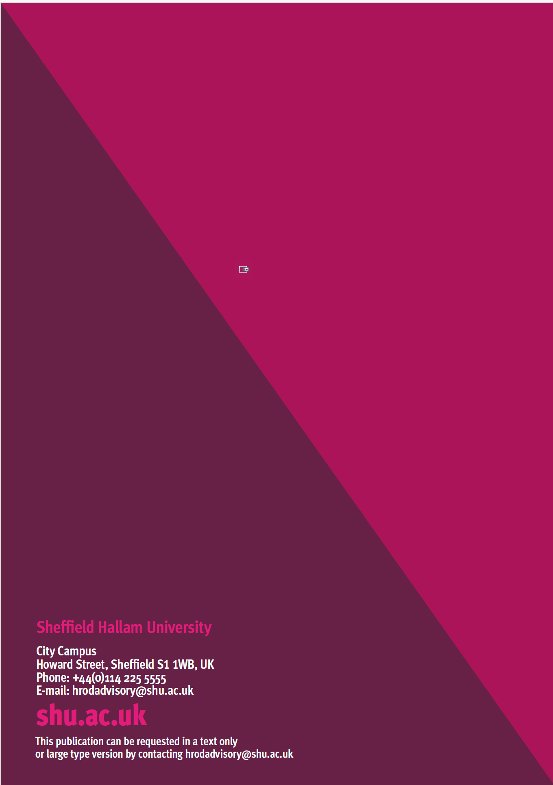

ONS ASHE, 2022 based on median hourly earnings excluding overtime for all employees (full-time and part-time). From UCEA’s infographic ‘Examining the gender pay gap in Higher Education’

