#LoveHome Design Challenge - Sheffield
We are living much more of our lives at home at the moment. We are sharing spaces of different sizes, layouts and styles with our families, however large or small, whatever ages and generations and using our homes in new and different ways. Perhaps as a school classroom, home office or play area. Today our homes are an even more important part of the communities and environment that surrounds us.

A lot of us are thinking about our homes much more, what we love about them, what makes them work for us and what we might change to make them even better. So, what greater time for you to think about your home and the community in which you live?

The Challenge

What matters to you and those you live with about home? If you had a magic wand what would you do? What would you keep and what would you change about your current home? Would you adapt your existing home to improve it, or would you like to create a brand new one to live in? What new spaces would you have for you, your family and friends to use? What new gadgets would you add to make your home a better place to live and hang out? Would you stay where you live now within your existing community or move somewhere else?

This LoveHome Design Challenge is inviting you to collaborate with the whole of your household, from the youngest to the oldest, to design your dream home. We want you to ask your parents, guardians, family relations and friends what they love about home. Use all this feedback to design the home of the future that will improve all your lives. You can work on this alone or as a household or a class team.

You can be as inventive as you like in creating this home. Think about a space and place that will make you feel happy and keep you safe and warm. Think about a home that looks after you, your community and the planet.

We need to protect our planet and adapt to our changing climate. So we need to change the way we build homes and the way we live in them. We need to user our precious resources wisely. How can your new home reduce your use of energy, water and raw materials? Will your home be able to generate energy from renewable resources? Can you reduce the materials you use to build your new home through clever design or using repurposed materials? Can you use materials that are sustainable, naturally produced, recycled and energy efficient? Can your home be built to adapt and change as your needs change as you get older?

We also want your ideas on how this home should function. What technology will you use to make life easier and more enjoyable? How will this differ for you and other members of your household and their needs?

Finally, think about your home in its environment and neighbourhood. Our current circumstances are highlighting the importance of connection. In your future home how will you, family and friends connect both physically and socially? How can you design your home so you keep in contact with your neighbours, friends and local community and avoid social isolation?

Show us what features you think are important and how we can share and enjoy spaces for fun, relaxing, playing, communicating, working, creating, growing food and all the other important parts of home and community life.

What Next?

We want you to design a green home, place or space, that you love, that looks after you, those around you and the planet. We want you to think about how you and those you live with will use the house and its surroundings and how this will influence the way it looks.

There is not a deadline to complete or submit. You can take as much or as little of this time as you want to create your home.

You can bring your thoughts and ideas to life in any way you like. You can draw your house by hand or use computer software or games such as Minecraft, Fortnite or Sims. Make a model out of any material you can find, use Lego, make a collage using magazine pictures or photographs. You might produce a short video with interviews, animations or social media platform, write an article, story or poem.
The choice is entirely yours.

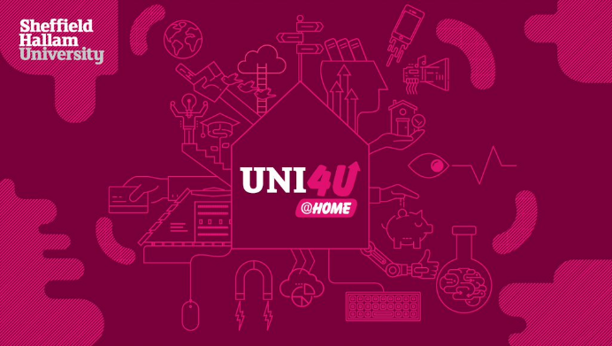
When you have finished send us everything you want to share to sclo@shu.ac.uk

Find out more about our architecture and built environment courses at https://www.shu.ac.uk/about-us/academic-departments/natural-and-built-environment

View our Uni4U@home resources at
https://www.shu.ac.uk/about-us/schools-and-community-outreach/uni4u-at-home

We will share our favourites with MOBIE and post them on our Twitter account and let you know what we think of your designs and submissions.

Remember, home is not just a place where you live, but how you live and where your heart is. Home is a sacred place. Good luck! #LoveHome

