**How to see Marks and Feedback:**

**(Date posted: Monday 10th February, 2020)**

In this guide, we’ll go over how you can see marks and feedback using PebblePad.

1. We begin this process on the homepage of Pebble+.

Click the ‘Burger Menu’ button at the top-left of the screen.

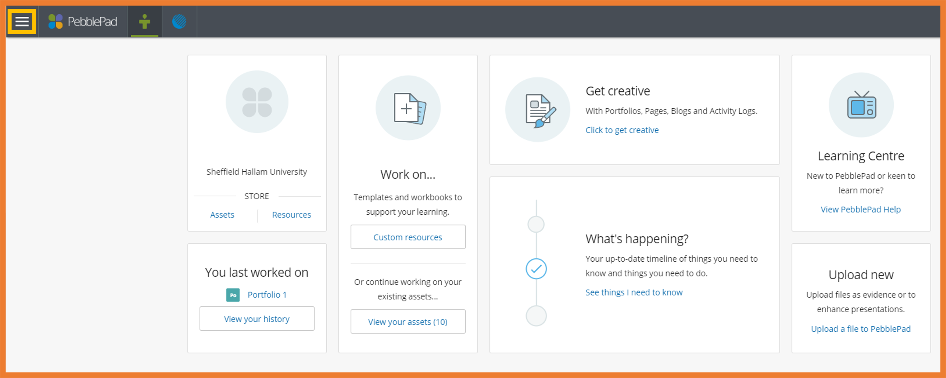

**Step 1: Burger Menu**

**Step 2: The Asset Store**

The clipboard icon is one of several icons located to the right of each item in the asset store list.
In this instance, the clipboard icon has a '1' next to it, which means it has been submitted once.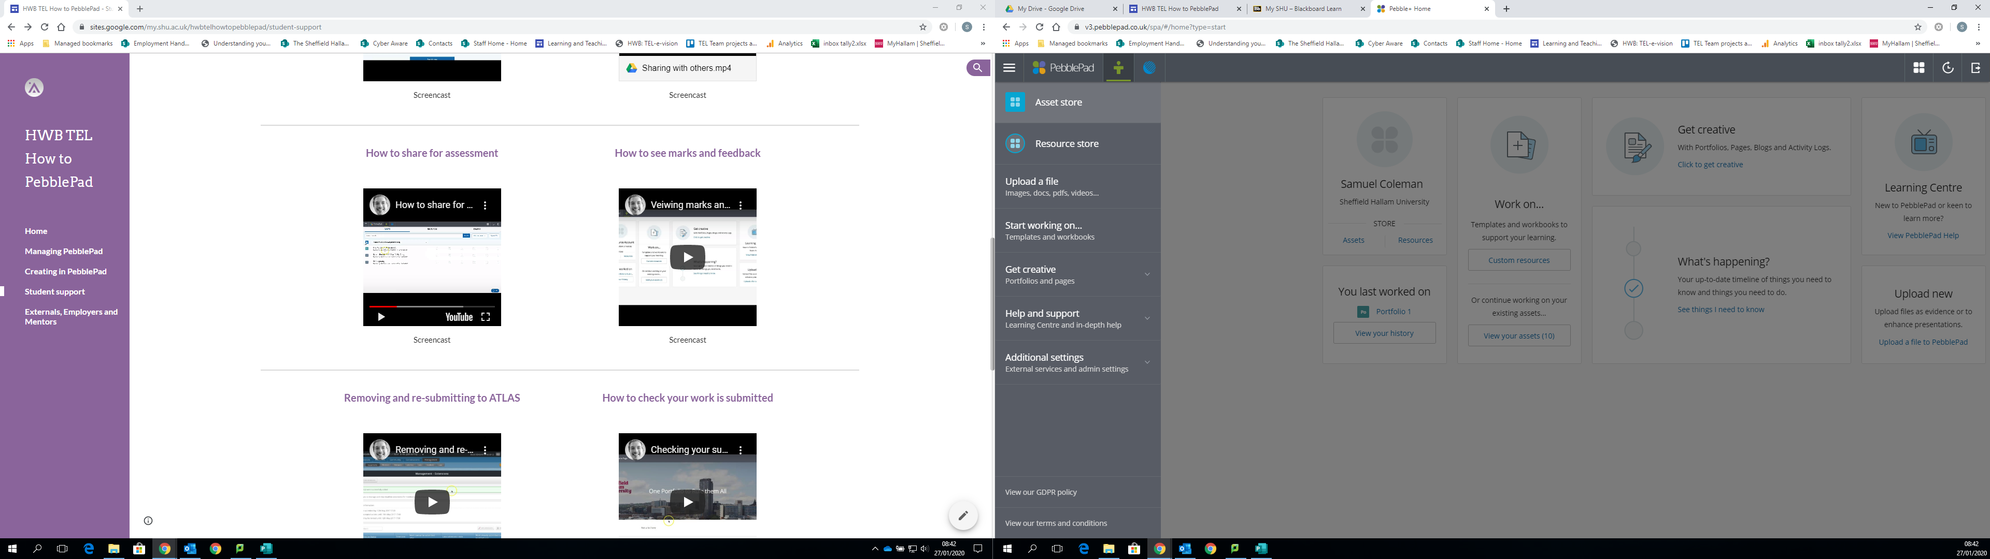

If you’ve already submitted an asset as an assignment, this clipboard icon should be bolded and have a number to the right of it.

This is what this selection of icons should look like before marking and feedback have been released.

A list of the works (assets) you’ve created should appear.

A drop-down menu will appear.

Click on the ‘Asset store’ button at the top.

The list of assets in our example here are made up of a range of items, such as portfolios, meetings, and reflections.
Each item has details who last modified it, and at what date/time.

The asset titles (image above) will display on the left and the icons (image below) will display to the right of them.

**Step 3: Confirmation of Marks and Feedback**

When marks and feedback are released, you should usually receive an email from PebblePad confirming that these are available to view.

We’ll now look at the same thing, except after marks and feedback have been added.

Once you have been informed that you have received marks and feedback, return to the Pebble+ main menu and, again, click the burger menu.

As mentioned earlier, the burger menu is located at the top left of the PebblePad homepage.
It appears as three horizontal lines.

**4. Viewing Written Feedback and Grades**

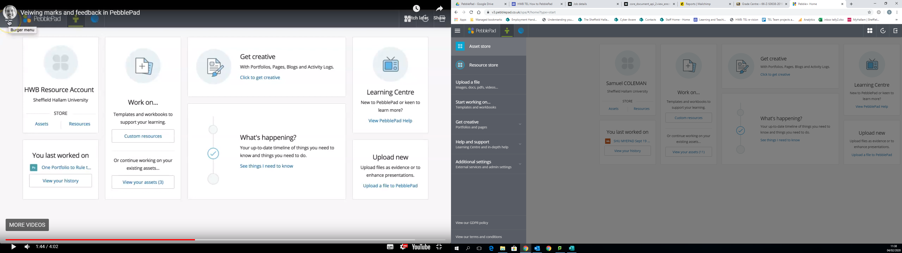

Once again, click the ‘Asset store’ button to bring up your list.

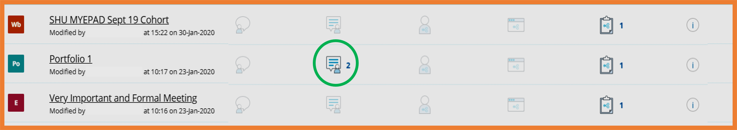

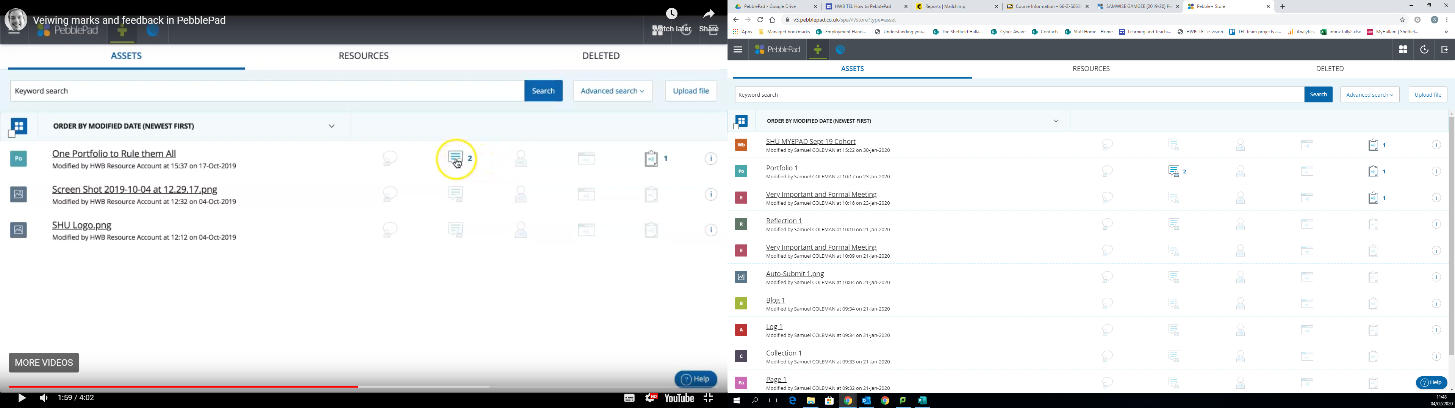

If you have feedback/grades on an asset, the feedback icon should be highlighted, with a number next to it representing the amount.

Clicking this icon will bring up this menu. Here you can see the written feedback, as well as an allocated grade. All of these will feature information on when they were posted and by who.

Yours may look slightly different (might have a marking-grid attached, etc.).

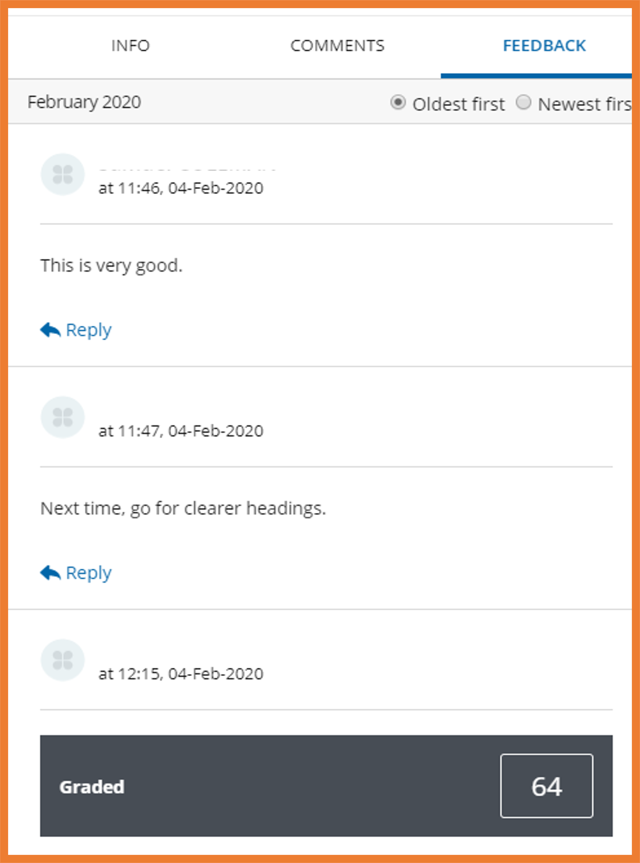

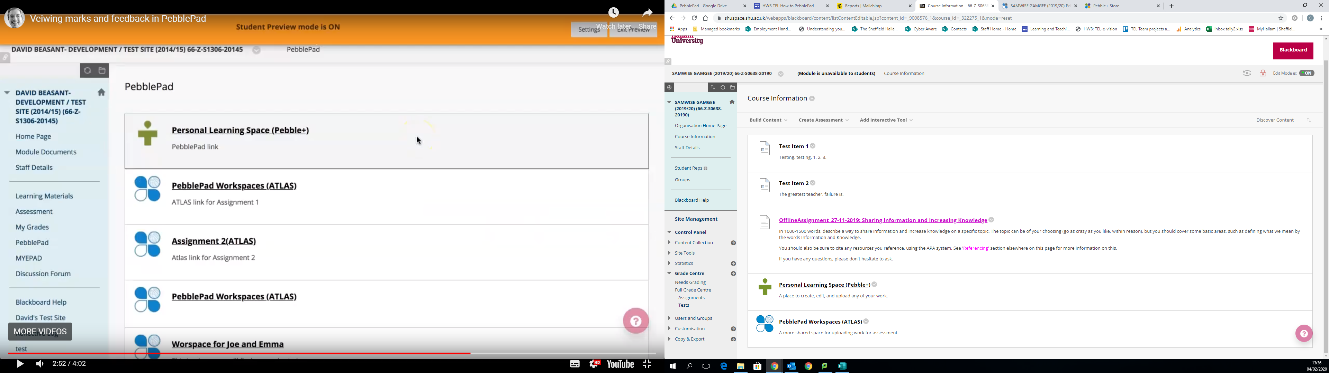

The 'Submission details' section shows several details: the title of the work being submitted, the date and time of submission, the date and time of the latest modification of the work, and the name of the publisher of the work.
To the right is a number representing the score given by markers, and a clipboard icon, which links to any written feedback attributed to the work.

**5. Viewing Feedback and Grades in ATLAS**

This should take to you to the ‘Submission’ page on ATLAS. Your submitted work will be listed under the ‘Submission details’ section (example in picture below).

The grade and feedback should display via numbers and icons to the right of your submission details.

The link you want is ‘PebblePad Workspaces (ATLAS)’.

The process we’ve just gone through allows you to view your feedback/grade via Pebble+.

It is also possible to view your feedback/grade in the ATLAS workspace. (You won’t be able to view the feedback comments themselves here; this is more a way to check if feedback has been provided on a specific piece of work).

If you go to your Blackboard site and find the ATLAS link. This will differ from course to course but the links should look a lot like the ones pictured below. If you can’t find them, contact your course leader.