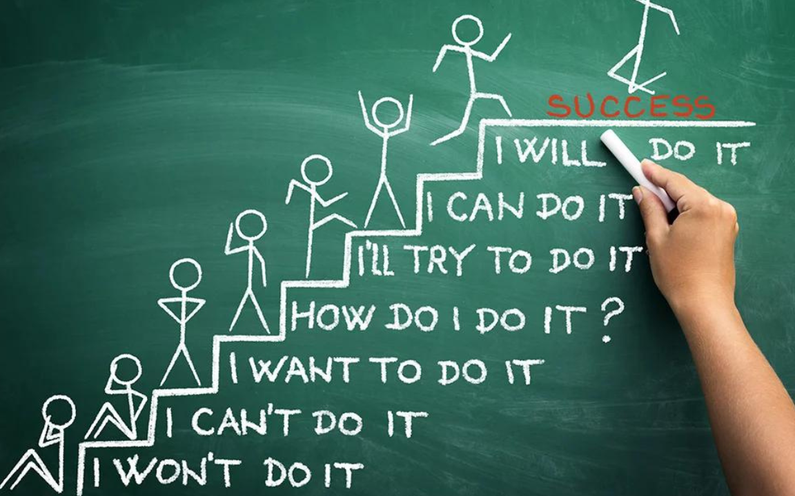

Motivation, Getting Started & Staying Focussed

Balance your thinking (also known as arguing the opposite): “I can’t get my head around it” take a step away and plan – list all the steps it will take to get it done so you can see that you can. “I’ll fail” – list all the reasons why you might not. “I can’t do this right now” – I could try for 15 minutes and see how it goes, or I could plan what I need to do.

Practice Self-Compassion: Tame your inner critic by noticing the negative self-talk and challenging it. Try thinking of what you would say to a friend. Negative self-talk is a good way to keep yourself stuck!

Environment: Choose a space that is separate from your relaxing space to work in if possible. Make your environment work for you. Do you work better with music / sound or quiet? Do you work better with someone else there or on your own?

Limit distractions: Make sure your workspace is set up to help you to work better with limited distractions. This goes for both your physical and your digital space. Try some of the strategies from the Reduce Digital Distraction website. Keep a look out for the workshops starting again for this too.

Schedule your focussed time​: This will help you by dedicating time to the task as well as help motivate you to get it done. Your schedule should be balanced with something to look forward to after, especially if it is a task, you aren’t looking forward to completing.

The 10-Minute Rule: Give yourself permission to only commit to 10 minutes of work. When you reach the 10-minute mark, ask yourself if you want to keep going or quit. Getting started is usually the hardest part. Once you get going, it’s usually much easier to keep going.

Take a break / change things up: Go out for a walk, tidy your workspace, go speak to someone for a few minutes, physically get up and move away from the space, move and set up in another room, put some music on in the background… It might be a good way to reset.

Manage your task / your to-do list: If your list of things to do or your task is overwhelming – this can be a big motivation crusher. Choose the main items you need to achieve from your to do list and just focus on those, start with the easiest or smallest too, it’s a good boost to tick something off. If your whole task is overwhelming; use the task breakdown to break your task into smaller more manageable steps.

Be flexible and realistic: Try to be flexible with what you hope to achieve, if you get stuck on something, can you come back to that and move onto something else for now? It’s better to make progress on something else than sit for an hour and not feel you have achieved something. Be realistic with how long you can focus on something productively for and try to avoid multitasking so you can focus on the task at hand. ​

Practice self-care: A good night’s sleep, good nutrition, good hydration, giving yourself time to do something you enjoy all have an impact. You will find yourself more easily motivated if you are taking care of yourself.

Rewards: Reward yourself for completing a task or a step towards it. Weather smaller, more frequent rewards or a bigger reward for a complete job, it’s always easier to work towards a reward or a treat! It’s also worth reminding yourself that when it’s done, you’ll have free time again to do something else.

Seek help: Why not speak to your module leader or Academic Adviser? It could be that your motivation will improve once you feel like you are on the right track or that you have understood the task. You could also attend a 1:1 appointment with a Skills Adviser, book onto a webinar or read through a skills guide to help give you some focus. If you are really struggling with this you could see if Student Wellbeing’s online resources, group workshops or speaking to a practitioner could help.

Use Supports: Use supports to help you. This could be another person, like a course mate, housemate, friend or family member to check in with you – being accountable to someone else can help us to feel the pressure needed to get it done. There are also many Apps you can use like Focus to do, Mindview, Trello, Forest. You could use alarms and timers or the Pomodoro Technique ​to help you.

