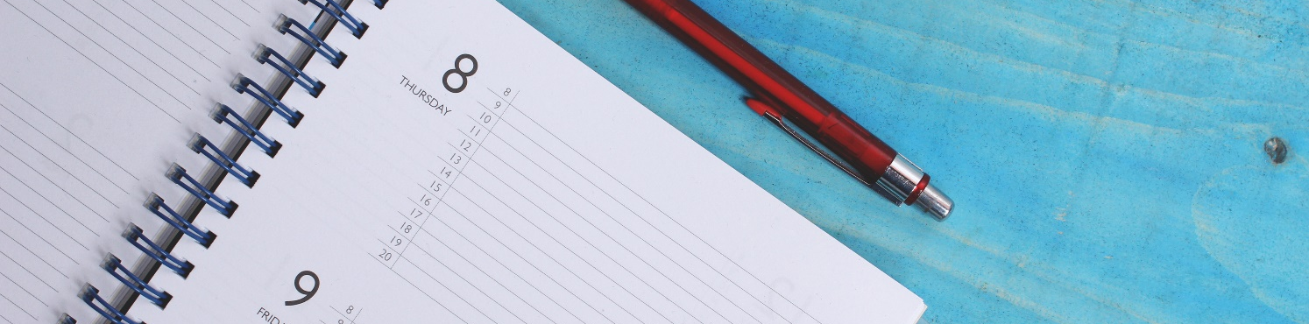

Preparing for an appointment

Make sure you are clear on what the meeting is for or about. Don’t be afraid to ask for clarification.

It is often difficult to remember everything you want to talk about when you only have a set time, especially if there are multiple things to discuss. Make some notes to take with you of things you want to discuss:
- Things you want to share with the person you are meeting.
- Questions you have or things you want clarification on.
This will help to make sure you say everything you want to without missing anything out.

Before the appointment:
- Check the time of the appointment and set a reminder if this helps.
- Check the type of appointment e.g. phone call, online or face to face.
- If it is online - make sure you have the link to join the meeting and have access to a quiet or private place to go for this.
- If it is a phone call - make sure you have access to a quiet or private place to go for this.
- If it is in person - make sure you know the location. Plan enough time to get there, especially if it is somewhere new to you.

Medical / GP Appointments
Doc Ready can help you to prepare and to build a checklist of things that you want to talk about in an appointment with your GP.

