Email Management and Digital Support

Self-reflection
What made you come here today?

What do you find most difficult about managing your emails or using digital platforms / technology?

What has helped you with these difficulties in the past?
This is a good place to start, you can build on what has worked.

Notes:
Use this space to make notes of;
- anything useful to remember
- anything you want to come back to or find out more about
- any resources that might be useful to try
- any questions you have that you want to ask
- any actions you want to do from this

Checking emails:​

You need to check your student email regularly​. ​Regular checking will enable you to spend less time on this task by keeping on top of it.

How often? ​How regularly do you check / work on your inbox?

When? ​When during the week? What time of day?

Where?​ Where are you when you are doing this task? What device are you using?

How long do you spend on this?​ ​Is it more or less time than is helpful?

If you don’t check your inbox regularly, what is it that stops you?​

Build it into your routine:
Checking your email regularly is part of your student contract, so build it into your routine and make it a habit to help you to stay on top of your inbox.

Seinfeld Strategy:
Don’t break the chain.
Mark every day that you do the task on a calendar.
If you ‘break the chain’ make extra effort to make sure you don’t miss 2 days in a row.

Start small using the ‘Tiny Habits’ strategy:
A – Anchor – Anchor the moment you want to make the change after something you already do. Use an existing thing to trigger the reminder to do the new thing.
B – Behaviour - The new habit you want but scaled back to be super tiny - and super easy. You can build on this.
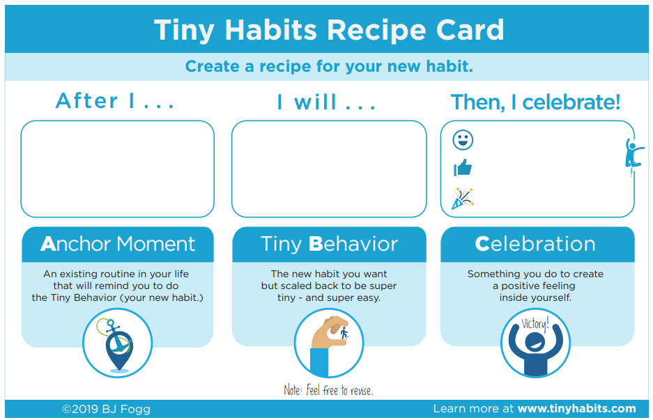
C – Celebration - Immediately after you do your new habit, celebrate so you feel a positive emotion. That helps wire the habit into your brain.

Strategies to help:
5 Minute Tidy​

This is a minimum of 5 minutes - you can change the length of time to suit you​.
- Delete not-useful emails
- Move ‘for reference’ emails into a folder​
- You will be left with those that are important or need action ​
- Start working through the things that need an action

OHIO
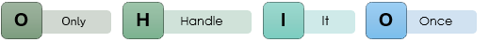
Don’t scroll past it to come back to later, deal with it now if possible.

The 4 T’s


Inbox ‘almost’ zero​
- Create a folder and name it ‘Archived - Date’ ​
- Move all emails into this folder,​ leaving the last month / few weeks in your inbox (Do not delete them!)
You can still search for them, but your inbox is in a more manageable state​.
Important: Once you are on top of your inbox, schedule time (5-10 mins) regularly to go through your ‘Archived’ folder to check for things that may still need attention or filing.

Inbox and Calendar Management Plan
When and how often will you check your inbox?

Where and using what device?​

How long will you aim to spend on this?​ ​(use a timer!)

What barriers might prevent you from sticking to your plan?

How will you overcome these barriers?

What is your motivation to stick to this plan?

What tools will you try going forward?

Inbox management:
☐ Folders​
☐ Flags
☐ Tasks​
☐ Colour categories ​
☐ Mark read / unread​
☐ Search and filter​
☐ Rules ​
☐ Other ____________________________

Calendar management:
☐ ​Connect your timetable
☐ Different views and layouts​
☐ Tasks​
☐ ​Block your time out​
☐ Use the reminders​
☐ Set recurring reminders
☐ Colour categories ​
☐ Other ____________________________

What strategies will you try out to help stay organised in your calendar?

Reflection and next steps:
What things have been useful and what will you take away with you from the session?

One thing I will try this week…

Take some time now to think through any barriers that may stop you from doing this and what you can do to help yourself make sure that you can achieve this.

Further support:
We run the following sessions regularly:
 | Time Management and Organisation  Practical strategies to help you with organisation managing and organising your time.  Booking Link: go.shu.ac.uk/organisation
 | Managing Study, Deadlines and Assignments  Practical strategies to help manage study and deadlines including approaching and breaking down your work.  Booking Link: go.shu.ac.uk/managingstudy
 | Motivation and Procrastination  Practical strategies to help you to better understand and improve motivation and manage procrastination.  go.shu.ac.uk/motivationprocrastination
 | Productivity and Focus  Practical strategies to help you boost your productivity levels and help improve your focus.  Booking Link: go.shu.ac.uk/focus
 | Support and Social Opportunities  Practical strategies to help you to find and access the support and social opportunities available to you here at Hallam.  Booking Link: go.shu.ac.uk/socialsupport

You are always welcome to come back and repeat sessions if this is helpful.
We also run a Peer Support Check-in on a Wednesday from 3pm – 4pm.
 | Peer Support Check-in  Come and ‘check in’ with staff and peers, to receive and or provide support in a supportive environment. You are welcome to come along and discuss topics from the sessions, student life, or use the session as a social opportunity
You can check when it is running using this link: go.shu.ac.uk/checkin

