Time Management & Organisation

Self-reflection
What made you come here today?

What do you find most difficult about managing your time or being organised?

What has helped you with these difficulties in the past?
This is a good place to start, you can build on what has worked.

Notes:
Use this space to make notes of;
- anything useful to remember
- anything you want to come back to or find out more about
- any resources that might be useful to try
- any questions you have that you want to ask
- any actions you want to do from this

Building Habits
Building habits takes time, repetition and consistency, as well as a certain level of motivation.
What habit do you want to build in?

Is it realistic? Set yourself up for success, not failure. Is it too big, can I make it smaller or break it down?

What is your motivation? Why do you want to start this habit?

Seinfeld Strategy:
Don’t break the chain. Mark every day that you do the task on a calendar.
If you ‘break the chain’ make extra effort to make sure you don’t miss 2 days in a row.


Start small by building ‘Tiny Habits’
https://tinyhabits.com/welcome/
It’s as easy as ABC:
A – Anchor – Anchor the moment you want to make the change after something you already do. Use an existing thing to trigger the reminder to do the new thing.
B – Behaviour - The new habit you want but scaled back to be super tiny - and super easy. You can build on this.
C – Celebration - Immediately after you do your new habit, celebrate so you feel a positive emotion. That helps wire the habit into your brain.
For example; I want to get into the habit of checking my emails each day.
A – After I ... *make my morning coffee*
B – I will... *check my emails*
C – Then I will celebrate by... *saying ‘it’s done’ and crossing it off my calendar*
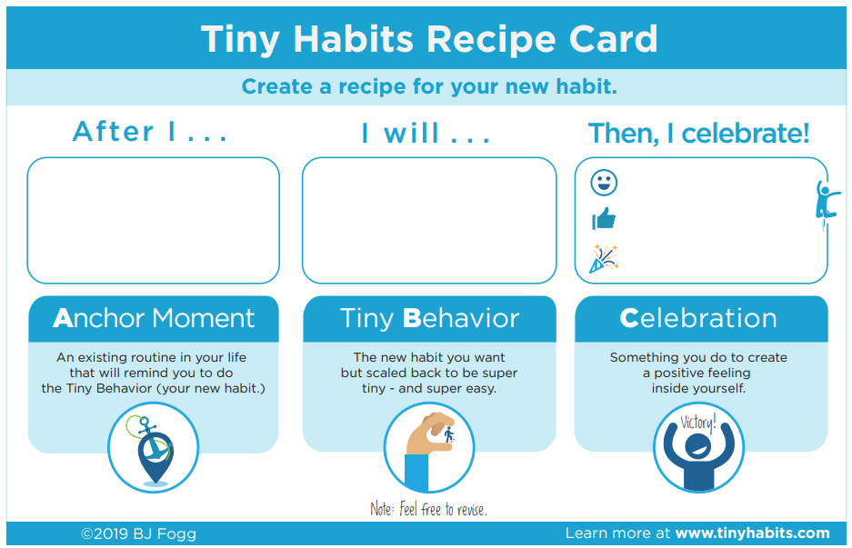
What tiny habit will you start with?

SMART Goals
SPECIFIC - your goals need to be clear and explicit.
MEASURABLE – a measurable goal is where you can identify exactly what you will see, hear and feel when you reach it.
ACHIEVABLE & REALISTIC – If you set your goals and ambitions very high this might put extra unnecessary pressure on you. If your goal doesn’t seem achievable and realistic you could break up the goal into smaller goals. Don’t set yourself up to fail.
TIME BOUND - set a time limit for when you can expect the agreed changes to have taken place. This can then be reviewed as needed. Setting a time limit helps you focus the actions that need to be taken to achieve goals.

Set yourself a SMART goal
What is your SMART goal?

Why do you want to reach this goal?

What supports do you have to reach this goal?

What steps should you take?

Problems you might encounter:

Ways of dealing with these problems:

Planning your time
When? When can you set aside time to plan? When works best for you?

How often? How often will you plan / review your plan?

What takes up your time?

How? What tools will you use to help you to manage your time?

Not sure where to start?
Have a go at prioritising your to do list using the list and grid below.

 | URGENT | NOT URGENT |  | TO DO LIST
IMPORTANT | Top Priority | Third Priority |  | ☐  ☐  ☐  ☐  ☐  ☐  ☐  ☐  ☐  ☐  ☐  ☐
NOT IMPORTANT | Second Priority | Last Priority |  | ☐  ☐  ☐  ☐  ☐  ☐  ☐  ☐  ☐  ☐  ☐  ☐

Time Blocking Tips
- Identify what you need to do / work on for the day.
- Figure out when you’re most productive.
- Group similar tasks if possible.
- Schedule your time blocks.
- Block breaks and personal time.
- Don’t be too specific for the block.
- Include buffer time.
- Adjust as needed.
Buffer time – this is important and most of us forget to include it when we plan. Buffer time includes the additional things that take time in between (e.g. travel time) and it also requires you to think practically about how long things will realistically take.
Buffers to remember to include in my planning:

Planners
You can find a wide range of cheap options for daily, weekly or monthly planners in shops and online. You can also visit our resources pages for links and examples to download.
Thinking about all the things we have covered, choose your busiest day of the week and have a go at blocking out your time below:
TIME | DAY: |  | TO DO LIST
08:00 |  |  | ☐
09:00 |  |  | ☐
10:00 |  |  | ☐
11:00 |  |  | ☐
12:00 |  |  | ☐
13:00 |  |  | ☐
14:00 |  |  | ☐
15:00 |  |  | ☐
16:00 |  |  | ☐
17:00 |  |  | ☐
18:00 |  |  | ☐
19:00 |  |  | ☐
20:00 |  |  | ☐
21:00
22:00

Reflection and next steps:
What things have been useful and what will you take away with you from the session?

One thing I will try this week…

Take some time now to think through any barriers that may stop you from doing this and what you can do to help yourself make sure that you can achieve this.

Further support:
We run the following sessions regularly:
 | Email Management and Digital Support  Practical strategies to help you to manage your inbox and calendar, information about accessing digital support.  go.shu.ac.uk/digitalsupport
 | Managing Study, Deadlines and Assignments  Practical strategies to help manage study and deadlines including approaching and breaking down your work.  go.shu.ac.uk/managingstudy
 | Motivation and Procrastination  Practical strategies to help you to better understand and improve motivation and manage procrastination.  go.shu.ac.uk/motivationprocrastination
 | Productivity and Focus  Practical strategies to help you boost your productivity levels and help improve your focus.  go.shu.ac.uk/focus
 | Support and Social Opportunities  Practical strategies to help you to find and access the support and social opportunities available to you here at Hallam.  go.shu.ac.uk/socialsupport

You are always welcome to come back and repeat sessions if this is helpful.
We also run a Peer Support Check-in on a Wednesday from 3pm – 4pm.
 | Peer Support Check-in  Come and ‘check in’ with staff and peers, to receive and or provide support in a supportive environment. You are welcome to come along and discuss topics from the sessions, student life, or use the session as a social opportunity
You can check when it is running using this link: go.shu.ac.uk/checkin

