Understanding how and why you procrastinate
Do you identify with any of these types of procrastination?
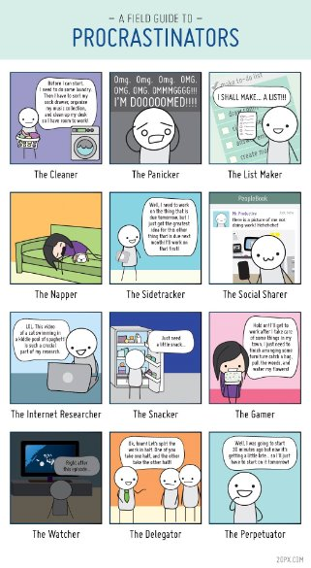

How do I procrastinate?
How can I use this to help me?

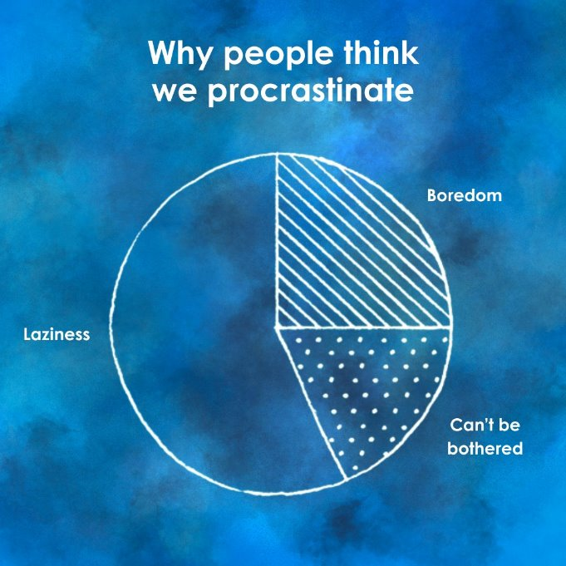
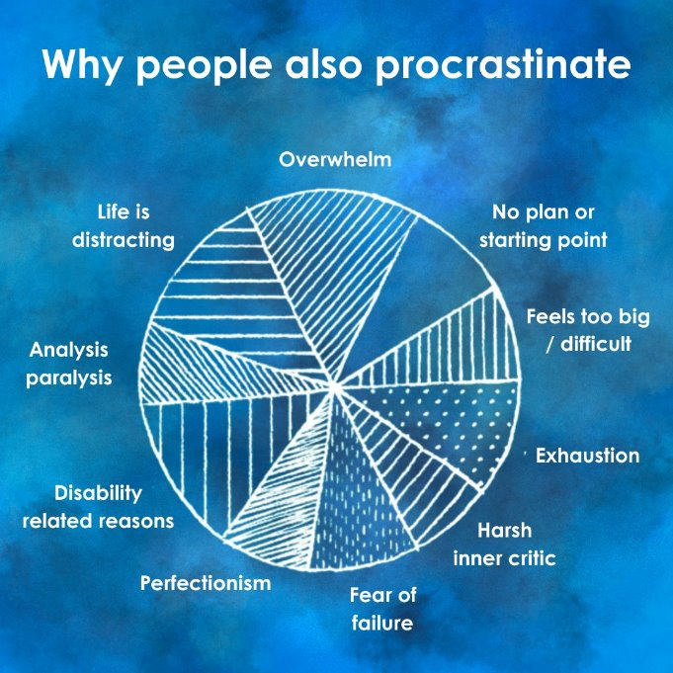

Why do I procrastinate?
How can address this / help myself?

