**Sheffield Hallam University logo**

***College of Health, Wellbeing and Life Sciences***

***Department of Social Work Social Care and Community Studies***

**Foundation Degree**

**Working with Children, Young People and Families**

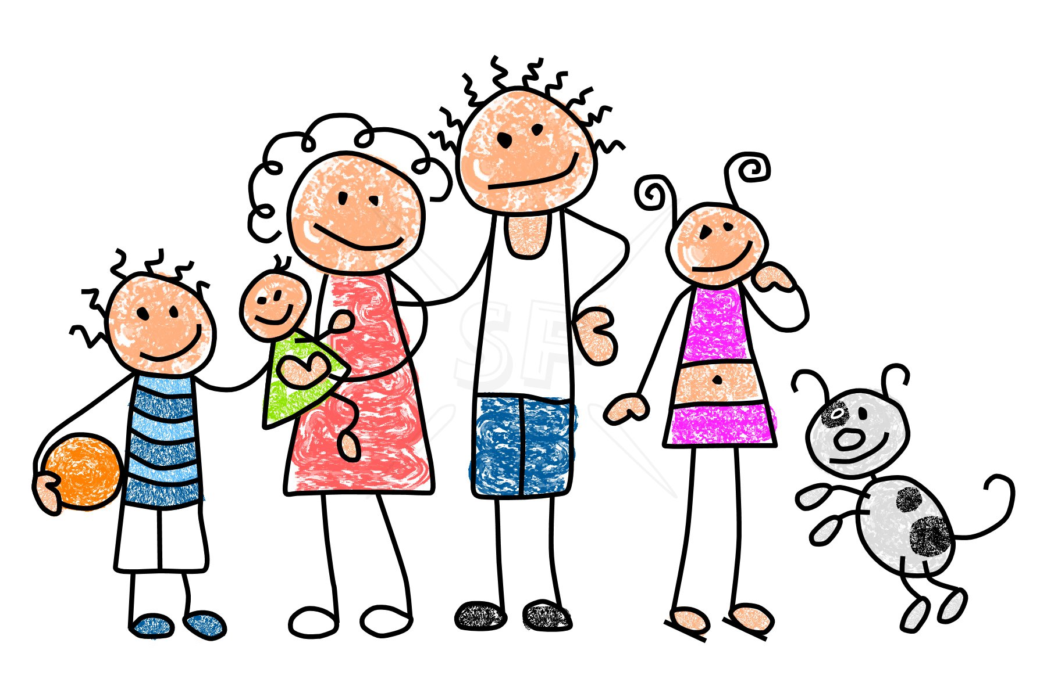

**Work Based Learning Two**

**Portfolio Guidance**

# Writing Your Portfolio

NB: All names and identifying details of agency, staff and service users must be changed or erased in order to ensure that confidentiality is maintained (please refer to SHU Consent and Confidentiality Guidance which can be found on the WBL Blackboard site)

**Your Work Based Learning Two Portfolio**

**Section One**

Describe the placement setting and the area in which it is situated. Describe the composition of the local community and include references to statistical data and evidence in order to support your work e.g. National Census Data, The Index of Multiple deprivation etc.

Describe the work undertaken at the placement and its aims and objectives. Discuss how the service/agency meets the needs of children, young people and families with reference to the legal and/or policy focus of the work e.g. parenting, family support, education etc.

(Suggested word count approx. 500 words)

**Section Two**

**Reflective Learning Journal**

During the time you are at your placement you are expected to keep a reflective learning journal or dairy. The purpose of the journal is to enable you to provide evidence of your learning and your ability to link theory to practice. You should use the Reflective Cycle to enable you to reflect upon and analyse your experiences. You should use your learning journal to record your thoughts, ideas, insights, feelings and observations on a regular basis throughout your placement.

Whilst the reflective journal is not about quantity of work but more about the quality of the entries you include you should note that if there is insufficient quantity within the learning journal it is unlikely that you will have demonstated sufficient evidence to meet the requirements of the curriculum. It is therefore suggested that your journal contains at least 2 - 3 entries per week and that the overall word count is not less than 4000 words

**The Reflective Cycle**

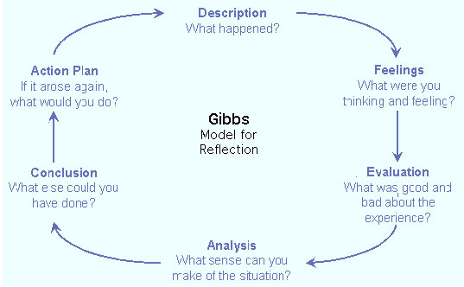

A suggested template for your reflective learning journal

|  |  |
| --- | --- |
| **Description**  Describe what happened. |  |
| **Feelings**  What were you thinking and feeling at the time? |  |
| **Evaluation**  What was positive and what was negative about the experience. |  |
| **Analysis**  What sense can you make out of the situation. What does it mean? |  |
| **Conclusion**  What else could you have done? What would you do differently? |  |
| **Action Plan**  How will you adapt your practice in the light of this new understanding? |  |

**Section Three**

Choose one significant experiences or events from your placement and write an in-depth reflective account of these experiences using the Reflective Cycle

These accounts should include reference to theory, evidence and research and should include a reference list (suggested word count 1500)

**Section Four**

Reflect on a situation from your placement in order to help you to identify an opportunity for improving the experience of service users, for example, through more effective multi agency working or communication. You do not have to implement your idea but you could consult with staff, service users and volunteers about your idea and begin to identify how your idea could be implemented and evaluated (suggested word count 1500 words)

**An example of a service improvement idea**

**Improving Communication with Parents and Carers in a primary school setting**

I have observed that at my placement in a primary school much of the communication that takes place with parents and carers is undertaken through means such as newsletters, or notes that are sent home with the children. I recognise and acknowledge that this type of "one way" communication is vital to the school and serves to keep parents and carers informed about daily events and issues as a process it provides little opportunity to encourage parents and carers to become more involved in the communication process (Swick 1994) There is little opportunity for parents and cares to engage with teachers on a regular basis for updates regarding their child's progress or in relation to consultation and participation about, for example, changes that are taking place in the school or activities and events that the school is planning.

I have undertaken some research into this area and have found that there is evidence to suggest that a "two-way" communication system with parents and carers allows for a more in depth and collaborative sharing of information, concerns, and feelings and that it is essential in establishing a dialogue and in building relationships, rapport and a sense of collaboration, all of which it is suggested contribute positively to the ability to understand more fully the needs of parents, carers and their children and offer support which more appropriately meets the needs of children and families (Berger 1995).

The single most important determinant of a child’s success in school has been found to be parental interest and support and there is evidence to suggest that a direct relationship exists between the support a parent receives and the support a parent gives to their child (Siraj-Blatchford 2009)

It would therefore follow that it is important to establish positive relationships with parents and carers and offer positive messages about their children's progress. It is important to share with them their child's accomplishments and achievements on a regular basis (Sherbert Research 2009).

Evidence also suggests that if a trusting and open relationship has already been established with a parent or carer this will support more positive outcomes and a more open and honest dialogue when there are concerns or problems to discuss (Siraj-Blatchford 2009) It is important to note here that if we begin and end our conversations with parents and carers on a positive note we can help to insure against alienating parents (Manning, 1985) Positive contact with parents and carers also helps to alleviate both theirs and their children's apprehension and anxiety and strongly conveys the message that they are both valued and are seen as partners in the education of their children (Gestwicki 1992).

Parents and carers who feel that a teacher or, for that matter any professional, genuinely cares for their child and wants their child to succeed as much as they do, are more likely to view working together more favourably and be more willing to share information about their child and their family. The exchange of observations, insights and ideas can help everyone to respond more appropriately to a child's needs (Epstein 1995)

Through my observations and research I have come to the conclusion that a more effective two-way communication system could be developed and implemented within the school. One idea I had was to develop an exchange communication system through the introduction of scheduled conversations with parents and carers which could take place during drop-off or pick-up times in addition to parent's evenings which are held at the end of term. My proposal is that the development of this communication system would enhance and support communication on a more informal basis with parents and carers and would help to ensure a more vibrant and ongoing dialogue regarding all aspects of the child's health, education and wellbeing and would in turn contribute towards eliciting a more holistic approach to understanding and meeting the needs of each child and family (Swick 1994) It is my belief that this could promote a more welcoming and positive atmosphere and thus enhance parent/teacher communication which in turn may invite further parent and carer involvement in school and in the child's learning and educational journey (Berger 1995)

References

Berger, E.H. (1995). *Parents as partners in education: Families and schools*

*working together*. Englewood Cliffs, NJ: Merrill.

Epstein, J. (1995). *School/family/community partnerships: Caring for the*

*children we share.* Phi Delta Kappan, 76(9), 701-711.

Gestwicki, C. (1992). *Home, school, and community relations: A guide to*

*working with parents.* Albany, NY: Delmar.

Siraj-Blatchford, I. and J. Siraj-Blatchford (2009). Improving Children’s Attainment through a Better Quality of Family Based Support for Early Learning. London, Centre for Excellence and Outcomes in Children and Young People's Services (C4EO).

Sherbert Research (2009). Parents as Partners - 'Harder to Engage' Parents: Qualitative Research. London, Department for Children, Schools and Families.

Swick, K (1994). *Family involvement: An empowerment perspective. Dimensions of Early Childhood,* 22(2), 10-13.U.S. Department of Education (1993).

Watson, T., Brown, M., Swick, K.J. (1983). *The relationship of parents’ support to children’s school achievement*. Child Welfare, 72(2), 175-180.

**Section Five**

The placement supervisor will undertake 2 direct observations of the students practice whilst on placement. The observations will be formally recorded using the pro-forma below and they must be included in the portfolio

**Supervisor Observation**

|  |  |
| --- | --- |
| Name of student |  |
| Name of Supervisor |  |
| Situation observed |  |
| Comment on the students ability to plan, organize and undertake the activity |  |
| What are the particular strengths of the student |  |
| What area/skills/knowledge could the student improve/develop |  |
| Supervisors signature |  |
| Date |  |

**Section Six**

You must submit a placement log sheet which evidences 200 hours of practice and which is signed by the placement supervisor.

|  |  |  |
| --- | --- | --- |
| **Student name** |  |  |
| **Name of placement** |  |  |
| **Date** | **Hours undertaken** | **Supervisors signature** |
|  |  |  |
|  |  |  |
|  |  |  |
|  |  |  |
|  |  |  |
|  |  |  |
|  |  |  |
|  |  |  |
|  |  |  |
|  |  |  |
|  |  |  |
|  |  |  |
|  |  |  |
|  |  |  |
|  |  |  |
|  |  |  |
|  |  |  |
|  |  |  |
|  |  |  |
|  |  |  |
|  |  |  |
|  |  |  |
|  |  |  |
|  |  |  |
|  |  |  |
|  |  |  |
|  |  |  |
|  |  |  |
|  |  |  |
|  |  |  |
|  |  |  |
|  |  |  |
|  |  |  |
|  |  |  |
|  |  |  |
|  |  |  |
|  |  |  |
|  |  |  |

**Section Seven**

|  |
| --- |
| **Work Based Learning Supervisor Summative Report** |
| Student name |
| Name of placement |
| What is your assessment of the students overall performance over the course of the placement |
|  |
| What are the particular strengths of the student |
|  |
| What skills and knowledge could the student develop further? |
|  |
| Any other comments |
|  |
| **Pass Fail (please circle as appropriate)** |
| **Signed**  **Date:** |

**Section Eight**

**Portfolio Checklist**

Please use the checklist to check that you have included all required work in the portfolio before submission.

|  |  |  |
| --- | --- | --- |
| Section | Content area | Checklist |
| Section One | Description of agency, area and work undertaken |  |
| Section Two | Reflective Learning Journal |  |
| Section Three | In-Depth Reflective Account |  |
| Section Four | Service Improvement Reflective Account |  |
| Section Five | Two Supervisor Observations |  |
| Section Six | Signed Weekly Placement log sheet |  |
| Section Seven | Work Based Supervisor Report |  |

**In addition your portfolio may also include:**

* Examples of work you have undertaken at placement e.g. planning, activities etc.
* Evidence of any training or professional development courses you have taken e.g. certificates etc.
* Policy document or information about the placement, its services etc.
* Feedback from colleagues and service users
* Any other evident you feel is relevant to demonstrate your professional learning and development