Student Failing to Progress or Cause for Concern

This document contains guidance and a pro-forma for the Student Failing to Progress or Cause for Concern process to be initiated between a student radiographer and the placement staff.

This process is a feature of the assessment process which aims to provide a managed focus in situations where the performance of a student requires additional attention beyond the normal systems of support and guidance. The process provides all parties with a formal way of documenting and addressing a range of concerns, with a view to providing positive support for the student.

In the event of any concerns, it is advised that the process should be triggered as early as possible to allow the student to identify and respond to the concern(s).

What is a Student Failing to Progress or Cause for Concern?
There may be occasions in placement when the performance or behaviours of a student requires additional actions beyond the normal systems of support and assessment.

In such cases Link Lecturers, Clinical Liaison Officer (CLO’s) and/or Supervising Radiographers (SR) are required to set in motion the Student Failing to Progress - Cause for Concern process.

A Student Failing to Progress/Cause for Concern form should be initiated in cases of:

Lack of ability to accurately perform practical skills | The student is unable to accurately perform practical tasks to meet the required standards for the particular stage of the course.
Lack of ability to demonstrate or apply theory and knowledge to practice | The student is struggling to understand relevant knowledge involved in a particular aspect of the role of the Diagnostic Radiographer; Or, the student is having difficulty/underperforming or is unable to apply theoretical knowledge to practice. (Must be considered in line with meeting the required standards for the particular stage of the course)
Lack of progress | A student is considered to be failing, or is judged to be in danger of failing, to meet the required standards for the particular stage of the course. Such cases may be resolvable if action is taken early enough.
Lack of professionalism | The student consistently acts outside of professional boundaries For example: punctuality, dress, lack of self-critical awareness, unable or unwilling to accept professional criticism, use of offensive language, difficult relationships with staff, and so on.
Professional misconduct | The student is considered to be behaving in a way which is professionally unacceptable. Please discuss serious breaches with the LL to look at the appropriateness of other processes.
Other | Any other aspect which gives the mentor cause for concern. CLO must specify.

The purpose of initiating a Student Failing to Progress - Cause for Concern Form is to ensure that the student is aware of the concerns at the earliest possible stage so that appropriate supportive action plans can be agreed in partnership with the student.

Some students who make a slow start can become very effective radiographers when given appropriate support to develop their skills and confidence.

This process is essential to ensure that timely and effective interventions are introduced early to support student progression and learning.

Examples of actions which may be appropriate include:

- Ensuring the student receives consistent guidance about action to be taken.
- Ensuring the difficulty and type of examinations undertaken is appropriate for the current situation.
- Arranging for the student to work alongside a designated experienced mentor in a support role. For example leading specific examinations to allow them to work to their strengths and hence develop successful practice.
- Providing extra support in developing the students subject knowledge. For example time with reporting radiographers.
- Setting clear and unambiguous short-term achievable targets.

Who should instigate the Student Failing to Progress - Cause for Concern process?
Any of the following professionals can initiate this process, including:
The Clinical Liaison Officer / Supervising Radiographer / Link Lecturer / Practice Educator

What is the process?
The instigator should start filling in the Student Failing to Progress - Cause for Concern form and formally inform their student that the process has been.

Possible outcomes from a cause for concern?
Outcomes are variable, depending on the reason for instigating this process, and the severity of the issues identified.
Some examples include (but are not limited to):
• Student demonstrates improvement and cause for concern process withdrawn.
• Student does not demonstrate improvement:
o This could lead to a referral in the clinical module (failure of clinical practice).
o This could lead to withdrawal from placement.
o This could lead to referral to further processes in some instances.

Remember:
“A Cause for Concern is intended to be a supportive action plan that helps a learner grow and develop, rather than a punitive measure. Failure to follow the Cause for Concern does not automatically lead to escalation into another process."

The Student Failing to Progress - Cause for Concern Process

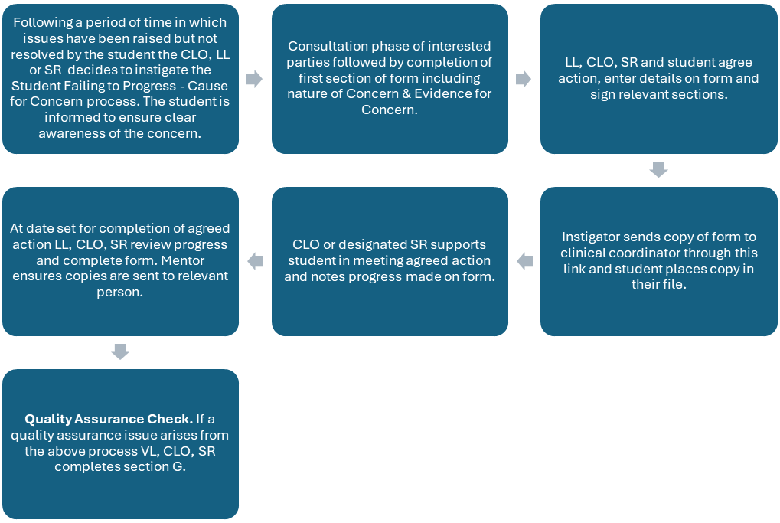

Useful documentation:
- Fitness to Practice
- Reporting accidents, incidents and concerns on placement
- Exceptional reporting of serious concerns/incidents – Process Map
- Process for managing a concern raised about a student on placement
- Placement notification and escalation process to address concerns about a student’s welfare

Student Failing to Progress - Cause for Concern Form

Name of Student
Name of Clinical Liaison Officer/Practice Educator
Name of Supervising Radiographer (if required)
Name of Link Lecturer
Name of other staff involved (if required)
Date:

A. Form initiated by |  | Role

Lack of ability to accurately perform practical skills
Lack of ability to demonstrate or apply theory and knowledge to practice
Lack of progress
Lack of professionalism
Professional misconduct
Other
B. Nature of Concern
(Please describe the nature of the concern(s)and mark the appropriate box(es)

Evidence for concern
(Please document the evidence for the concern)

C. Agreed action
(Please document agreed action using the table below)
Specific  What are your goals for this area? What have you identified as something you need to develop/learn/practice? What do you want to do? | Measurable  How are you going to track your goal? How do will you know when you have achieved it? | Attainable  Is this achievable? How do you know it is? Can you realistically complete this within a certain timeline? | Relevant  Why is this goal important? | Time-bound  How long should this take? When will you monitor progress?

Signature of Clinical Liaison Officer &/or Supervising Radiographer
 |  | Date
Signature of Link Lecturer
 |  | Date
D. I understand that if these targets are not effectively addressed, I may fail to meet the Standards for my clinical placement

Signature of student
 |  | Date
E. Monitoring of progress on agreed action |  |  | Dates

F. Conclusion of process
(if the process has not been resolved please complete section I and consult with the link lecturer to view next steps).

 | Date

G. Quality Assurance Check

 | Yes | No
1. Are there any broader issues that affect quality assurance?
2. Are there any issues related to safe practice
3. Has the matter been referred to an appropriate Board/Committee?

H. Please use this as confirmation that the cause for concern has been resolved or alternatively see section I below:

Signature of Student
Signature of CLO/PE
Signature of link lecturer
Date

I. Please sign and date the form if the cause for concern has not been resolved:

Signature of Student
Signature of CLO/PE
Signature of link lecturer
Date

**SHU Academics: Following completion of this form please upload to the Cause for Concern Tracker here.**

**All: A full copy of this form should be shared with all parties at each stage and retained until a resolution is made*

