




TECHNICIAN commitment Action Plan
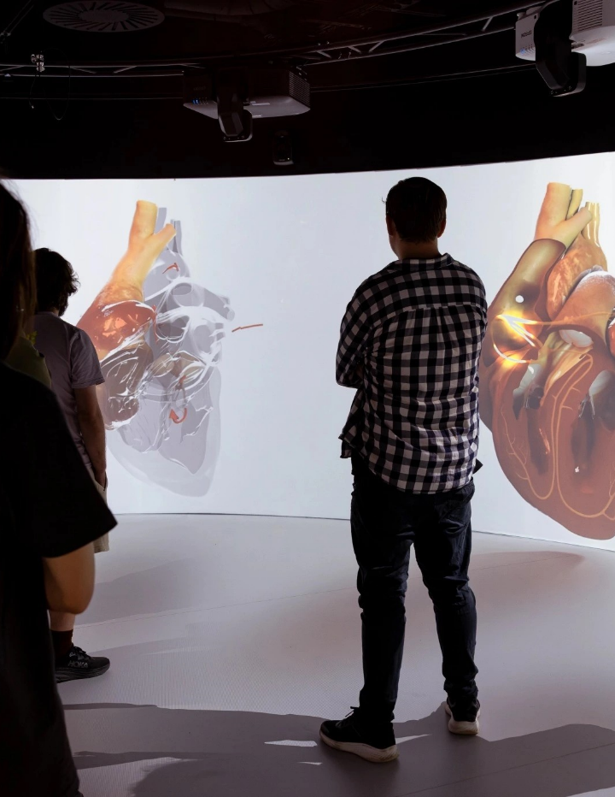

Prepared by Technicians Commitment Working Group (July 2026)
Appendix 3: SHU Technician Commitment Action Plan July 2026

Executive Summary
Sheffield Hallam University became a signatory of the Technician Commitment in 2019. Following staffing changes and organisational restructuring, the University’s renewal lapsed in 2022.
Despite this, the principles and priorities of the original action plan have continued to be embedded across the University’s activity. Work to promote the role of technicians, and to enhance their visibility, recognition, career development and sustainability, has remained active both internally and externally.
Sheffield Hallam University is now seeking to rejoin the Technician Commitment in 2026, building on this sustained progress, and reaffirming its commitment to supporting and developing its technical community.

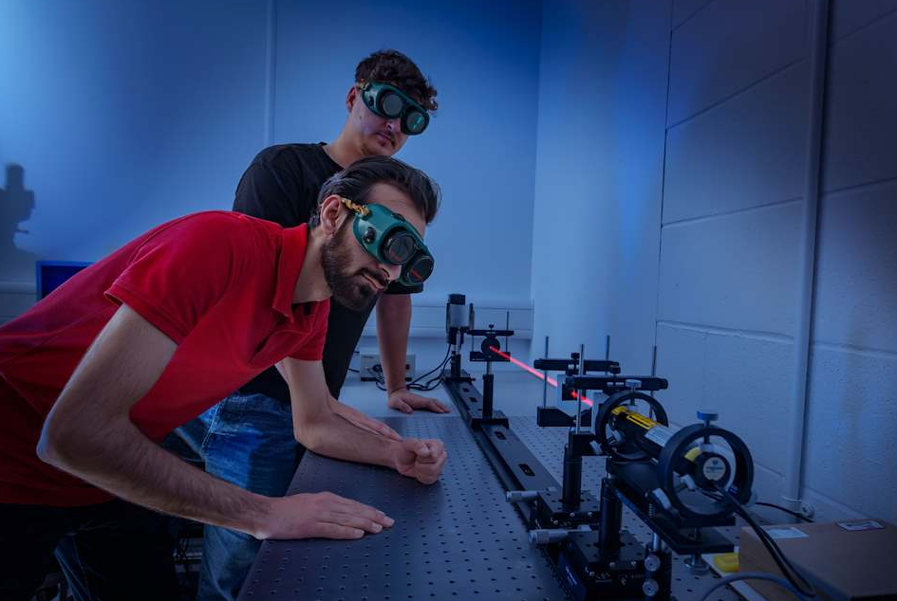

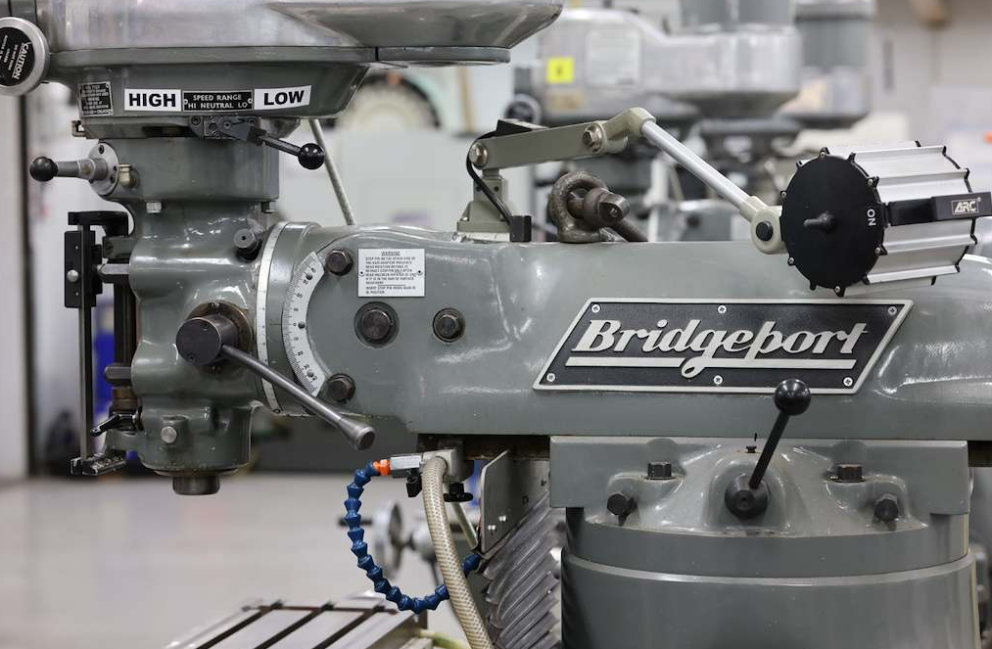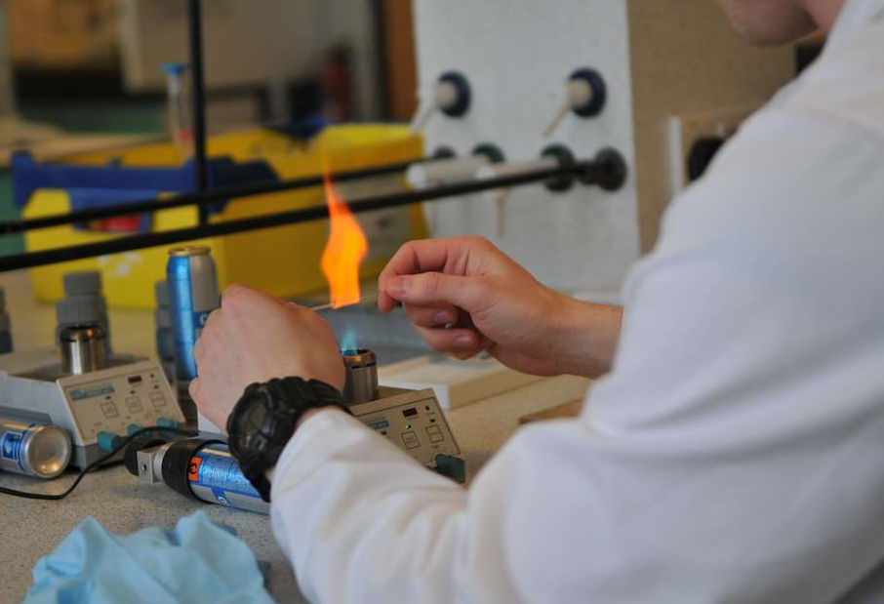

1. Objective
The primary objective of Sheffield Hallam University is to rejoin the Technician Commitment signatory list in 2026 by:
- Working collaboratively with internal communications, and where appropriate external communications, to increase the visibility of Technical Operations, Resources and Services (TORS)
- Strengthening recognition of TORS staff and their contribution to teaching, learning, research, and consultancy, including authorship on publications, inclusion in grant and consultancy costings, and celebration of achievements
- Increasing engagement with professional development reviews to support individual career development, while working with Senior Leaders to strengthen the strategic development of TORS and its workforce in line with University priorities
- Aligning TORS with the strategic direction of Sheffield Hallam University, with a focus on developing a sustainable technical workforce and exploring opportunities for service commercialisation to support financial sustainability

2. Relaunch strategy & progress
The relaunch strategy adopts a multi-channel approach, including:
- Re-establishing communication with the Technician Commitment
Contact has been successfully re-established, and documentation has been shared outlining the requirements and process for renewal and self-assessment
- Re-establishing the Technician Commitment working group
A new lead, Jan Timms, Head of Technical Operations in Clinical Practice and Wellbeing, has been appointed to reform the Technician Commitment working group. The group combines previous members with new representatives and consists of ten individuals. Eight members are from Technical Operations, Resources and Services (TORS), representing roles across grades 4 to 8, from Assistant Technician through to senior leadership
The group also includes a Senior Human Resources and Organisational Development (HROD) Advisor in Organisational Development and a Senior Administrator from the Vice-Chancellor’s Office, ensuring cross-University representation.
Updated terms of reference have been agreed, and membership details are published on the TORS SharePoint site. Subject to successful reapproval, the group will meet quarterly to maintain the action plan, monitor progress, and collaborate on priority projects and communications activity.

Review of previous documentation and action plan:
The previous self-evaluation form and action plan tracker have been reviewed and updated to reflect progress up to December 2025. Actions that are now embedded as business as usual have been marked as complete.
Actions that are in progress but not yet fully embedded have been retained on the tracker and assigned a RAG rating of green or amber. Actions that remain achievable but require further development have been reviewed and rated as amber or red.
Where actions are no longer achievable within the next 12 to 18 months, due to workforce capacity or changes in strategic direction, they have been either revised or marked as not feasible and rated red.
This updated tracker has informed the development of a revised Technician Commitment action plan to support the resubmission.

Prepare documentation:
The Technician Commitment Renewal Self-assessment has been completed in collaboration with the working group, with supporting appendices developed to provide additional evidence and context.
The appendices include:
- Appendix 1: Staff training (anonymised, in progress) – example of a revised training record
- Appendix 2: MI Talent Commission report recommendations: Sheffield Hallam University response – outlining the University’s response to the 16 recommendations set out in Section 3, ‘Our vision, principles, and recommendations’
- Appendix 3: Sheffield Hallam University Technician Commitment Action Plan, July 2026
- Appendix 4: 01.06.2026 SHU Technician Commitment Action Tracker (Re-submission)
Request final review and sign-off
Request final review and approval from the Director of TORS, prior to submission to the Vice-Chancellor for final sign-off.
Publish action plan
Ensure a copy of the Sheffield Hallam University Technician Commitment Action Plan is made available on the Sheffield Hallam University website.
Submission of self-assessment documentation
Submit the required self-assessment documentation to the Technician Commitment in July 2026 for consideration.
Celebrate success
Prepare and publish an internal news article highlighting Sheffield Hallam University’s successful recognition as signatories to the Technician Commitment.

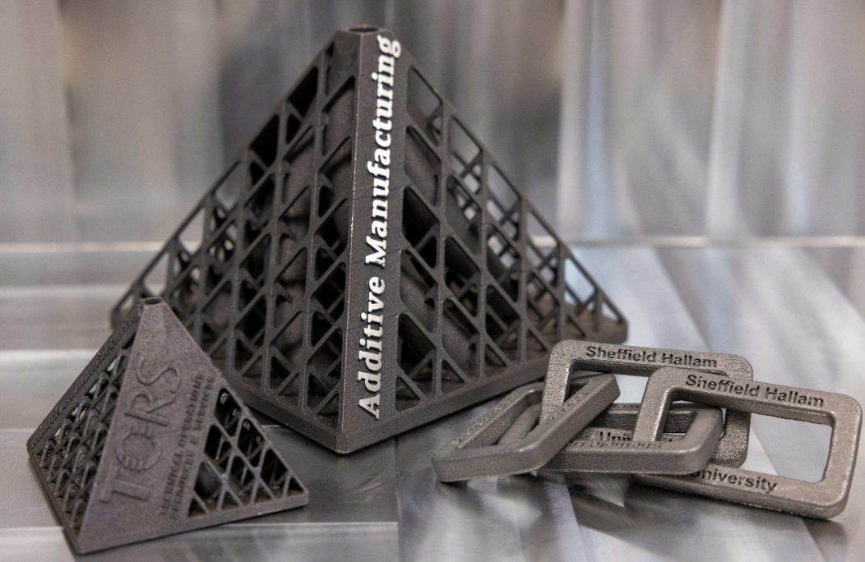

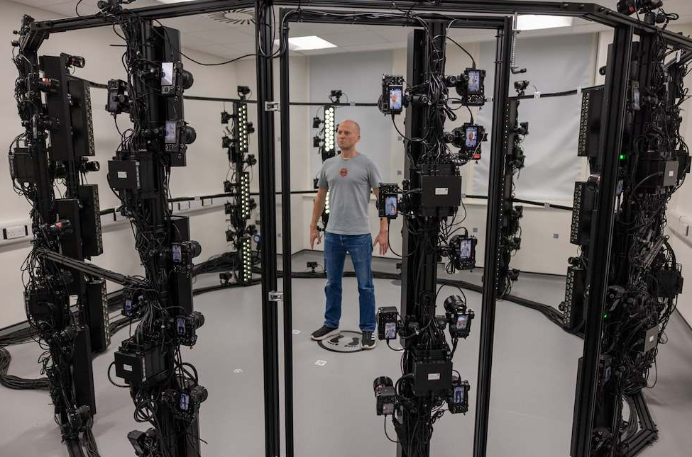

3. Actions & results to date
The 2023 action plan has been used as a baseline to develop a revised action tracker in support of the Technician Commitment resubmission.
Actions have been reviewed, updated and re-categorised to reflect current progress, alignment with the University’s strategic priorities, and future delivery focus. This process has enabled a clear assessment of what has been achieved, what is in progress, and where further development is required.
A summary of key actions and progress to date is provided in Table 1 below.

Objective | Action | Deadline | Visibility | Recognition | Career Development | Sustainability | Recent Evidence
- Showcase the diversity of TORS across Sheffield Hallam University, raising awareness of the breadth and depth of technical expertise. | Engage internal communications channels and publish quarterly good news stories. | On-going from May 2026 |  |  |  |  | See evidence 1
 | Director of TORS to publish fortnightly celebrations of TORS output via Internal engagement site | On-going from June 2026 |  |  |  |  | See evidence 2
 | Update web and SharePoint content to align with the new structure, embedding examples of work. | Ongoing. New ‘Welcome to TORS’ staff SharePoint page to launch in September 2026. External website updates in progress but delayed due to wider University website review. |  |  |  |  | See evidence 3  See evidence 4
 | Work with the TC working group to develop titles of internal TORS awards and a suitable nomination and assessment process. Aim to link this into a celebration event / SHU TORS conference event. | Following attendance of Manchester Metropolitan Universities Technicians Conference in July 2026. Work to deliver a smaller scale event in the Summer of 2027 for SHU TORS. Aim to scale up the production in following years. |  |  |  |  | None to date. Work is due to start in September 2026.
- Establish costing mechanisms and actively promote direct costing of TORS support on research grants. | Work with University Finance to establish costings for each grade of technical support using a full economic costing (FEC) approach. | December 2027 |  |  |  |  | Associate Director of TORS is working with finance to cost TORS delivery across teaching and learning, and research.
 | Following approval by university governance, promote these across academic Colleges and research centres to ensure inclusion in grant applications. | March 2028
- Ensure that the strength and depth of TORS technical expertise is reflected in promotional materials, including prospectuses. | A range of actions are contributing to this (see actions 1 and 2). Development of both a physical and digital TORS handbook is underway, detailing TORS spaces, areas of expertise and how to access them. | December 26 for physical handbook |  |  |  |  | See evidence 4 re interactive digital maps.  See evidence 5.
- Promote established institutional reward and recognition schemes to Technical Managers and academic partners to recognise individual and team excellence within TORS. | Sheffield Hallam previously delivered annual Inspirational Awards for teaching and support. TORS staff have received several nominations and awards. As these have not run for the past two years, managers are encouraged to consider external professional and industry awards whilst further investigation is made into establishing SHU internal awards. | On-going from June 26 |  |  |  |  | SHU have had 3 technicians nominated for awards as the Sim Tech (https://simtechawards.my.canva.site/)
- Communicate and encourage professional registration amongst TORS staff. | Encourage staff to pursue Advance HE Associate Fellowship and/or recognition with relevant professional bodies. | On-going from June 26 |  |  |  |  | Two TORS technicians working towards CASES (Sport Scientist) membership in 2026/27.
- Contribute towards the development of external networks and frameworks regionally and nationally. | Actively engage with other institutions and external bodies, including the Science Council, Clinical Skills Network and Jisc UK XR community for further and higher education, to contribute to the development of professional standards and frameworks. | On-going from June 26 |  |  |  |  | Technical Manager, Clinical Simulation is Vice-Chair of the Yorkshire and Humber Clinical Skills Network. Senior Technical Specialist (XR) invited as a panel member at the BodySwaps conference (Bristol, 2025). Team recognised in NHS England Technology-Enhanced Learning (TEL) newsletter.
- Ensure technical staff are formally recognised within research outputs where their contribution is significant and merits acknowledgement. | Actively encourage academic colleagues to include technical staff as named authors or within acknowledgments on papers/journal articles and conference material. | On-going from June 26 |  |  |  |  | TORS have presented at a regional Clinical Skills Conference and an NHS workforce development meeting on the design of a student healthcare uniform hijab. See also evidence 6.
- Proactively engage in PDRs and Mid-Year Reviews. | Achieve 100% participation in the PDR process, with a stronger focus on performance, wellbeing, development opportunities, and future goals. Proactively encourage staff to gain professional qualifications to enhance technical skills and experience. | Ongoing from June 26 |  |  |  |  | TORS achieved the second highest completion rate for the PDR process, behind Human Resources and Organisational Development, based on Sheffield Hallam University’s formal tracking. 100% completion is not achievable due to long-term sickness absence.  Attendance at key conference events was encouraged, including IST.
- Develop clearly defined career pathways for all technical staff. | Use structural and operational changes arising from change processes to create clearly defined career pathways within Technical Services and ensure parity among these. | Ongoing from June 26 |  |  |  |  | TORS has undergone several changes over the past six years, using each as an opportunity to review workforce needs. This has led to the formation of new work clusters to consolidate research activities and the creation of two new roles: Senior Technical Specialist (Grade 7) and Technical Supervisor (Grade 6). A further period of change is anticipated.

4. Evidence
Evidence 1
Example of a published article highlighting Dr Celine Souilhol, Senior Technical Specialist in cell biology. Plans are in place to extend this approach by featuring additional TORS staff and introducing quarterly staff spotlights and celebration of achievements.

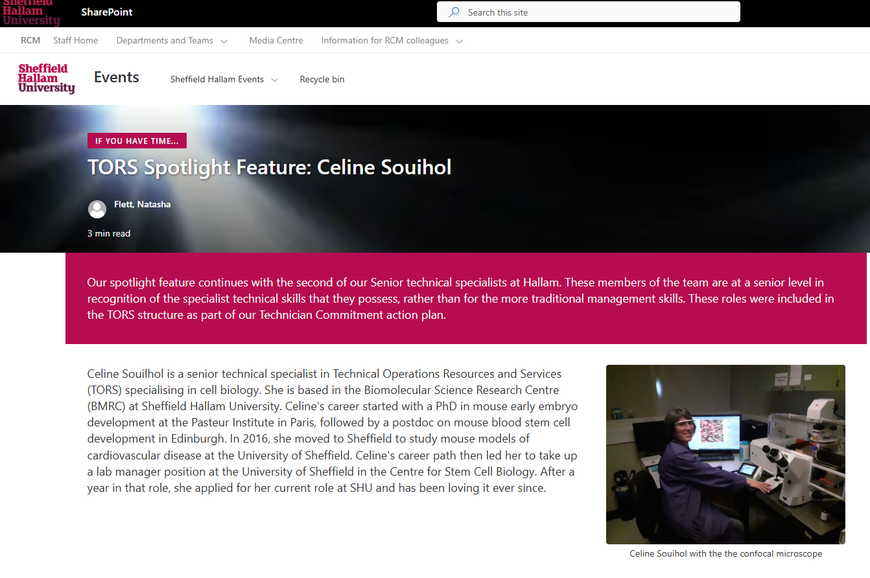

TORS was featured in Sheffield Hallam University’s internal newsfeed as part of coverage of the South Yorkshire Institute of Technology launch, including quotes from Daniel Ashton, Senior Technical Specialist and member of the TC working group, and Dr Richard Cutting, Director of TORS.

“Bringing this to life has been a phenomenal achievement, powered by TORS' vision and expertise. Their meticulous behind-the-scenes work has ensured immersive learning is seamless for staff and students.”
Dan Ashton, Senior Technical Specialist
“These two new innovative facilities are significant additions to the University’s technical and specialist equipment base which TORS manage and support. They complement and extend our already significant capability to deliver simulated practices, and I am certain that they will provide exciting opportunities for applied learning, research, and collaboration both at Hallam and beyond.”
Dr Richard Cutting, Director of TORS


Evidence 2
Published an initial ‘good news’ story showcasing collaboration with an external content creator and the Clinical Simulation team, resulting in a video that has achieved over 600,000 online views.
https://www.youtube.com/watch?v=-v2ZhcJcnBE
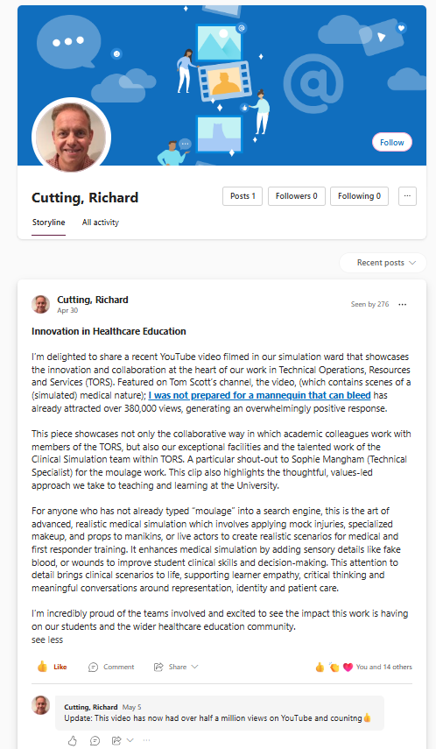

Evidence 3
In January 2026, the TORS SharePoint landing page was refreshed to improve accuracy and accessibility for all Sheffield Hallam University staff. The review included the removal of outdated contact information and verification that all hyperlinks were current and functioning correctly.

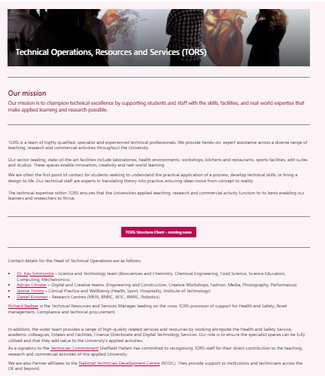

Evidence 4
Image from June 26 of the development of new TORS SharePoint Site. This work is being led by Jan Timms and Kerry Porter from the VC Office and Technician Commitment working group. Using Kerry as a critical friend based outside of TORS, we are working together to establish what information Sheffield Hallam’s staff may want to find regarding TORS services at a glance.
The front welcome page. Links to our external facing interactive maps:
City Campus: https://www.thinglink.com/scene/2069825964732318182
Collegiate Campus: https://www.thinglink.com/scene/2069838271269044710
Olympic Legacy Park Plus: https://www.thinglink.com/scene/2126309602759803366

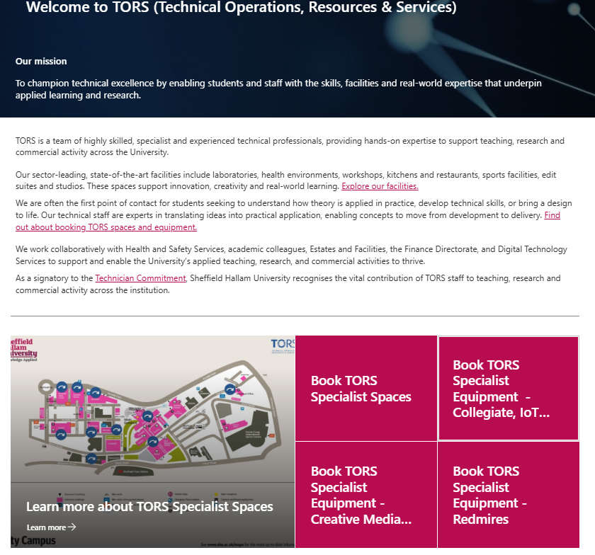

Each image links to a defined team within TORS where further information is available. The aim is to publish this on the All Staff SharePoint in September 2026, once all teams have had the opportunity to review their content.

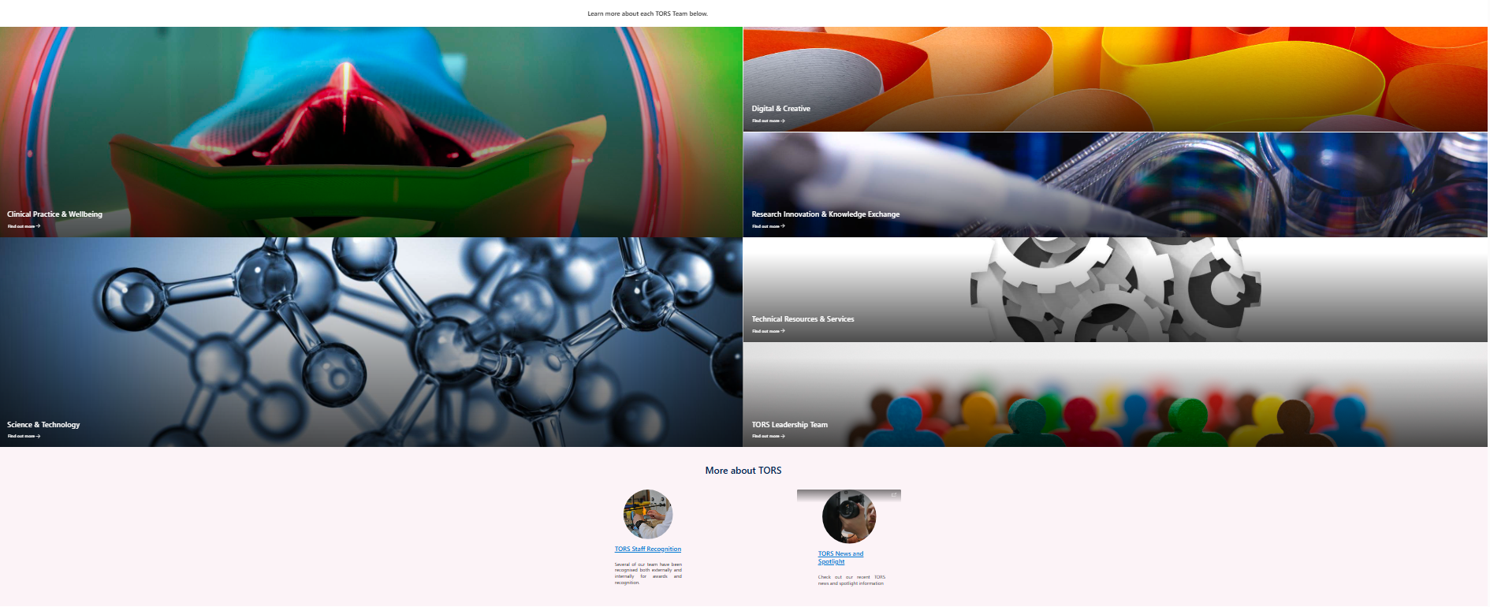
Evidence 5
The links below provide tours of some of Sheffield Hallam’s specialist facilities, as featured on the online prospectus.
Physiotherapy / healthcare: https://www.youtube.com/watch?v=ryIrdP8YiHs&t=136s
Engineering: https://www.youtube.com/watch?v=IDo7KI3_xTE&t=3s
Media and Arts: https://www.youtube.com/watch?v=1iOLg2NZTes&t=10s

Evidence 6
Recent papers / presentations with TORS staff contributions:
- Celine Souilhol: Senior Technical Specialist.
SABAHI-KAVIANI, Rahman, GOGOLOU, Antigoni, SOUILHOL, Celine, VAN DER KROEG, Mark, KUSHNER, Steven A, DE VRIJ, Femke MS, TSAKIRIDIS, Anestis and LUTTGE, Regina (2026). Nervous System-on-Chip: Innovative Microfluidic Platform to Compartmentalize hiPSC-Derived Neural Networks. Micromachines, 17 (2): 199. [Article]
TARDAJOS AYLLON, Blanca, BOWDEN, Neil, SOUILHOL, Celine, DARWISH, Hazem, TIAN, Siyu, DUCKWORTH, Carrie, PRITCHARD, David Mark, XU, Suowen, SAYERS, Jon, FRANCIS, Sheila, SERBANOVIC-CANIC, Jovana, OAKLEY, Fiona and EVANS, Paul Charles (2025). Endothelial c-REL orchestrates atherosclerosis at regions of disturbed flow through crosstalk with TXNIP-p38 and non-canonical NF-κB pathways. Cardiovascular Research, 121 (5), 748-759. [Article]
- Anthony Bell: Senior Technician
BELL, Anthony (2025). Crystal structures of leucites – past, present, and future? Crystallography Reviews, 1-39. [Article]
BELL, Anthony (2025). Project Boron – quantitative analyses for Boron by XRF. In: Society of Glass Technology Conference, Cambridge, UK, 01-03 Sep 2025. Society of Glass Technology. (Unpublished) [Conference or Workshop Item]
BELL, Anthony (2024). Crystal structures and X-ray powder diffraction data for AAlGe2O6 synthetic leucite analogs (A = K, Rb, Cs). Powder Diffraction. [Article]
- Anthony Bell: Senior Technician & Francis Sweeny: Senior Technical Specialist
BELL, Anthony and SWEENEY, Francis (2025). Tetragonal–cubic phase transition in RbGaSi 2 O 6 synthetic leucite analogue. Powder Diffraction, 40 (4), 294-303. [Article]
LOVE, Katrina, GEORGE, Jamie, BELL, Anthony, SWEENEY, Francis, CUTFORTH, Derek, LONERGAN, Charmaine, DIXON, Derek, KRUGER, Albert and BINGHAM, Paul (2023). The effects of phosphorus pentoxide additions on the thermal, rheological, and structural properties of sodium borosilicate glass. Journal of Non-Crystalline Solids, 600: 121999. [Article]
- Janine Timms: Head of Technical Operations: Clinical Practice and Wellbeing
REHMAN, Naheeda, TIMMS, Janine and MASTERSON-NG, Shirley (2026). How a university created a uniform hijab for Muslim nursing students. Nursing Times, 122 (3), 1-3. [Article]

5. Next steps
Continue to support and progress the role of the Technician both internally and externally. The immediate next steps are:
• Submit the Technician Commitment renewal self-assessment and action plan guidance (July 2026)
• Achieve signatory status for the Technician Commitment and promote this across Sheffield Hallam University
• Schedule quarterly Technician Commitment workgroup meetings to review the action plan tracker
• Continue to champion positive news stories from TORS through internal communications channels
• Explore opportunities to develop a technician conference or celebration of work, including potential internal awards and a nomination process



