Supporting students with their engagement is very important to us. You will be asked to record your attendance at taught activity through Study Goal.
Study Goal is a web-based app that allows students at Sheffield Hallam to register their attendance. In Study Goal, you can:
- Check-in to your taught activity
- View your recent check-in history
- View your overall recent engagement metrics
- View your recent module engagement metrics

How to record your attendance using Study Goal
- Access the following website: https://student.la.jisc.ac.uk.
- Enter your student email address.
- Enter your regular SHU username and password.
- Your lecturer will provide a 6-digit code at the start of your taught activity.
- Enter this code into the box and click ‘Check-in’.
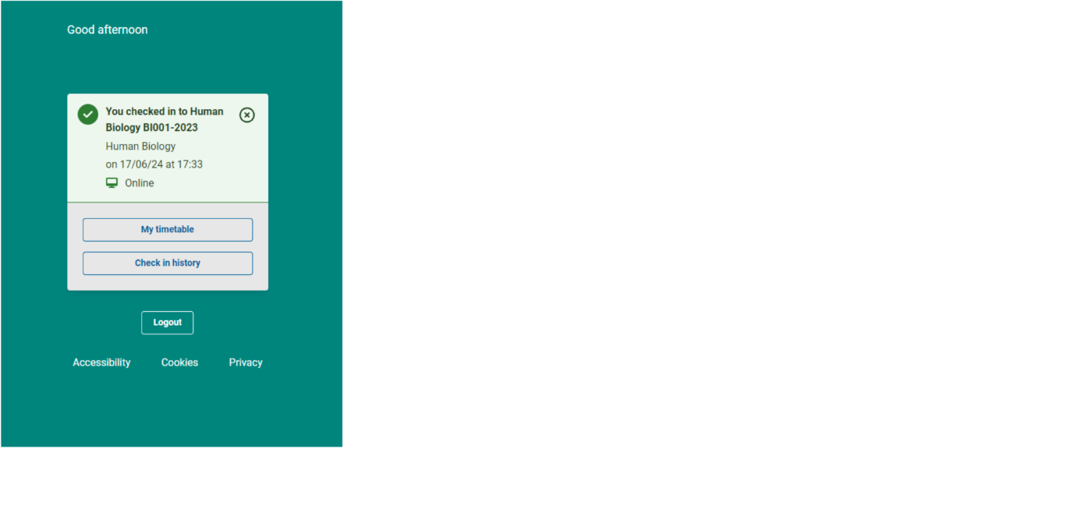
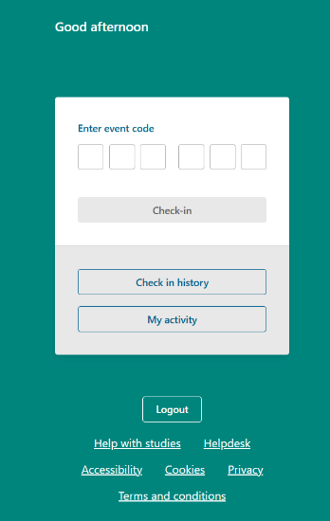

- Click on My timetable to view your upcoming events.
- Click on Check in history to see your previous attendance status at events.

How to interpret your engagement metrics
You can see your overall recent engagement summary metrics and your module summary metrics.
- Once logged in, click on My activity.
- Your Engagement summary displays your recent engagement across all your modules.
  - Attendance: this is your attendance for the past 14 days across recent events.
  - Blackboard: this is your Blackboard use for the past 14 days across current modules.
  - Submissions: this is your Blackboard submissions for the past 28 days across current modules.
- Module summary displays your recent module engagement.
  - Please note if there is no data displayed here, there are no active modules and your recent engagement will show the last recorded percentages when your modules were active.
  - Click on the module name to display the ‘Module engagement summary metric’ page.
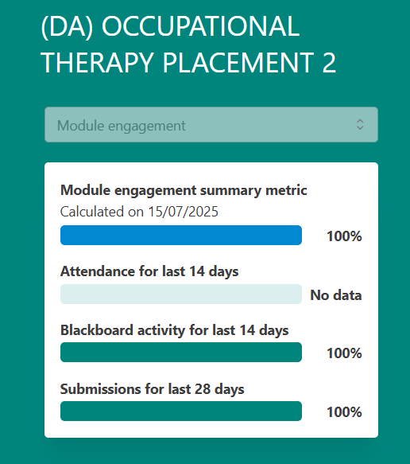
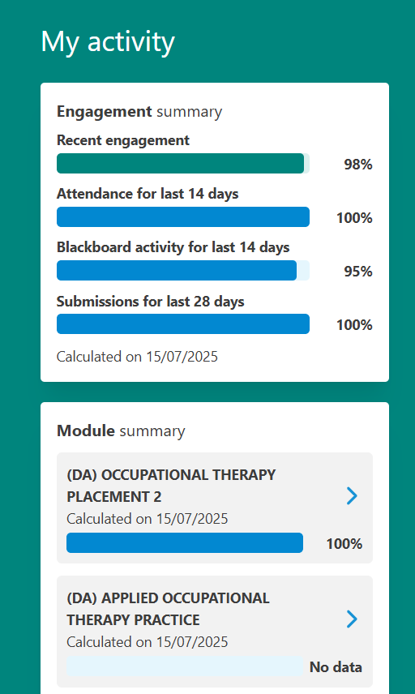

More information and help

The information button in lower right corner provides definitions. Click on the button to display these definitions.
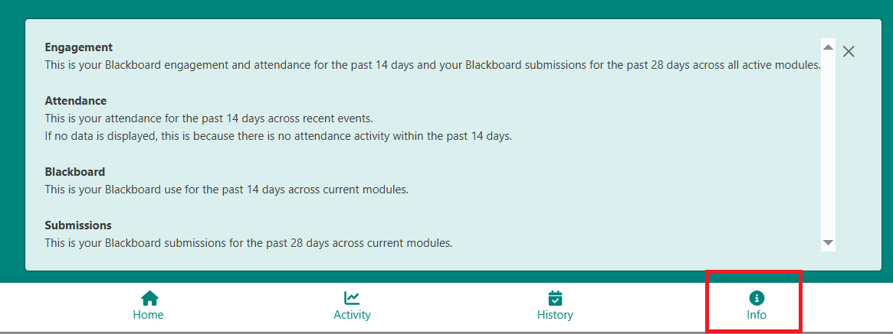

If you have a technical issue with Study Goal, please contact IT Help, or if you are having difficulties connecting to the wi-fi whilst on campus, please refer to the connecting to the SHU wireless network guidance.
If your attendance is marked incorrectly for a session, such as for a session you were not required to attend, please contact your module tutor.

