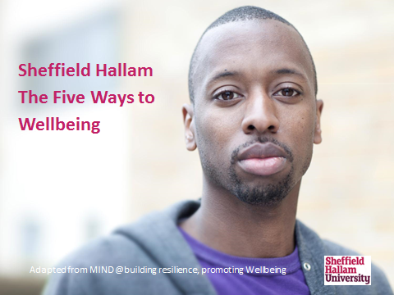
This workbook belongs to:
Name:
Course:

About this workshop
This workshop has been developed with your wellbeing in mind.

Stress and Low mood are unfortunately increasing features of 21st century life and we are hoping that this workshop helps you develop skills for managing this and developing resilience.

Students will gain an understanding of what wellbeing is. You will explore how to use wellbeing ideas to help manage stress and low mood.

At the end of this workshop and through further reading participants will be able to:
• Discuss what we mean by wellbeing.
• Develop an understanding of low mood and stress.
• Introduce and develop awareness of the five ways to wellbeing
• Understand how the five ways can develop and support psychological wellbeing.
• Identify issues for self-care and set goals for future self-management using your workbook and self-help resources).
The workshop will enable you to reflect and evaluate how the five ways to wellbeing can support you in your studies and overall wellbeing.

How to use this workbook
This is your workbook. You will use it to record your learning throughout the workshop and beyond. It will act as a resource for you to refer to after the workshop and as a means by which you can chart your development.

Outline of the course

What am I hoping to learn on this:

2 hours | Welcome and Introductions: Expectations of the course and how to use the workbook
 | Activity 1: Discuss what we mean by wellbeing
 | Theory session: Understanding Wellbeing
 | Theory session: Understanding Stress & Low Mood
 | Activity 2: How does stress affect you? What situations make you feel stressed?
 | Theory session: Introducing the Five ways to wellbeing
 | Activity 3: Group exercise - Five ways to wellbeing mapping
 | Activity: Goal setting
 | Useful resources support services
 | Questions and evaluation

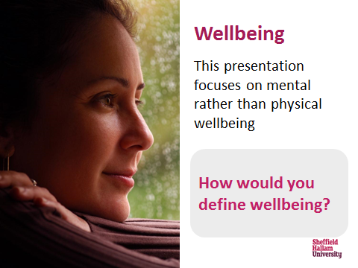

Activity 1 - defining wellbeing

How would you define wellbeing? Come up with one or two ideas

Write them down or if you’re in a group, have chat about it. group

Notes

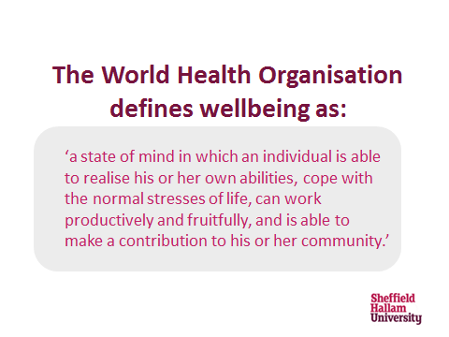

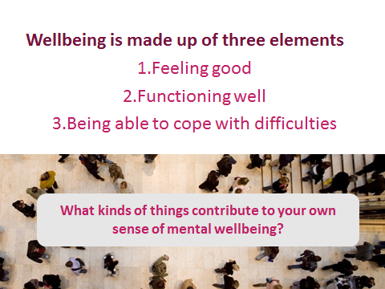

What kind of things contribute to your own sense of psychological wellbeing?

Activity 2 - Stress and its effects

Stress can be defined:
"A feeling of being under too much mental or emotional pressure. Stress increases hormones in your body to help you deal with pressures or threats. This is sometimes called a "fight or flight" response. Your stress hormone levels usually return to normal once the pressure or threat has passed. A small amount of stress can be useful. It can motivate you to take action. However, if you're constantly under stress, stress hormones will stay in your body. This will lead to symptoms of stress."

How does stress affect your:

- Feelings
- Thoughts
- Physiological (Bodily) symptoms
- Behaviour
Recognising stress - in your workbook, jot down one or two of the above that indicate you are stressed

Notes:

Activity Three – What makes you stressed?
Notes:

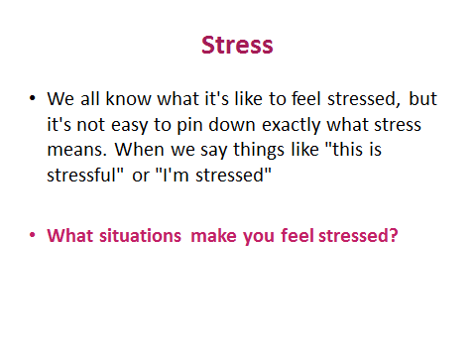

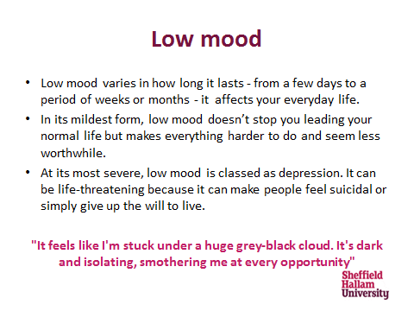
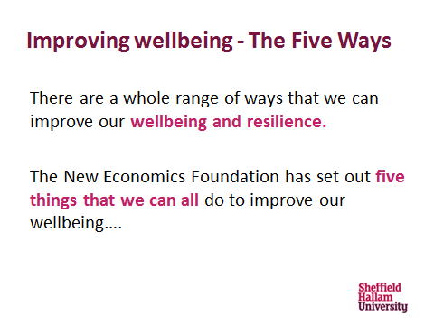

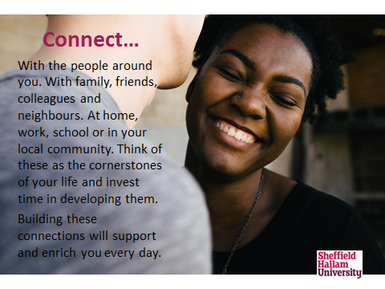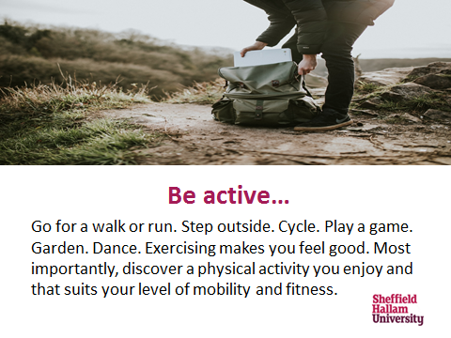

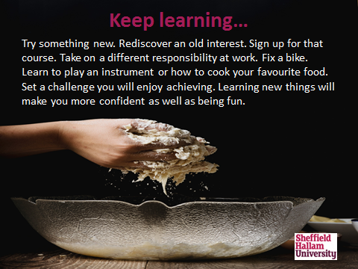
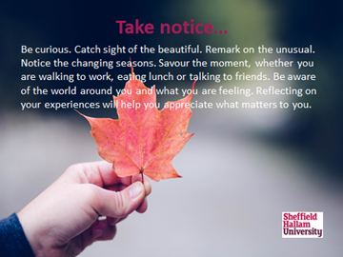

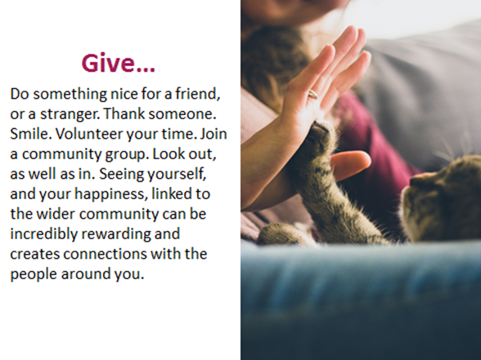
Take notice:

Be active:

Give:

Activity 4 - Five ways to wellbeing mapping
Go back to your page 5. See if your ideas fit into the five ways to wellbeing:
Connect:

Keep learning:

Insert pledge here

Activity 5 - Making a Five Ways Pledge

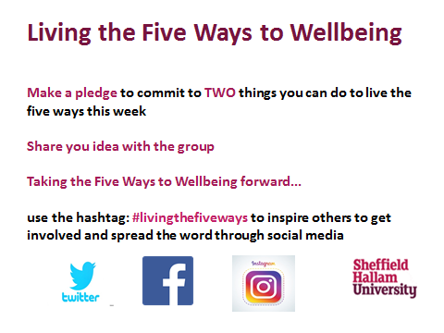

My action plan for the next 3 months

Collate all the development needs you have identified during this workshop and turn them into a SMART* action plan below
Five Ways Goal | Timeframe | Steps to achieving objective | who can support me | Date completed | Reward

*SMART stands for Specific, Measurable, Achievable, Relevant and Time – bound. It’s a tool to plan goals in a way that makes it more likely that you’ll stick to them.

Resources and References: These resources provide a good overview of the ongoing changes to promote better wellbeing.
Student Wellbeing provides a range of self-help resources online and at our City Campus reception. If you prefer to work with hard copy and are not able to print the resources off, copies of many of the online materials, as well as a small collection of books, are available on loan from Student Wellbeing Reception.
Big White Wall https://www.bigwhitewall.com/
Big White Wall is a safe online community of people who are anxious, down or not coping, who support and help each other by sharing what’s troubling them, guided by trained professionals. It can help you start to take control and get the support you need to feel better. Available 24/7, Big White Wall's professionally trained Wall Guides ensure the safety and anonymity of all members, so you can express yourself freely and openly. Join using your SHU email address. This is purely to validate your status as a Hallam student - the University does not receive data on who has registered.
Emergency/Contact numbers/Web resources
Student Wellbeing phone no 0114 2252136 and email address student.wellbeing@shu.ac.uk
NIGHTLINE 0114 2228787 Text: 07786 207 208 Email: nightline@sheffield.ac.uk Instant Messenger
Nightline is a student-run, confidential and anonymous non advisory listening and information service. We have been providing support to students of University of Sheffield for over 40 years and expanded in to Sheffield Hallam University around 5 years ago.
SAMARITANS 0114 276 7277 National telephone: 116 123 (this number is free to call) jo@samaritans.org
NHS Sheffield health and Social care NHS Trust 01142716310
SHEFFIELD MIND 0114 258 4489 110 Sharrow Lane, Sheffield S11 8AL https://www.mind.org.uk/
Mental Health Foundation https://www.mentalhealth.org.uk/
Rethink 0121 522 7007

