

**How to Develop a Healthy Routine**

**and Get a Good Night’s Sleep**

 **Free Online Session**



**Wednesday 5th May**

**3-4:30pm**

**Learn some tips to help you:**

* 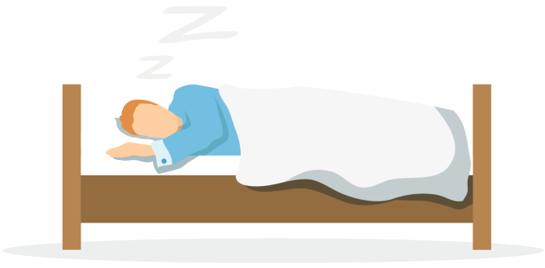Keep a good routine
* Get a good night’s sleep
* Develop helpful coping strategies

Call now to book a place 0114 2264380

or [complete an online referral form](https://gateway.mayden.co.uk/referral-v2/103f989e-50b6-4523-836d-2d2ab2aa0506).