How to Manage Excessive Worry

Free Online Session
Wednesday 28th April
3-4:30pm
Learn some tips to help you:
- Recognise different types of worry
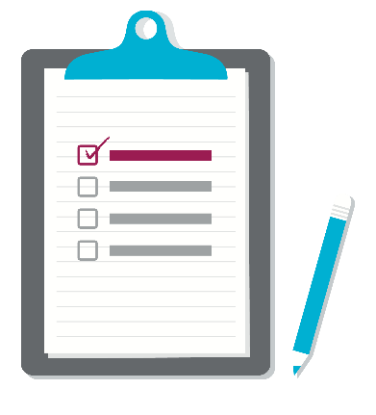
- Manage worry and let go of worries

Call now to book a place 0114 2264380
or complete an online referral form.

