

Journey Snapshot

We'd like you to think about your journey to university to help future students who are thinking about their next steps. Things to consider include; what influenced you, what you enjoyed, how you made your choices and how your experiences during university shaped you as a person. This snapshot is almost like a case study - we want you to be honest about what you found difficult but also how your experiences have helped you to develop and grow as a person.

Please complete the template overleaf, and bear in mind that we'll be turning this into a poster. Overall, your text needs to be no longer than 1 side of A4, so please keep it brief. We've added specific questions but you could also consider the following in your answers:

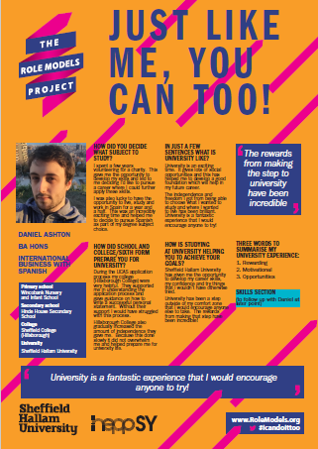

* How did you make your course choice and your university choice, did you come straight to university or did you take a gap year?
* What is your favourite part of studying at Sheffield Hallam (e.g. friends, subject studied, extra-curricular activities etc.)
* What do you plan to do in the future?
* What kind of opportunities did you take advantage of whilst at university, college and school?

For this poster to be relatable to students, alongside the information you provide overleaf, we will also need to include at least your first name, a photo of you, the course you're studying, you're last attended sixth form or college and your last attended secondary school.

See the one of our current Role Models posters above to give you an idea about what yours will look like



Page 1 of 3

**Please complete the information below for our records of who is involved in the project:**

|  |  |  |
| --- | --- | --- |
| **Are you happy for us to share this information alongside your Journey Snapshot? (delete as appropriate)** | | |
| **First name** |  | Required* |
| **Last name** |  | Yes  No |
| **Course studied at SHU** |  | Required* |
| **Last attended sixth form or college** |  | Required* |
| **Last attended secondary school** |  | Required* |
| **Last attended primary school** |  | Yes  No |
| **The following information is for our records only and will not be used in display materials** | | |
| **Email address** |  | |
| **Telephone number** |  | |
| **Home postcode** |  | |
| **Date of birth** |  | |
| **Are you a current student ambassador at SHU?** | Yes  No | |

**\*** This is required to give the posters a bigger impact to current students and to make you more relatable as a Role Model.

**Privacy Notice**

The privacy of students is important to us and the University takes care to safeguard it. Your information will be stored securely and used in compliance with data protection law. If you chose to get involved with any stage of the project we will share your data with the collaborative partners working on the programme of activity (HeppSY or South Yorkshire Futures etc.) where appropriate. The information you provide will be published on our website and in communication materials circulated within schools and colleges (submissions may be edited for clarity and size). After 3 years, your information will not be used for new publications, but may still be in circulation after this time. We may also contact you from time to time for your feedback and development of the project. Please note you are able to change your mind about being involved in the project at any time, however, published documents may be difficult to recall. If at any point you have questions about how the information you share with us will be used or stored, please get in touch via email ([WPOteam@shu.ac.uk](mailto:WPOteam@shu.ac.uk)) or see our website: <https://www.shu.ac.uk/outreach-data>



Page 2 of 3

|  |  |
| --- | --- |
| It's always nice to put a face to a name and story, please insert a **picture** of you here to be shared with your statement (it doesn't have to be formal, just good quality and appropriate to share e.g. no night out pictures) |  |
| **How did you decide what subject to study at university?**  (no more than 2-3 sentences) |  |
| **How did school and college/sixth form prepare you for university?**  (no more than 2-3 sentences) |  |
| **In a few sentences, tell us what university is like?**  (no more than 2-3 sentences) |  |
| **How is studying at university (and Sheffield Hallam University) helping you to achieve your goals?**  (no more than 2-3 sentence) |  |
| **What 3 words could you use to summarise your experience at university?** |  |
| **What 3 skills have you really used at university and how have you developed these?** |  |



Page 3 of 3