Intensity Modulated Radiotherapy (IMRT)
Suggested clinical activities
You are on a clinical placement where they use IMRT to treat certain cancer types / groups of patients. The following collection of activities is considered useful in enabling you to further enhance your knowledge of this advanced method of treatment and understand how it is applied in a clinical setting.
An introduction to IMRT
The ultimate aim of both conventional 3D conformal radiotherapy (3DCRT) and IMRT is to enhance the therapeutic ratio i.e. limit the dose to normal tissue as much as possible, and maximise the dose to the target.
Conventional 3D conformal radiotherapy (3DCRT) achieves this by conforming the 'shape and size' of the beam to that of the tumour/ target volume. Unfortunately, when this target volume has a complex, non-uniform shape and is near to or even wrapped around an organ at risk (OAR), it is difficult to conform the ‘dose’ to this shape, and as a result, the portion of the OAR immediately surrounding the target will inevitably receive a high dose.
Activity
With conventional 3DCRT, a possible solution to this problem is to use a series of sequential (one after the other) phases, which deliver the high dose to the primary site and a lower dose to areas close to OAR, or areas that may in fact only need a lower dose e.g. at risk of spread. There are disadvantages to phased treatments though.
List what you think these might be.

So how does IMRT allow us to overcome this problem?
IMRT varies the dose intensity across the beam. This enables us to tailor the dose distribution more precisely to the shape of the target.
The following diagram helps to illustrate this.
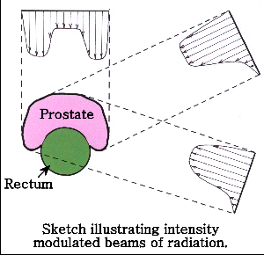
Note how the intensity across each beam varies and that for each beam there is less intensity in the path of the rectum. The required high dose to the prostate tissue is built up across the different beam angles. For example; note how the anterior beam delivers a low intensity of dose to the centre of the prostate. The high dose needed to this part of the prostate is delivered from the oblique/lateral beams.
Activity
Think about the cancer types/treatment sites that your department used IMRT for. Why do you think IMRT might be more beneficial for these patients than conventional 3DCRT?

How is the varied intensity across the beam achieved?

IMRT delivery methods
Simply put, the varied intensity across the beam is achieved using the MLCs, which move into different positions throughout the delivery of the beam, shielding some areas within the field more than others.
There are a number of different ways in which IMRT can be delivered:
- Conventional IMRT (fixed beam angles)
  - Step and shoot - Elekta
  - Dynamic – Varian

- Intensity Modulated Arc Therapy
  - Volumetric Arc Therapy (VMAT) – linac based - Elekta and Varian
  - Serial Tomotherapy (slice therapy) – linac based - NomoSTAT
  - Helical Tomotherapy (slice therapy) – Tomotherapy Hi-ART unit

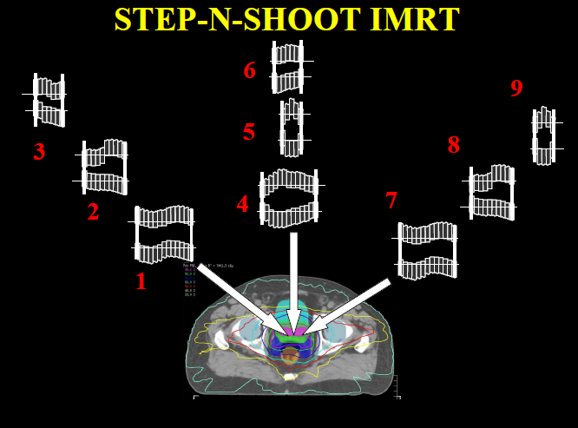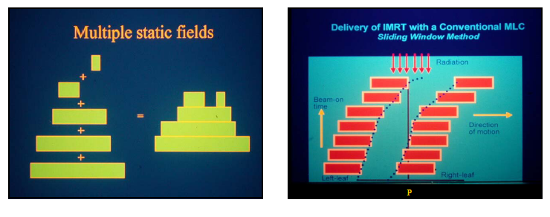
Step and shoot: Each beam angle consists of subfields which are delivered sequentially. The machine is only switched on for each sub field once the MLC’s are in the correct position. Once the MU’s have been delivered for that segment, the machine will switch off and the leaves will move to the next position.
Dynamic (sliding window): The MLC's move across the beam at different speeds to build up areas of low and high intensity. Radiation remains on as the leaves are moving. The radiation received by each point will be proportional to the number of MU delivered during the time in which one leaf passes that point and exposes it, to the time the next leaf moves across blocking the radiation beam.

Activity
What types of IMRT do you have within your department? What sites/cancer types are treated?

Intensity Modulated Arc Radiotherapy
There are no set beam angles. The intensity modulated beam is delivered as the gantry arcs around the patient. It is dynamically delivered.
With VMAT the whole volume is treated using an intensity modulated beam (moving MLCs) as it arcs around the patient. The gantry speed adds a further dynamic component that can be used to control the intensity of the beam as needed. Many treatment sites will only require the completion of one arc to deliver the intended dose. Some, more complex dose distributions may require the completion of two arcs.
With Tomotherapy, a thin, collimated fan beam delivers the treatment in intensity modulated ‘slices’ across the volume. Helical Tomotherapy is the most popular method seen in departments. A pneumatically driven binary multi leaf collimator modulates the intensity of this fan beam as it arcs around the patient. The slice width (5, 2.5 or 1cm), modulation factor (ratio of max leaf opening time to mean opening time) and pitch (influenced by the speed of the treatment couch), are further factors that can be adjusted for each individual patient, as a means of influencing the conformation of dose.
Activity
In summary, Helical Tomotherapy delivers a therapeutic dose of radiation in a similar way to which a diagnostic CT scan is acquired. So the following terms should be familiar to you. Describe your understanding of these:
- Fan beam
- Slice width
- Pitch

All treatment units will have an integrated imaging verification system. With Helical Tomotherapy, the integrated imaging modality is Megavoltage (MV) CT. Again, the fan beam is used to acquire this image. Please note; this is different to the cone beam CT imaging you may be familiar with on the linear accelerators.
Accuracy & Reproducibility
Activity
Why do you think it is of upmost importance to ensure IMRT treatment delivery is accurate and reproducible?

Activity
What methods of immobilisation and verification are used within your department to ensure an accurate IMRT treatment delivery? Consider the specific protocols used and the reasons for these e.g. do you perform daily IGRT. Also, highlight if any of these methods are different from what might be used for conventional 3DCRT. Do you think the accuracy could be further improved?
You may choose to use some evidence from within the literature to support your points.
Activity
Based on your observations on the IMRT treatment unit; what factors do you think might affect the accuracy and reproducibility of the daily set up? Have you observed any set up problems?

Treatment verification
Activity
Liaise with the radiographers on the IMRT treatment unit and arrange some time to review the verification images taken on set. Use these to revise your knowledge of anatomy. Also, try to arrange some time to learn more about the image review process. For example:
- What anatomical structures do the radiographers use to match/register the images?
- What action levels (tolerances) do they use?
Maybe if you can, have a go at looking at previously acquired images and analysing the images yourself. Do you reach the same error measurements?
IMRT planning
Conventional radiotherapy is what we call ‘forward planned’. Do you know what we mean by this?
Activity
Briefly outline the key stages of the planning process for conventional 3DCRT.

Simple step and shoot IMRT may also be forward planned. This may also be referred to as ‘field in field’ radiotherapy e.g. used for breast cancer RT.
However, most IMRT is ‘inverse planned’. The following outlines the key stages involved:
- Contouring
The target and OAR are delineated. Note; there may be more than one PTV contoured i.e. PTV1, PTV2 etc.... as each may require a different dose prescription; just like for conventional phased treatments where you would have a phase 1 volume and then a phase 2 volume and so on... The key difference with IMRT is that the different doses to these different PTVs can be delivered all at the same time, due to the creation of intensity modulated beams.
- Setting of pre-determined beam characteristics
For example; field placement (for fixed field IMRT); pitch and field width (for Tomotherapy).
- Setting of dose constraints and priorities
Minimum and maximum doses to be received by the PTV, OAR and other contoured structures.
- Optimisation
Optimisation algorithms process the information inputted and produce what is deems to be an optimal plan based on this criteria.
- Re-optimisation
The planner reviews the real time DVHs and adjusts these and/or the initial priorities set, to achieve the best outcome.
- End of optimisation
The planned intensity profiles are converted into ‘deliverable’ beam fluencies (MLC leaf sequences).
Activity
So what do you think the key differences are between forward planning and inverse planning?

Activity
In order to learn more about IMRT plans:
- Review a few treatment plans for different cancer types and identify the different doses applied/prescribed to the different PTVs delineated. Maybe try to compare these with the doses applied if they were treated conventionally. Look for a past case report you might have done for this or look conventional (typical) doses stated in a Radiotherapy textbook.
- Liaise with the planning department to see if you can spend some time observing an IMRT plan being formulated. Try to identify the different stages of the planning process as outlined above.

Article Review
Activity
Choose an article which investigates how IMRT might impact on outcomes for a given cancer/ treatment site. Try to select one that is focused on a cancer type treated with IMRT within your department.
Use the proforma below to write up a review and critique of this study.
What is the title of the article?

What was the aim of the study?

What method did they use to address this aim?

What were the key results of the study?

What were the author’s conclusions?

What is your assessment of the reliability and validity of these findings and conclusions?

What have you learnt from reading this article?

Additional learning
Activity
In addition to these activities, use the space below to document and reflect on any other activities you have been involved in or experiences you have had whilst on your placement(s). For example; have there been any pivotal incidences? Other self-directed reading you have done?

Summary of learning
Activity
Critically reflect on your learning following the completion of these IMRT related activities and your clinical placement(s) on the IMRT treatment unit(s). Include an action plan for further learning (as needed).

