Teaching Development Grants
Individual Grant Scheme

2 INSPIRE: Increasing Intrapreneurial Skills through Pedagogy, increases Innovation, Retention and Employability

Keywords:
intrapreneuralism, intrapreneur, innovation, employability, health sector education
Author Contact Details:
Name | Heidi Probst
Institutional role | Senior Lecturer/Research Fellow
Contact address | Robert Winston Building  11-15 Broomhall Road  Sheffield Hallam University  Collegiate Crescent Campus  Sheffield
Postcode | S10 2BP
Telephone | 0114 225 4359
Email | h.probst@shu.ac.uk

Abstract
Radiation Therapists represent a critical workforce element in the cancer care pathway. Providing safe radiotherapy to patients requires specialist knowledge and training. This study focused on oncology practitioners studying masters modules to augment career progression to Advanced or Consultant grades; although the study outcomes have relevance to the wider education of Health Care Practitioners (HCP). The Department of Health QIPP (Quality Innovation, Productivity and Prevention)¹ agenda requires practitioners to consider efficient and productive ways of providing safe care for patients- this agenda needs innovative, intrapreneurial practitioners across a range of professions to drive change. Research shows formal education increases the confidence of professionals moving into specialist roles^{2;3}; intrapreneurship is particularly relevant to these roles but the development of skills for enterprising activity is rarely attended to in NHS training. Intrapreneurship is an individual intention or drive to innovate within an organisation, developing and implementing novel solutions to organisational problems often in a ‘bottom-up’ way⁴.
The aim was to develop and implement an intrapreneurial pedagogy and evaluate the impact on the enhancement of intrapreneurial skills in health professionals.

Contents
Background and Rationale 3
Aims and Research Questions 4
Project Aim 4
Research Questions 4
Outcomes 4
Methodology and Work Plan 4
Trustworthiness and Authenticity 7
Data Analysis 7
Student (User) Engagement in the project 8
Deliverables 8
How can the deliverables be adopted more widely? 8
What is the potential benefit of widespread adoption of an IEP? 9
Theory into Practice 12
Managing expectations 12
Learning Tasks 14
Skill Development 16
Embedding 17
Embedding Strategy-People 17
Embedding Strategy- Processes 17
Embedding Strategy- Resources 20
Benefits 20
Students Engagement 20
Impact of the IEP on student learning 24
case Examples of The impact of learning on patient services 26
Quantitative evaluation of the impact of the iep on innovative behaviour 26
Issues and Debates 28
Teaching Issues 28
Learning Issues 28
Resources 29
Breast Cancer Radiotherapy (IEP) Module Blackboard Site Plan 29
Bibliography 29
Useful Links to inspire 32
Appendix 1 35
Managing Expectations- Excerpt from the module handbook 35
Developing Wider Intraprenurial Skills 35
How confident or able are you at... 36
Appendix 2 38

Background and Rationale

Radiation Therapists represent a critical workforce element in the cancer care pathway. Providing safe radiotherapy to patients with a range of cancer diagnoses requires specialist knowledge and training currently provided through under-graduate degree training. To enhance these Health Care Practitioners (HCPs) capabilities within the workplace various masters programmes exist to contribute to continuing professional development and to augment career progression. In 2007 the UK National Radiotherapy Advisory Group (NRAG) report to ministers identified that in order to meet the government objective set out in the NHS Cancer plan of providing services among the best in Europe a dramatic revision of workforce provision needed to be considered; recommending increased use of the advanced and consultant grades⁵.

Where these grades have been employed in other disciplines (such as nursing) there has been demonstrated efficiency, reduced waiting times, and a more patient focused service⁵. Development of professionals into advanced roles can only happen with concurrent knowledge development². Research shows formal education increases the confidence of those moving into specialist roles⁶; intrapreneurship is particularly relevant to these roles but the development of skills for enterprising activity is rarely attended to in NHS training.
Intrapreneurship is an individual intention or drive to innovate within an organisation, developing and implementing novel solutions to organisational problems often in a ‘bottom-up’ way⁴.
Intrapreneurs learn from their failures and successes, using this experience in their next intrapreneurial activity; processing information in an intuitive way⁷. It is suggested that educational programmes designed to develop intrapreneurial skills should focus on: learning by doing; developing solutions under pressure; gleaning information from a range of sources; solving problems and learning from failure⁸. Therefore, the evidence suggests that a module that is designed around pedagogy that is relevant to intrapreneurs learning styles and personality traits could be most suited to developing skills for innovation.
This study focussed on oncology practitioners studying masters modules to augment career progression to Advanced or Consultant grades; although the study outcomes have relevance to the wider education of HCP (including nurses, physiotherapists, Occupational therapists, and imaging practitioners). The Department of Health QIPP (Quality Innovation, Productivity and Prevention)¹ agenda requires practitioners to consider efficient and productive ways of providing safe care for patients- this agenda needs innovative, intrapreneurial practitioners across a range of professions to drive change. Furthermore, Health Education England’s new Education Outcomes Framework consists of 5 domains; domain 3 is specifically related to the demonstration of a link between education and training and improvement and innovation in patient care. Therefore, it is pertinent that educators of health care professionals consider a relevant pedagogy to foster the development of intrapreneurial skills.

Aims and Research Questions

Project Aim
The aim was to develop and implement an intrapreneurial pedagogy and evaluate the impact on the enhancement of intrapreneurial skills in health professionals. Specifically, to identify if an intrapreneurial enhanced pedagogy increases Post Graduate (PG) practitioners innovative behaviour (including confidence in their intrapreneurial skills) within the workplace.

Research Questions
- What are the learning experiences that have had most impact on identified intrapreneurs working within radiotherapy?
- What impact does an intrapreneurial focused pedagogy have on the enhancement of innovative behaviour?
- What impact does an intrapreneurial focused pedagogy have on the enhancement of intrapreneurial self efficacy?
- Can an intrapreneurial focused pedagogy have a subsequent impact on health services?

Outcomes
- A model of how different learning experiences influence the development of intrapreneurial activity within the health sector.
- An evidence-based pedagogy for the enhancement of intrapreneurial behaviour and intrapreneurial self efficacy for health sector training- an asset that can be translated to other disciplines.
- An evaluation of the influence of educational intervention on practitioners’ impact on the service and subsequent career potential.
- A learning resource (based on evidence –based pedagogy)

Methodology and Work Plan
A mixed method, three staged process was employed as identified below.

Research Design

Stage 1 – Identifying Learning Experiences of Intrapreneurs within Radiotherapy
Qualitative interviews were undertaken with radiotherapy intrapreneurs utilising a Grounded Theory (GT) approach, identifying the learning experiences that have shaped their ability to innovate. A theoretical model was developed of how intrapreneurial Radiation Therapists exercise intrapreneurial activity within the NHS, including the learning activities that augmented their innovations. The interview data was enhanced by a review of the literature on educational interventions to increase intrapreneurial skills. In the traditions of Glaser ⁹the literature was only considered once a model had started to emerge.

Stage 2 –Developing the e-learning content of an M-level module to enhance intrapreneurial skills
Utilising the data from stage 1 the teaching approach of an existing e-learning module (Breast Cancer Radiotherapy-BCR) was reviewed and online resources developed; building an evidence-based pedagogy to the module design. In this stage a PG student who had already completed the first version of BCR developed some of these resources; building on her personal experience of the module and utilising her own intrapreneurial skills. In addition, the PG student was utilised as a specialist e-moderator for one of the problem based learning activity discussions. As an identified intrapreneur she added additional authenticity to the discussion forum.

Stage 3- Testing the impact of an e-learning Intrapreneurial pedagogy.
The impact of the pedagogical changes was assessed both qualitatively and quantitatively with a prospective assessment of PG students. As it was not possible to randomly allocate students to different module designs a pre and post module questionnaire of two separate cohorts was undertaken. The modules included were the BCR module (intrapreneurial pedagogically enhanced- the intervention group), Prostate Cancer Radiotherapy module, advanced communication and information in supportive care, Paediatric cancer and its management, Intensity Modulated Radiotherapy, Pre- treatment imaging and Psychology of cancer care were standard modules used as the control arm. All modules are for HCPs within Oncology wanting to expand their knowledge, where intrapreneurial skills are fundamental to securing employment in advanced roles.
A pre-post design survey was employed across the study groups. Data collection points were both pre and post module completion, using the following tools:
- A measure of innovative behaviour, organisational emphasis of intrapreneurship, and intrapreneurial personality ⁴ ,
- Cognitive Style Index ¹⁰
- Intrapreneurial self efficacy ¹¹ and
- Intrapreneurial personality
Problem based learning was used within the pedagogically enhanced module.

Figure 1 A diagrammatic Presentation of the Study Design

Inclusion Criteria
Stage 1
- Qualified practicing Radiation Therapists
- Demonstrated intrapreneurship
Stage 3
- Students enrolled onto the chosen modules

Sampling and Recruitment Strategy
Purposive sampling: Stage 1 participants were recruited from a list drawn up by the project team, meeting the characteristics of an intrapreneur ¹². Sample size was determined by the developing data, recruitment was halted once data saturation had occurred (at around interview 5 no new themes were emerging but further interviews were conducted to ensure saturation and to test emergent themes).
Stage 3 participants were invited from the module enrolment lists. As no comparable studies have been identified it is not possible to calculate a required sample size to demonstrate a significant difference between study arms; this stage is considered a feasibility study.

Trustworthiness and Authenticity
The following techniques were employed:
- Using a credible list of experts that exhibit intrapreneurial characteristics.
- A practitioner from outside the project team and a valid definition of intrapreneurship ¹² to authenticate the list.
- ‘member checking’, use of a field journal, peer de-briefing, and reflexivity by the interviewer.
- Purposive sampling to ensure diversity of characteristics in the stage 1 sample.
- Piloting of questionnaires for reliability testing.

Data Analysis
Stage 1 (RQ1)
Grounded Theory open coding was used to identify incidents as they arose. Through the constant comparative method of coding, incidents were categorised according to their properties and compared to generate a theory; this was then compared with evidence and discussion within the literature on educational interventions to enhance intrapreneurial/entreprenurial skills.
Stage 3 (RQ2 and 3)
Demographic and confounding variables such as size of employing institution, personality characteristics, age and gender were measured across both control and intervention arms. Mean post test scores on innovative behaviour (and separately intrapreneurial self efficacy) were assessed. Correlation analysis was undertaken to identify relationships between the variables. A follow up survey (at weeks 50-52) will re-assess levels of innovative behaviour and self efficacy but will also look for qualitative information regarding actual changes to the service that have been implemented since the survey at time point 1 (RQ4).

Student (User) Engagement in the project
Stage 1: An UG student was employed as a casual researcher to search for relevant literature to augment the development of a model for how intrapreneurs develop their skills through learning experiences. In stage 2 an Advanced Radiotherapy Practitioner and a current MSc student identified as an intrapreneur, helped to develop learning resources based on the pedagogy developed through stage 1. This PG student had completed the first version of the BCR module hence was familiar with the content, and is employed in a leading cancer centre in the UK, ensuring cutting edge topics were considered within the PBL scenarios developed as part of the action learning strategy for the IEP. The PG student also undertook e-moderation on the discussion forum for the final PBL task adding further authenticity to the discussion of possible solutions.

Deliverables
- A model has been developed to describe the influences, experiences and skill developments along the path to intrapreneuship (see figure 3 below)
- An evidence-based pedagogy for the enhancement of intrapreneurial behaviour and self efficacy for health sector training- an asset that can be translated to other disciplines (see figure 4 below).

How can the deliverables be adopted more widely?
In order to succeed in establishing widespread adoption of this pedagogy it is first necessary to demonstrate that the pedagogy can lead to changes in the student’s practice with positive benefits on patient care; this is the focus of continuing research following completion of the funded period.

However, considering theories on the adoption of innovation within organisations^{13;14} it is important to also harness the enthusiasm of those termed ‘early adopters’ by Everett M Rogers ¹⁴ in the early stages as they act as test beds for the innovation, helping to develop the innovation for a wider market. Hence, it is our strategy to develop a communication and awareness initiative alongside the local testing identified above.

This awareness initiative will start with a presentation at a national Radiography educators conference in November 2012. Delegates at this conference cover specialities of both Imaging Science and Radiotherapy and Oncology; providing an opportunity to introduce the initiative to potential early adopters in a similar field and in a science field that is aligned but different to oncology. Thus providing an opportunity to evaluate the IEP across different settings and giving an opportunity to adapt the pedagogy to make it suitable and attractive to a wider market.

What is the potential benefit of widespread adoption of an IEP?

There are three key benefits to establishing widespread adoption as follows:

- Benefit to patient care. In order to improve care to patients the health service needs to continually evolve, this will only occur with the development of new and better care processes, and treatment interventions developed through creative and innovative practice of intrapreneurs. Widespread adoption of an IEP could lead to greater innovation in health services with a natural corollary on patient care.
- Benefit to practitioner job satisfaction. There is some evidence that job satisfaction is higher in those individuals that work in extended roles where intrapreneurial activity is more likely ^{15;16} . In addition, those that demonstrate job satisfaction are more likely to stay in their job (ie improved retention)¹⁷.
- Meeting current policy drivers. The new Health Education England outcomes framework has a key indicator that will be looking for evidence that education and training leads to improvement and innovation in patient care. The adoption of an IEP may allow educators to meet current policy initiatives.

Figure 3 The Path to Intrapreneurship

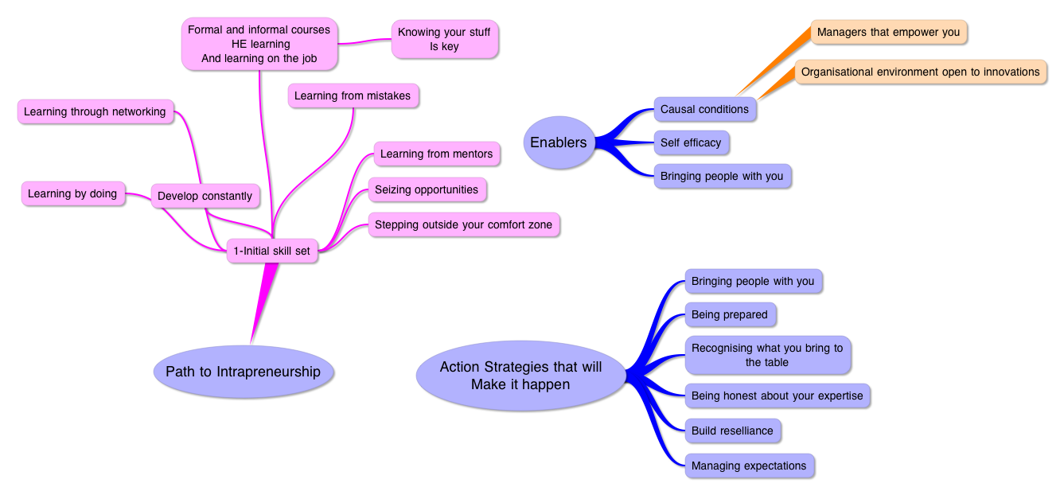

Figure 4 Proposed Intrapreneurial Pedagogy

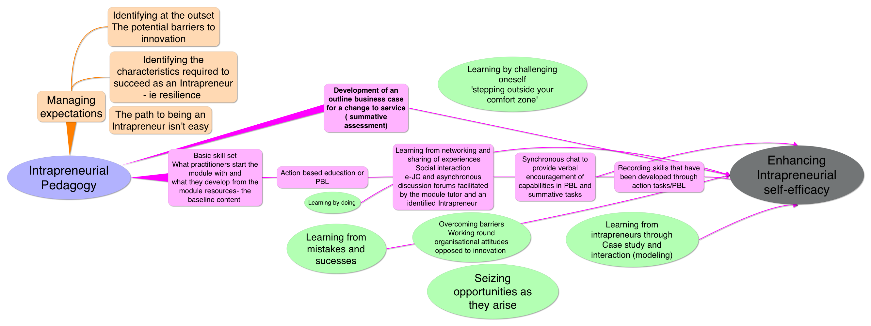

Theory into Practice
In order to develop the IEP we took each aspect of the modelled 'path to intrapreneurship' and incorporated these elements in the IEP. In the IEP shown in figure 4 the colour coding reflects different facets of the module delivery and can be divided into three categories discussed in more detail below:
- Managing expectations
- Learning tasks
- Skill development

Managing expectations
The focus and approach of the IEP module was very different to that of other modules on offer within the Radiotherapy and Oncology post-graduate portfolio. An online pedagogy based on the Gilly Salmon five stage model has been adopted on all our online modules for some time and this model remained within the IEP module; something existing students that had completed other modules would be familiar with providing a suitable infrastructure to the module delivery. However, the fundamental shift in focus to the development of intrapreneurial skills was anticipated to be potentially intimidating to the students and if the IEP was to be successful we needed to ensure the students understood the purpose, usefulness and potential impact of the learning approach being adopted. Hence, to ensure students were responsive to the learning strategies they were to face, a strategy to manage expectations was devised (see table 1 below).

Table 1.The components of the strategy to manage expectations.

Components | Methods | Point in the Module
Students introduced to Intrapreneurialism | 1)Through e-mail communication  2)Through the module handbook e-mailed ahead of the module start (see appendix for example) | Before the start
Emphasis on the aim and Intrapreneurial focus of the module | 1)Pre-module information (e-mails and handbook)  2)Virtual Learning Environment (VLE) opening welcome page an audio file introducing the aims and focus of the module  3) Support and discussion of the rationale for the module assignment (outline business case) through synchronous chat, and an audio infoposter | 1) Before the start  2) At the start of the module  3) At the start and throughout the module
Reinforcing the purpose of the module and the development of intrapreneurial skills | 1) Through announcements on the VLE  2) In live chat sessions using SKYPE  3) On discussion forums | Throughout the module
Defining the challenges and barriers to innovation | 1) Though live synchronous discussions on SKYPE  2) Audio files of intrapreneurs in the resources section of the VLE describing challenges they have faced | 1) At the start and throughout the module  2) throughout the module

Key messages were repeated as part of the strategy to reinforce key facets of the IEP that we wanted students to be aware of as they worked their way through the module. The word cloud below reflects the focus on key terms and messages taken from pre-module documentation sent to students.

Figure 5 Word cloud of key message components of the managing expectations strategy.

Learning Tasks
The curriculum delivery was designed to incorporate the following key concepts from the phase I interviews:
- Learning by doing
- Learning from networking
- Learning from mentors
- Learning from mistakes
- Learning through challenging tasks
Table 2 below presents how each of the above concepts was built into the module delivery.

Table 2. Application of intrapreneurial learning concepts in practice
Intrapreneurial Learning Methods | Application
Learning by doing | - Action-based learning using Problem-Based Learning methods adopted for the online environment.  - PBL scenarios required students to undertake tasks reflective of current problems faced by Breast cancer specialists.
Learning from networking | - Using PBL scenarios students were required to use existing networks within their local employing organisation to gain understanding and perspectives on the problems posed  - Using a wider community of practitioners students were encouraged to engage with an electronic journal club (e-JC) to discuss an article relevant to the module content. Practitioners from the global community access this e-JC giving students the opportunity for discourse with peers beyond the confines of the module cohort and across international boundaries where variations in practice can be debated.  - Link to an article on the importance of making professional connections
Learning from mentors/role models | - Short audio files from intrapreneurs were used to highlight strategies for overcoming barriers and challenges to innovation within the NHS.  - A previous PG student and an identified intrapreneur e-moderated one of the asynchronous discussion forums and gave feedback on students audio summaries for a PBL task.
Learning from mistakes | - Using a feed-forward assessment policy allowed the opportunity to encourage students to reflect on performance across formative and summative tasks and to help them develop a practice of learning from errors and potential failings.  - A PBL scenario was designed around a case study the student identified from their own practice where there had been short-comings in the delivery of care.
Learning through challenging tasks | - Through the PBL scenarios students were encouraged to set up focus groups or presentations with staff within their departments to harness peer perspectives; potentially opening students to critical questioning. This required students to be confident of their specialist knowledge and the evidence within the literature in order to respond to questions and to support any arguments proposed as solutions for the problem scenario.  - Instead of using traditional methods for formative and summative assessments students were required to undertake novel tasks designed to give students the experience of being out of their comfort zone, but with an opportunity for support through peer and e-moderator discussions. Tasks included producing and uploading audio summaries of a critical review of the literature on a specific aspect of breast cancer care and the development of an outline business case proposing a change in practice to the current care provided within their employing Institution. None of the students had previously had experience of recording audio summaries or writing a business case.

Skill Development
In order to develop innovative practitioners we felt it was important to highlight to students the skills and characteristics of intrapreneurs so that students could aspire to developing or enhancing these characteristics. Characteristics such as resilience, and intrapreneurial self-efficacy, and the ability to recognizing their own skill package (what they have to offer), manage others in order to harness the skills of others and reduce barriers to implementation of innovations.
Our first approach was to raise awareness of the skills and characteristics of intrapreneurs to the students through the modelled path to intrapreneurship (Figure 1). We encouraged students to self assess some skills relevant to employability at the start of the module so they could identify areas of weakness to develop as the module progressed; this was augmented by the use of the cognitive style index ^{7;18} so students could identify their propensity towards a particular mode of learning. Being aware of skill deficiencies at the outset and also learning method preference should allow students to approach the content of a module more efficiently; investing more time in activities that are congruent with their preferred learning method or cognitive style¹⁹. Equally, encouraging students to try learning methods that are incongruent with their cognitive style may also broaden that individual’s ability to solve-problems across a spectrum of siyuations.
Throughout the module we added audio sound bites on 'Developing your Potential'. These included intrapreneurs talking about their role, how they developed their intrapreneurial skills and the importance of stepping out of your comfort zone.

Embedding
In this section we will discuss the strategic approach to embedding the IEP across radiography education in the UK; including how we propose to ensure sustainability of the innovation. Embedding and sustainability in this section use the definitions proposed in the JISC guide to sustaining and embedding innovations²⁰ and will be discussed under the following headings:
- People
- Strategies, Processes
- Tools and Resources

The strategy that will be adopted for embedding the IEP across radiography educational providers is a combination of the Four-phase strategy for embedding e-learning innovations described by Jasinski²¹ and the recommendations by JISC²⁰.

Embedding Strategy-People
A key aspect of the strategy for embedding the IEP across the professional training for therapy and imaging radiographers in the UK is to harness early adopters. Identifying the relevant early adopters and their readiness for implementing IEP in their practice is part of the embedding strategy process defined below. A key element for identifying the right people for embedding the IEP is the use of networks and the harnessing of interconnectedness between stakeholders. The stakeholders initially for this project are Radiography education managers, the education lead for the College of Radiographers (CoR) and policy drivers within the new Health Education England body. A new conference in November 2012 (Achieving Excellence in Radiography Education and Research) will be a perfect platform to engage radiography education managers and the education lead for the CoR as well as identifying potential early adopters.
As part of developing networks and communities of practice around innovations in healthcare we also plan to build on a current collaboration with Radiation Therapists in Canada based at the Princess Margaret Hospital in Toronto. Using the research leads in the radiotherapy department as additional early adopters and developing a mobile version of the IEP to increase intrapreneurial activity within therapist researchers.

Embedding Strategy- Processes
As part of the strategy to embed the IEP it will be necessary to demonstrate that the IEP meets a current need by enhancing innovation in health care practice. Therefore, we plan a further period of evaluation in the first instance. The pedagogy is to be tested further on a dissertation module in semester 1 (2012-2013) to allow further insight into the impact of the IEP on intraprenurial self -efficacy, increased innovation within the practitioners practice or enhancement of patient care. We are focusing on the MSc dissertation module which includes approximately 90 students. This will give us an opportunity to assess the benefits of the IEP and its application in a different content area and provide a larger sample to draw inferences from. In addition, this experience will give us an opportunity to refine the model and assess how easy it will be to export the pedagogy across different modules, courses or continuing professional development (CPD) initiatives. Figure 6 on page 19 depicts the strategy for embedding. A sporting analogy is used to explain the strategy proposed. Much like the preparation for a major sporting event successful adoption requires preparation, marketing, team selection, team tactics, implementation, feedback and review of the tactics.
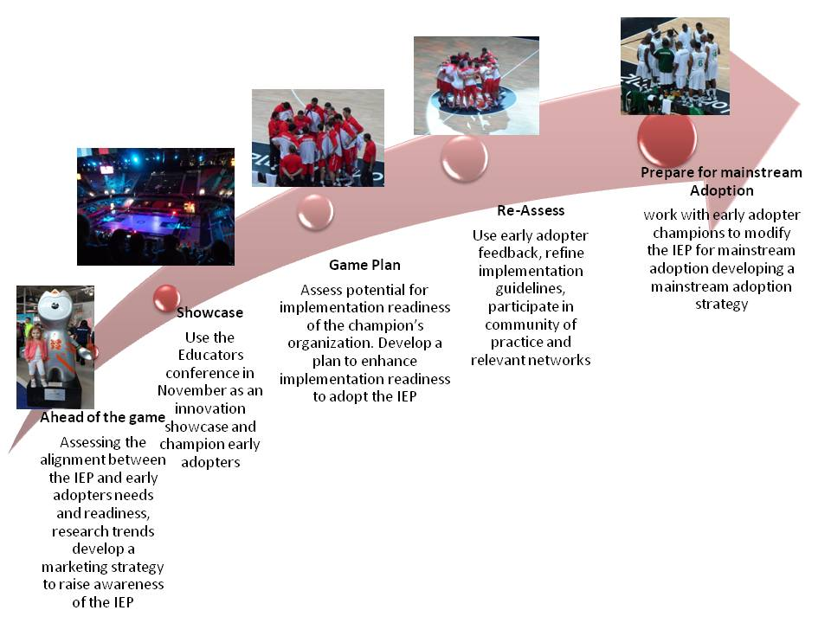
Figure 6 Practical Steps for implementing a strategy for embedding the IEP

Embedding Strategy- Resources
A range of resources to facilitate the embedding of e-learning innovations already exist, these will be adapted and include templates, case studies and tools ²¹.
Many of the ‘developing your potential’ resources used within the IEP are re-useable objects that can be incorporated easily within other e-learning modules; enhancing potential sustainability. For the application of the IEP on the dissertation module (to be trialled in semester 1 2012-13) a number of additional audio sound bites are planned that have a specific research focus (typically around generating ideas, overcoming the barriers to research, developing a research culture etc) these will be developed with research experts that fit the criteria of intrapreneurs¹². Many identified research intrapreneurs have already agreed to provide their time to produce these interview sound bites and once produced can be used on CPD platforms or on mobile packages to reach a wider group of practitioners.

Benefits
Policies such as the QIPP agenda¹ and the Health Education England outcomes framework²² mean that HEIs that provide training for health practitioners need to consider educational provision that will encourage innovation and improve patient care. There is a clear need to develop innovative practitioners and the IEP provides an opportunity for Institutions to meet this current need. The wider benefits are to patients in the form of innovative or novel practices, and enhancements to patient care or the patient experience.

Students Engagement
This section describes the ways we engaged students throughout the online module. A multi-faceted approach was adopted that incorporated a blend of theories appropriate for engaging online learners (including the Gilly Salmon model²³ and the Community of Inquiry model^{24;25}) as well as the IEP design itself. The section on Theory in to Practice describes the strategy employed for managing student expectations and thus engagement with the IEP approach.

Figure 7 below demonstrates the interrelated components of the IEP; development of intraprenurial skills (skills for employability), activities with outcomes that have impact on services and the development of a vibrant online environment. Developing and sustaining a vibrant online community requires acknowledgement of the difference in approach that is needed with online versus traditional learning methods. Hence, it was necessary to apply appropriate online learning theories (in addition to the IEP) to the module delivery in order to maximize student engagement.

Figure 7 Components of the IEP that enhance student engagement
Developing intrapreneurial skills to enhance employability, including problem-solving authentic issues within the student’s own practice, encouraging innovation, and developing an understanding of the skills required to see an innovation put into practice

Focus on real problems in practice to inspire solutions that improve services and patient care
Building and maintaining a community of learners, construction of knowledge through discussion, social presence, cognitive presence and tutor presence,

The IEP is constructivist in nature relying on discourse with peers (both within and outside the module cohort) to enhance both the learning experience and the consolidation of knowledge development. Interviews in stage 1 of the study highlighted that intrapreneurs learned from networking with others and also from mentors. Therefore, tasks or e-tivities were designed to encourage students to network locally with staff in their employing department as well as a wider group of practitioners through our e-Journal club (e-JC). Utilizing both synchronous and asynchronous discussions planned for strategic points in the module (focused around the PBL sections and module assignment preparations) we aimed to consolidate knowledge development from this networking as well as research evidence synthesis through peer discussion; additional support was provided by an intrapreneur e-moderating a discussion forum. The infographic on page 20 demonstrates student engagement across the different discussion opportunities. Tutor (or e-moderator) presence was important for developing a vibrant online environment (and hence maximizing student engagement). Responses on asynchronous forums by the e-moderators were positive, encouraging and rapid in order to retain engagement. However, to retain authenticity and develop intrapreneurial skills the e-moderators were also questioning, and directive in places. Weaves of student posts²³ with e-moderators comments were used to motivate and encourage participants and to highlight examples of interesting, or innovative practice.
Ensuring the module outcomes and tasks were of practical relevance to the students was part of the strategy to enhance student engagement. Utilising a previous student of the module (and identified intrapreneur) to develop the online PBL activities helped to ensure relevant authentic learning could be achieved. The IEP design itself also incorporated the design elements identified as important for ensuring authentic learning experience ²⁶ (see Table 3 for details and Appendix 2 for the assessment model adopted).
Table 3 Authentic Learning Design Elements (adapted from Lomardi²⁶)

Design Element | Description
Real-world relevance | Learning tasks were matched to real issues practitioners were likely to encounter within their practice. Students were given tasks that mimicked the practice and culture of their discipline.
Ill-Defined problem | The tasks were ill-defined to reflect real professional issues which are also ill defined and not easily solved with any simple technique or existing approach. This required students to define the sub-tasks required to assess, evaluate and complete the main task.
Sustained investigation | Tasks were designed that required significant student input, thought and time reflecting authentic problems that required sustained investigation in order to arrive at appropriate solutions.
Multiple sources and solutions | Some initial resources were provided but students were required to examine the tasks from a variety of perspectives, using a variety of resources.
Collaboration | Collaboration was integral to the task designs both within the module discussion forums but also outside the module in the real environment of the student’s employing institution.
Interdisciplinary perspective | Tasks encouraged multi-disciplinary thinking, requiring discourse beyond traditional professional boundaries in order to enhance potential solutions.
Integrated assessment | Assessment utilized both formative and summative assessments that reflected real world processes requiring students to write executive summaries, case studies, and an outline business case. To develop intrapreneurial skills students were encouraged to undertake assessment methods outside their comfort zone including using audio summaries.
Polished products | The summative assignments culminated in an outline business case “valuable in its own right” and potentially ready to be submitted to the employing organization.
Multiple interpretations and outcomes | The tasks allowed for diverse interpretations competing solutions and creativity.

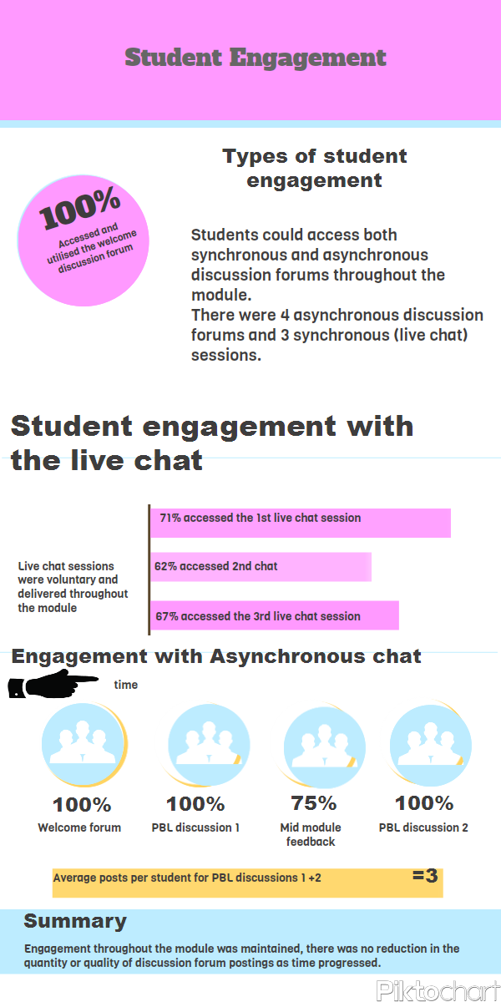

Impact of the IEP on student learning
The impact on the student learning experience will be presented through qualitative and quantitative data. A selection of comments made during the harvesting of mid-module feedback and comments made during synchronous chat sessions are presented in Box 1 on page 23. We utilised mid-module feedback to identify any key concerns that could be attended to prior to the end of the module. Seventy five percent of students from the cohort contributed comments via this method. Feedback was free form, students were not asked specific questions, comments made on a discussion forum the main themes arising from this mid-module process are identified in Table 4 below.
Table 4 Main themes from student comments
Comment/Theme | % of students that commented
Support from module leader very good | 80
Enjoying the module/finding it interesting | 60
Hard going compared to other modules | 50
Learnt a lot/invaluable experience | 50

Other comments related to the challenges posed by the different tasks as a little daunting at first but they liked the challenge and the variety in the approaches on offer.

Box 1 includes some comments made by students
Box 1
Student 1
“I found the Problem based learning approach useful but I also started research and reading many articles without really knowing what was required of me and therefore taking on more work and probably confusing myself much more than needed. However, once I stepped back and took a real look at what I needed to do I was much calmer and focused and feel like I tackled the summary quite well in the end…… I think that there have been some excellent summaries on here arguing different possible solutions reiterating that there is no one answer”.
Student 2
“Reflecting upon PBL approach, I found it useful as it gets you thinking about a variety of aspects surrounding the problem. I initially found that determining what was expected was time consuming but once I started to get into it things became clearer.”
Student 3
“The main benefit to me from doing a problem based approach is that I have a clearer concept of an "entrepreneur" in a healthcare setting. …….I am pleased to say now I see the importance of presenting a balanced, critically appraised summary that depends more on the evidence and literature, than forcing an issue through, or an individual agenda ( although these may still be present, but subordinate to quality research and presentation).”
Student 4
“I am really pleased that having started this module it has really made me stop and think about what we do and I have started talking to a number of radiographers within the department to gain their experiences of what they have found works well for the patients…... As a result a working party is being set-up to try and offer a number of options for these patients as it seems that there isn't a solution which suits everyone and often they are not highlighted by the clinician in advance.”
Student 5
Response to comments from the e-moderator on the discussion forum about her PBL report
“Thank you for the feedback, really helpful and I can't help but feel even more passionate about this subject.”

From the PBL activities all reports identified realistic solutions to the real problem scenario presented. For PBL task 1 20% demonstrated a plan of action to implement a service change locally. For PBL task 2 all demonstrated individual learning with 31% demonstrating action to change future services.

case Examples of The impact of learning on patient services
A nursing student in PBL task 1 was asked to consider the role of reduction mammoplasty as a solution to the technical difficulties and poor outcomes for women with larger breasts undergoing radiotherapy for a breast cancer. Following a review of the literature the student contacted the surgeons locally to discuss the issue. After identifying an interest locally from an Oncoplastic surgeon work continued to develop eligibility criteria for patients that would be suitable. The student went on to develop her final summative assessment (an outline business case) with the multi-disciplinary team (MDT); proposing a service for eligible patients to have the choice of reduction mamoplasty as part of their breast conserving treatment.
A Radiation Therapist student as a result of PBL task 2 identified a gap in their service. The key issues were discussed locally by the student with the MDT. In collaboration with the MDT the student developed an outline business case for additional Breast Care nurses to meet the identified need and planned to present the business case to Trust managers following completion of the module.

Quantitative evaluation of the impact of the iep on innovative behaviour

Table 5 shows the quantitative tools used pre and post module to evaluate the impact of the IEP design. The IEP was tested on a small cohort of students and post module scores were compared with a control arm that were not exposed to the IEP. As the numbers were small differences were not expected to be statistically significant at this stage.
Table 5 Tools used pre and post module
Tools | Number of Items (score min-max) | Alpha
Self Efficacy in Intrapreneurialism | 16 (16-80) | 0.89
SE Innovation | 4 (4-20) | 0.74
SE Management | 5 (5-25) | 0.75
SE Risk taking | 4 (4-20) | 0.65
SE Finance | 3 (3-15) | 0.77
Intrapreneural Personality | 12 (12-60) | 0.62
Innovative behaviour | 5 (5-25) | 0.9
Organisational Emphasis | 5 (5-25) | 0.9

Post module the mean score for self efficacy in innovation for students on the IEP module increased by 1.0 compared with a decrease across the control modules of 0.64. We identified strong (statistically significant correlations) between post-module scores for self efficacy in innovation and intrapreneurial personality (r=0.68 p<0.001). There were also weak correlations between innovative behaviour and intrapreneurial personality and organisational emphasis as shown in Figure 8 below.
Figure 8 Variables correlated with innovative behaviour post module

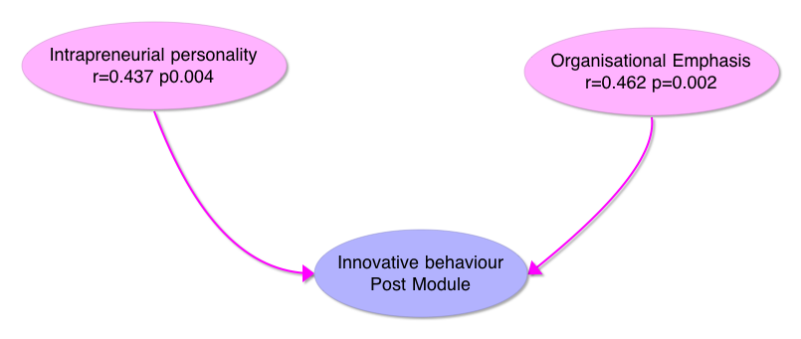

These results indicate that there may be a trend that the IEP can positively influence intrapreneurial self efficacy but a larger sample is required to prove the current improvement wasn’t a chance finding; this will be studied via a larger sample in semester 1 2012-2013.
Intrapreneurial personality appears to be correlated with self-efficacy in innovation so future analysis will need to control for this variable in order to assess the impact of the IEP. Similarly the weak correlations identified in Figure 8 indicate a need for caution when attempting in future analysis to ascertain the impact of the IEP on post module innovative behaviour as this data (and evidence from the literature) would support the inference that the employing organizations emphasis on innovation (as well as pre-existing personality traits) could influence an individual’s propensity to innovate, moderating the benefits of the IEP. Ultimately impact needs to be measured by evaluating actual changes or innovations in practice and plans have been made to follow-up the current and subsequent cohorts of students using appropriate impact measures²⁷, data on career development or progression will also be gathered to identify potential for employability benefits of intrapreneurial learning.

Issues and Debates

Teaching Issues
Q: Does using a PBL approach reduce the breadth of learning that can be achieved?
A: Using PBL does mean there is a compromise between breadth and depth of learning. However, the focus of the IEP is to develop the skills that health practitioners need to make advances within their field and to encourage learning beyond the confines of the structured University course. The benefits gained from using action based learning activities out-way the potential decrease in content that might not be covered in the curriculum as a consequence.
Q: The IEP requires substantial input and effort by the online tutors- are the outcomes proportional to the tutor effort? So is it cost-effective?
A: The small evaluation undertaken through this project demonstrated a widening of participant’s views and perspectives brought about by the IEP. There was reporting on the discussion forums from a proportion of students of activities already set in motion to enhance or improve patient care within their employing organization, demonstrating benefit. However, the true impact of an IEP must be measured through changes in practice or improvements in care and this will be the focus of a follow-up study.

Learning Issues
Below are some potential questions from a student perspective.
Q: I just want the credit; can you just give me the learning materials to read and the assignment so I can get on with it?
A: Yes we could do that, but the evidence shows that action orientated learning is more effective in developing the deep learning that is beneficial for improvements in patient care and professional practice. So it is much more effective for students to participate in the action orientated learning tasks than to spend time working through a repository of reading material. Designing a range of authentic tasks should ensure students feel the effort expended is of value to their own practice. Furthermore, ensuring the task output is relevant to the healthcare setting (ie use of a business case, executive summary or article for publication and not an essay) ensures students develop skills relevant for employability while gaining academic credit.
Q: I'm a busy professional and this seems a lot more work than other modules I've studied- is it worth it?
A: Helping students to identify at the start of the module/course their own aims and objectives for the study period should allow students to make their own assessments of whether the effort on the module is worth it. More importantly encouraging students in the early stage of the module/course to define their objectives in terms that reflect improvements to their practice, patient care, patient experiences or employability goals (e.g. development or improvement in a particular skill) should allow for individualization of learning. Choice is also important in the development of an individualized learning plan. Virtual learning environments can be designed to allow students easy navigation that suits their own learning path with the use of some form of guide system. On the IEP module incorporating a traffic light system for activities and resources should allow students to make best use of their time based on their pre-existing skill or experience base and their overall learning objectives. Tasks that are a priority for module completion and awarding of credit are highlighted red. Amber resources (or activities) can be undertaken or read at any time or saved to be read after the module is completed. Green tasks and resources reflect topics considered important for developing understanding or skills appropriate to the module core curriculum.

Resources

This section contains some resources that can be adapted or utilized in the context of developing an intraprenurial enhanced pedagogy. Please see Figures 3 and 4 above that model the path to intrapreneurship and the IEP design. Below is a site plan for an IEP e-learning module, a list of useful references and links, further resources can be found in appendix 1 and 2.

Breast Cancer Radiotherapy (IEP) Module Blackboard Site Plan
- Introduction- welcome page-
- Important Dates for the Module-
- Module Documents
- Staff Details
- Café Area- place for discussion forums, informal chat, networking and socialising
- Learning Materials- Separated into 3 sections (Pre-treatment, Radiotherapy Delivery, Patient-Care). Problem based learning used in section 2 and 3 (see Appendix 2 for example PBL scenario and brief for preparing an audio summary for PBL scenario 3)
- Module Assessment Page- Diagrammatic presentation of assessment process (see Appendix 2) Details of formative assessments, assessment brief for literature review and full outline business case, plus podcasts of interviews with managers
- E-tivity Group discussion page- place where PBL reports and audio summaries uploaded by students
- Live Chat- section where text from live SKYPE chat sessions are housed for those unable to attend the synchronous chat sessions.
- Resources – ‘Developing your potential’- folder containing resources on the path to intrapreneurship, article on making connections, podcasts with an intrapreneur.

Bibliography

(1) Allan Gibb. Concepts into practice: meeting the challenge of development of entrepreneurship educators around an innovative paradigm: The case of the International Entrepreneurship Educators' Programme (IEEP)". International Journal of Entrepreneurial Behaviour & Research 2011;17(2):146-65.
(2) Bagheri A, Pihie ZAL. Entrepreneurial Leadership Learning: In Search of Missing Links. Procedia - Social and Behavioral Sciences 2010;7(0):470-9.
(3) Carlo Raffo, Andy Lovatt, Mark Banks, Justin O'Connor. Teaching and learning entrepreneurship for micro and small businesses in the cultural industries sector. Education + Training 2000;42(6):356-65.
(4) Cecilia Hegarty. It's not an exact science: teaching entrepreneurship in Northern Ireland. Education + Training 2008;48(5):322-35.
(5) Cope J. Entrepreneurial Learning and Critical Reflection. Management Learning 2003 Dec 1;34(4):429-50.
(6) Cope J. Entrepreneurial learning from failure : an interpretative phenomenological analysis. Journal of Business Venturing 2011;26(6):604-23.
(7) David Rae. Understanding entrepreneurial learning: a question of how? International Journal of Entrepreneurial Behaviour & Research 2000;6(3):145-59.
(8) David Rae, Mary Carswell. Towards a conceptual understanding of entrepreneurial learning. Journal of Small Business and Enterprise Development 2001;8(2):150-8.
(9) David Rae. Entrepreneurial learning: a practical model from the creative industries. Education + Training 2004;46(8/9):492-500.
(10) David W.Taylor, Richard Thorpe. Entrepreneurial learning: a process of co-participation. Journal of Small Business and Enterprise Development 2004;11(2):203-11.
(11) Dylan Jones-Evans, William Williams, Jonathan Deacon. Developing entrepreneurial graduates: an action-learning approach. Education + Training 2000;42(4/5):282-8.
(12) Fayolle A, Gailly B. From Craft to Science: Teaching Models and Learning Processes in Entrepreneurship Education. Journal of European Industrial Training 2008;32(7):569-93.
(13) Fiet JO. The pedagogical side of entrepreneurship theory. Journal of Business Venturing 2001 Mar;16(2):101-17.
(14) Fiet JO. The theoretical side of teaching entrepreneurship. Journal of Business Venturing 2001 Jan;16(1):1-24.
(15) Gorman G, Hanlon D, King W. Some Research Perspectives on Entrepreneurship Education, Enterprise Education and Education for Small Business Management: A Ten-Year Literature Review. International Small Business Journal 1997 Apr 1;15(3):56-77.
(16) Gorman G, Hanlon D, King W. Some Research Perspectives on Entrepreneurship Education, Enterprise Education and Education for Small Business Management: A Ten-Year Literature Review. International Small Business Journal 1997 Apr 1;15(3):56-77.
(17) Hannon PD. Teaching Pigeons to Dance: Sense and Meaning in Entrepreneurship Education. Education & Training 2006;48(5):296-308.
(18) HELGE LOBLER. Learning Entrepreneurship from a Constructivist Perspective. Technology Analysis & Strategic Management 2006;18(1):19-38.
(19) Jarna Heinonen, Sari-Anne Poikkijoki. An entrepreneurial-directed approach to entrepreneurship education: mission impossible? Journal of Management Development 2006;25(1):80-94.
(20) Jarna Heinonen. An entrepreneurial-directed approach to teaching corporate entrepreneurship at university level. Education + Training 2007;49(4):310-24.
(21) Jason Cope, Gerald Watts. Learning by doing – An exploration of experience, critical incidents and reflection in entrepreneurial learning. International Journal of Entrepreneurial Behaviour & Research 2000;6(3):104-24.
(22) Jones C, English J. A contemporary approach to entrepreneurship education. Education + Training 2004;46(8/9):416-23.
(23) Kabongo JD, Okpara JO. Entrepreneurship education in sub-Saharan African universities. International Journal of Entrepreneurial Behaviour Research 2010;16(4):296-308.
(24) Kate Lewis, Claire Massey. Delivering enterprise education in New Zealand. Education + Training 2003;45(4):197-206.
(25) Kirby DA. Entrepreneurship Education Can Business Schools Meet the Challenge. Education + Training 2004;46(8):510-9.
(26) Kuratko DF. The Emergence of Entrepreneurship Education: Development, Trends, and Challenges. Entrepreneurship Theory and Practice 2005;29(5):577-98.
(27) Mitchell A, Cordy J. Vitae Intrapreneurship Phase 2: project paper . 2007.
(28) Mwasalwiba ES. Entrepreneurship Education: A Review of Its Objectives, Teaching Methods, and Impact Indicators. Education & Training 2010;52(1):20-47.
(29) Neck HM, Greene PG. Entrepreneurship Education: Known Worlds and New Frontiers. Journal of Small Business Management 2011;49(1):55-70.
(30) Pittaway L. Simulating entrepreneurial learning: integrating experiential and collaborative approaches to learning. Management Learning 2007;38(2):211-33.
(31) Pretorius MNG, Nieman G, Vuuren JV. Evaluation of two models for entrepreneurial education: An improved model through integration. International Journal of Educational Management, 19(5), p 413-427 2005;19(5):413-27.
(32) Rae D. Entrepreneurial learning: a narrative-based conceptual model. Journal of Small Business and Enterprise Development 2005 Mar;12(3):323-35.
(33) Rai SD. Social Entrepreneurship In Nursing - A Tool For Learning, Advocacy And Income Generation. SINGAPORE NURSING JOURNAL 2007;34(3):7-15.
(34) Rasmussen EA, S++rheim R. Action-based entrepreneurship education. Technovation 2006 Feb;26(2):185-94.
(35) Rita Klapper, Silke Tegtmeier. Innovating entrepreneurial pedagogy: examples from France and Germany. Journal of Small Business and Enterprise Development 2010;17(4):552-68.
(36) Roberts P. Development of entreprenurial activity in nurse education. Nursing Standard 23[28], 35-41. 2009.
Ref Type: Magazine Article
(37) Roberts P, Jester R. Development of entrepreneurial activity in nurse education. Nursing Standard 2009;23(28):35-41.
(38) Shepherd DA. Educating Entrepreneurship Students About Emotion and Learning From Failure. Academy of Management Learning and Education, 2004;3(3):274-87.
(39) Siok San Tan, C.K.Frank Ng. A problem-based learning approach to entrepreneurship education. Education + Training 2006;48(6):416-28.

Useful Links to inspire
http://www.forbes.com/sites/actiontrumpseverything/2012/07/22/how-extremely-successful-people-sell-their-ideas-internally/
http://www.bethtemple4u.com/2012/07/23/an-intrapreneurs-checklist-for-success-2/
http://www.entrepreneur.com/blog/224079
http://www.businessperform.com/articles/innovation-creativity/innovation-culture-communications-motivation.html
http://www.fastcompany.com/1844177/innovation-isnt-about-new-products-its-about-changing-behavior
http://www.cbsnews.com/8301-505125_162-57482636/5-reasons-you-should-fail-more-often/?tag=nl.e713&utm_source=buffer&buffer_share=dbef1
http://www.inc.com/karl-and-bill/5-signs-that-youre-an-entrepreneur-at-heart.html?nav=su&cid=em01017week32&utm_source=buffer&buffer_share=d25b2
http://www.cbsnews.com/8301-505125_162-57493239/the-most-important-message-to-leaders/?tag=nl.e713&utm_source=buffer&buffer_share=c3419

Reference List

(1) Department of Health QIPP agenda- Innovation. 2011.
Ref Type: Internet Communication
(2) College of Radiographers. Education and professional development; Moving ahead. 2006.
Ref Type: Report
(3) Jones ML. Role development and effective practice in specialist and advanced practice roles in acute hospital settings: systematic review and meta-synthesis. Journal of Advanced Nursing 2005; 49(2):191-209.
(4) Amo B, Kolvereid L. ORGANIZATIONAL STRATEGY, INDIVIDUAL PERSONALITY AND INNOVATION BEHAVIOR. Journal of Enterprising Culture 2005; 13(1):7-19.
(5) National Radiotherapy Advisory Group. Radiotherapy: developing a world class service for England (Report to Ministers). 2007.
Ref Type: Report
(6) Jones ML. Role development and effective practice in specialist and advanced practice roles in acute hospital settings: systematic review and meta-synthesis. Journal of Advanced Nursing 2005; 49(2):191-209.
(7) Allinson CW, Chell E, Hayes J. Intuition and entrepreneurial behaviour. European Journal of Work and Organizational Psychology 2000; 9(1):31-43.
(8) Garavan TN, O'Cinneide B. Entrepreneurship Education and Training Programmes:A review and evaluation part 1. Journal of European Industrial Training 1994; 18(8):3-12.
(9) Glaser B. Basics of Grounded Theory Analysis: Emergence vs Forcing. 1992.
(10) Allinson CW, Hayes J. THE COGNITIVE STYLE INDEX: A MEASURE OF INTUITION-ANALYSIS FOR ORGANIZATIONAL RESEARCH. Journal of Management Studies 1996; 33(1):119-135.
(11) Chen CC, Greene PG, Crick A. Does entrepreneurial self-efficacy distinguish entrepreneurs from managers? Journal of Business Venturing 1998; 13(4):295-316.
(12) DAYHOFF NE, MOORE PS. You Don't Have to Leave Your Hospital System to Be an Entrepreneur. Clinical Nurse Specialist 2003; 17(1).
(13) Frambach RT, Schillewaert N. Organisational Innovation adoption: A mulit-level framework of determinants and opportunities for future practice. ISBM Report 29-1999. 1999.
Ref Type: Report
(14) Robinson L. A summary of Diffusion of Innovations. 2009.
Ref Type: Report
(15) Probst H, Griffiths S, Adams R, Hill C. Burnout in Therapy Radiographers in the UK. British Journal of Radiology 2012; in press.
(16) Probst H, Griffiths S. Job satisfaction of therapy radiographers in the UK: Results of a phase I qualitative study. Radiography 2009; 15(2):146-157.
(17) Probst H, Griffiths S. Retaining Therapy radiographers: What's so special about us? Journal of Radiotherapy in Practice 2007; 6(1):21-32.
(18) Allinson CW, Hayes J. THE COGNITIVE STYLE INDEX: A MEASURE OF INTUITION-ANALYSIS FOR ORGANIZATIONAL RESEARCH. Journal of Management Studies 1996; 33(1):119-135.
(19) Sadler-Smith E, Allinson CW, Hayes J. Learning preferences and cognitive style - Some implications for continuing professional development. Management Learning 2000; 31(2):239-256.
(20) Joint Information Systems Committee. Sustaining and embedding innovations: Good practice guide. 2011. 6-8-2012.
Ref Type: Report
(21) Jasinski M. Innovate and Integrate:Embedding innovative practices. 2007. 6-8-2012.
Ref Type: Report
(22) Department of Health. Liberating the NHS: Developing the Healthcare Workforce (from design to delivery). 2012.
Ref Type: Report
(23) Salmon G. E-moderating: The key to teaching and learning online. second edition ed. Routledge Falmer; 2004.
(24) Garrison DR, Anderson T, Archer W. Critical Inquiry in a text based environment: computer confereing in higher education. The Internet and Higher Education 2000; 15(1):7-24.
(25) Lee R, Faulkner M. The roles of extrinsic factors in a community of inquiry model of e-learning. e-learning and digital media 2011; 8(1):58-66.
(26) Lombardi MM. Authentic Learning for the 21st centuary: An overview. Oblinger DG, editor. 2007. Educase learning Inititative.
Ref Type: Report
(27) Humphreys A, Richardson J, Stenhouse E, Watkins M. Assessing the impact of nurse and allied health professional consultants: developing an activity diary. Journal of Clinical Nursing 2010; 19(17-18):2565-2573.

Appendix 1

Managing Expectations- Excerpt from the module handbook

Developing Wider Intraprenurial Skills
This module is designed to help you develop the skills necessary for advanced or Consultant practice with a specialism in breast cancer. In particular the module is designed to enhance intraprenurial skills.
What is intrapreneurship? Intrapreneurship is an individual intention or drive to innovate within an organisation, developing and implementing novel solutions to organisational problems often in a ‘bottom-up’ way
How Will Developing my Intraprenurial Skills Help Improve my specialist skills?
The attributes of an intrapreneur include the ability to think outside the box, self confidence, a high level of knowledge and an ability to focus not only on improving patient care but enhancing the whole service. Those that function well in advanced practice or Consultant roles demonstrate all of these attributes. So while developing your knowledge of breast radiotherapy practice we will also be developing these other skills so that you can implement the knowledge you develop and enhance the service you provide.
How will I develop Intraprenurial Skills? The module employs problem based learning throughout. So you will be set problems or scenarios that you will need to research and gather information on. We will provide you will some background resources, links and articles as a starting point. In addition, these problems will require you to undertake tasks that you may not have any previous experience of. For example, you may choose to undertake a short presentation to colleagues locally to present ideas about your module assignment, set up a focus group with staff to gather their perspectives on a topic, and produce and upload an oral summary of your findings to the Blackboard site. You are not assessed at all on these skills but intrapreneurs learn best when they are outside their comfort zone, and build their skills by being challenged; so we will be replicating these situations in a learning environment where you can reflect on the experience within the online group with support and input from the module leader and intrapreneurs from within the profession.
Knowing How You Learn and Knowing What Your Weaknesses Are.
In order to develop or expand your skills and knowledge it is helpful to know how you learn.
“We all differ in the way we make sense of the world around us. Each of us has a preference or predisposition to gather, process and evaluate information in a particular way. This preference is our cognitive style. It affects the way we learn, solve problems and make decisions” Professor Allinson.
To help you identify what your cognitive style is you will be given the opportunity to complete the Cognitive Style Index online via a link sent to you via your SHU e-mail. You do not have to complete this questionnaire it is completely voluntary. You may also want to complete the Graduate Skills Profile below to self assess any areas of weakness prior to starting the module, you should use this self assessment to focus any activities during your study on this module.

This Graduate Skills Profile contains a single set of 15 graduate skills i.e. skills that employers believe to be important attributes in the people they choose to employ. You can rate each skill from 0-6 with 6 being very confident/very able and 0 being not confident or not able.

How confident or able are you at...
Analytical skills
…being able to break something down into its constituent parts

Decision making skills
…being able to balance factors to make a decision

Enquiry & research skills
…being able to find out information from a range of sources

Independent judgement
…deciding what you believe to be an appropriate representation of an issue

Ability to solve problems
…using a range of methods and strategies to solve problems

Imagination & creativity
…approaching problems or situations using new or imaginative thinking

Numeracy
…being able to mentally manipulate figures and understand a range of formulas and conventions

Ability to use IT
…being able to use common office software like word-processing and spreadsheets and being able to manage your own files and folders

Logical argument
…being able to use appropriate information to present an argument or to refute someone else’s position

Self skills
…includes self-management, self-confidence and self-awareness

Flexibility & adaptability
…being able to change your working methods, styles or preferences to meet the challenges of changing circumstances

Ability to work in a team
…adding value to a group of others working towards a common goal through your knowledge and personal skills

Ability to communicate effectively
…includes listening, written and oral communication

Specialised subject knowledge
…having a comprehensive understanding of your subject including traditional ways of thinking and contemporary theories

Ability to relate a subject to the wider social & economic context
...having an understanding of what your subject contributes to society including an understanding of any negative contribution

Overall rating: out of 90
Average rating:

Appendix 2
