To the employer:

Sheffield Hallam University is currently working with the government's Education and Skills Funding Agency (ESFA) to provide higher and degree apprenticeships. If you would like to work with your employee to support them as an apprentice you may be entitled to receive support from the government to fund your employee's apprenticeship studies either through your digital account (as a levy payer) or through co-invested funding (non-levy payer).

Please find overleaf an initial eligibility checklist. If you and your employee agree that they may be eligible to be an apprentice according to these initial requirements, please sign the enclosed Initial Eligibility Confirmation and ensure your employee returns this to us with their completed University application form.

When we receive the application form we will check if your employee meets the entry requirements for study on the University course and, if appropriate, we will make them an offer to study on the University course. If your employee also returns the Initial Eligibility Confirmation completed by you we will also check their initial eligibility for funding of their course as an apprenticeship. Where we believe they may be eligible to join the course as an apprentice (and you would therefore benefit from government support to fund their studies) we will provide to them the various forms required by the ESFA to complete and return. This further information will enable us to make an application to support your employee to become an apprentice on the government's scheme.

To help you through the process we have enclosed a 1-2-3 Guide for Employers. If you have any questions please do not hesitate to contact us on apprenticeships@shu.ac.uk.

Funding
Provided that your employee meets the ongoing eligibility requirements set down by the ESFA and engages with the course, they may be eligible for funding from the ESFA to cover 100% of the course fees if you are a levy-paying employer (payable from your digital account) or 90% of the course fees if you are a non-levy payer. Please see overleaf for a guide to help you identify which category your organisation falls into and further information on any additional funding that may also be available.

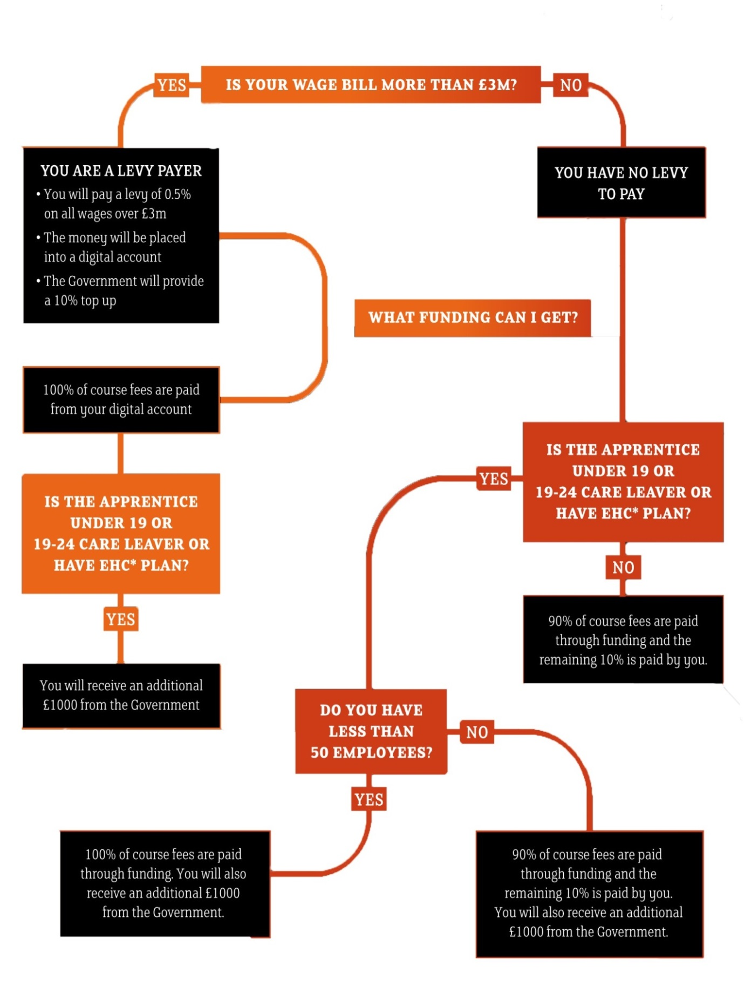
* Local authority Education, Health and Care Plan

Checklist for Initial Eligibility for Higher and Degree Apprenticeships
Starting on or after 1 May 2017
(May 2017 - March 2018 Education and Skills Funding Agency (ESFA) Funding Rules)
Funding is available to cover some of or the entire course fee for Higher and Degree Apprenticeships. Employer and employee/applicant must ensure that the following criteria apply to the apprenticeship. If any of these criteria do not apply, the employee ("you") will not be eligible for funding as a higher or degree apprentice:
- You were aged 16 or over on 30 June 2017
- You are a UK citizen (or have the Right of Abode in the UK, or are a citizen of a country within the European Economic Area and have been ordinarily resident in such country for at least the last 3 years)
- You have already achieved at least level 2 English and Maths (e.g. GCSE A* - C)
- You have the right to work in England
- You are currently in employment in England and will spend at least 50% or your working hours in England over the duration of the apprenticeship and you are not self-employed
- You are not planning on leaving the UK within the next 12 months (excluding holidays)
- If you have already undertaken an apprenticeship, you will have completed or achieved and left that apprenticeship before undertaking this apprenticeship with Sheffield Hallam University
- This apprenticeship with Sheffield Hallam University will not duplicate training or assessment you have already received from any other source
- You are not already being funded by the ESFA or any other government department for any other training or education

Step 1: Confirmation of Initial Eligibility for Higher and Degree Apprenticeships
2017/2018 Education and Skills Funding Agency Funding Rules

Please complete, sign and return this statement with your Sheffield Hallam University application form:
University Course (including pathway): …………………….…………………………………...
Apprenticeship Standard/Framework: ……………….…………………………………………..
[please delete as appropriate]
1. | Is the Applicant aged between 16 and 18 years old? | YES | NO
2. | Is the Applicant aged between 19 and 24 years old and do they have either an EHC Plan provided by their local authority or have they been in the care of their local authority? | YES | NO
3. | Does the Employer employ fewer than 50 people? | YES | NO
4. | Is the Employer a levy-payer? | YES | NO

We, …………………………………………………………………….… (Applicant/Employee)
and ………………………………………………………………… (on behalf of the Employer)
have read the Checklist for Initial Eligibility and confirm that we are not aware of any reasons why the applicant/employee is not eligible for apprenticeship funding.
We acknowledge that confirmation of eligibility will only be possible on submission of all ESFA Apprenticeship Funding Forms by Sheffield Hallam University to the Education and Skills Funding Agency.

To be signed on behalf of the Employer:
Signature: …………………………………………………..……………...………………………
Name: ………………………………………………………………………………………………
On behalf of (company): ………………………………………………………………………….
Date: ………………………………………………………………………………………………..

Further information and guidance:
Sheffield Hallam University Apprenticeship FAQs: http://www.shu.ac.uk/apprenticeships/
Education and Skills Funding Agency (ESFA) including full guidance and rules documentation: https://www.gov.uk/topic/further-education-skills/apprenticeships
only to be completed where you have answered 'yes' to question 2 in the confirmation of initial eligibility

HIGHER AND DEGREE APPRENTICESHIPS - ADDITIONAL PAYMENTS

Declaration given to Sheffield Hallam University

Sheffield Hallam University Course:
Apprenticeship Standard/Framework:
Course Start Date:
Employer Name:
Name of the Applicant:
Date of Birth of the Applicant:

I, the Applicant, hereby confirm that on the Course Start Date:
- I shall be aged between 19 and 24 years old; and
either
- I have an EHC plan provided by my local authority
or
- I have been in the care of my local authority
[please delete as appropriate]

I hereby confirm that you are authorised to share the above information with my Employer and that I consent to you processing this information in order for you to comply with the obligations placed on you by the Education and Skills Funding Agency in connection with the delivery of my apprenticeship.
Signature of Applicant: ……………………………………………………………………………

Name of Applicant: ………………………………………………………………………………..

Date: ………………………………………

The ESFA will also fund certain other individuals such as non-EEA citizens with permission from the UK government to live in the UK (not for educational purposes) and who have been ordinarily resident in the UK for at least the last 3 years; armed forces personnel and apprentices whose occupation involves significant travel outside of the UK as part of their job. If this may be applicable to you, please contact the University to discuss further.
If you have not achieved this or are unable to evidence this, please contact the University to discuss further.
If you work for fewer than 30 hours a week or have a zero hours contract you may still be eligible for funding, provided that you work enough hours each week to undertake sufficient, regular training and on-the-job activity. In such cases the minimum duration of your apprenticeship will be extended pro rata and in the case of part-time working, using the following formula specified by the ESFA: 12x 30/average weekly hours. For example, if you work part-time for 20 hours per week and the required minimum duration for your apprenticeship course is 12 months, you must be in learning for at least 18 months.
Or such longer minimum duration period as may be specified in the apprenticeship standard or framework, as applicable.
The ESFA will fund an apprentice to undertake an apprenticeship at the same or a lower level than a qualification they already hold if the apprenticeship will allow the individual to acquire substantive new skills and it can be evidenced that the content of the training is materially different from any prior qualification or a previous apprenticeship. If this may be applicable to you, please contact the University to discuss further.
There is no requirement to answer this question. However, if this is applicable to the Applicant and they are willing to disclose this information they must also complete and return the enclosed confirmation (which is required by the ESFA's Funding Rules).
A child in care is defined in the Funding Rules as: - an eligible child = a young person who is 16 or 17 and who has been looked after by the location authority/Health and Social Care Trust for at least a period of 13 weeks since the age of 14, and who is still looked after - a relevant child = a young person who is 16 or 17 who has left care after their 16th birthday and before leaving care was an eligible child - a former relevant child = a young person who is aged between 18 and 21 (up to their 25th birthday if they are in education or training) who, before turning 18, was either an eligible or a relevant child or both.

